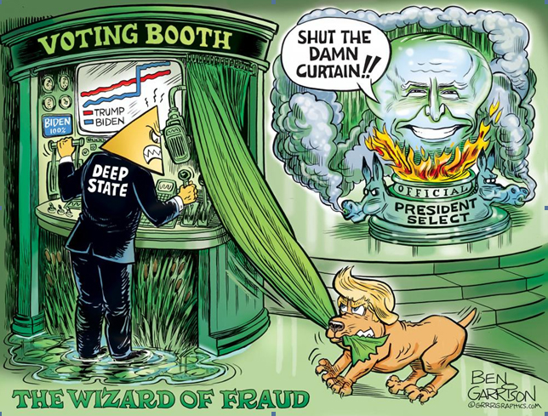
ELECTION FRAUD IN AMERICA
– A NATIONAL DISGRACE
Click & Sign up for free political incorrect Grrrgraphics
CONTINUOUSLY UPDATED
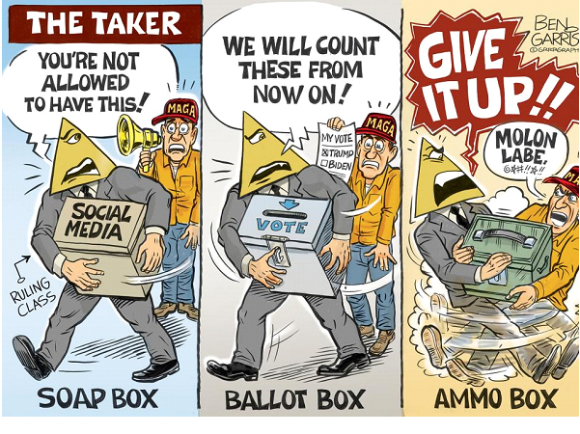
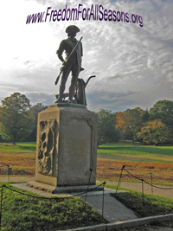
Abstract
“Do not say that I am deceiving you today. The fact is that it’s necessary for me to speak before you, and therefore sow seeds of confusion in your minds. If a true seer should see what I am doing, what a laughing stock I would be in his eyes. But now there is no escape from it.”
Wu-Men
Little Zen Calendar
January 28, 2021
My mission in this research report is to present enough evidence from the last 2020-2021 election and then some to establish beyond a reasonable doubt for a reasonable open minded American that there was substantial proof of significant election fraud as to change the outcome.
I have for the most part, gathered hard evidence from experts who have presented undeniable evidence that something happened and it happened very quickly at precise times.
Fraudulent election and other behavior of too many municipals and states have been well documented. In this 2020 – 2021 election hundreds of election witnesses have come forward testifying of the mishandling of votes, ballots not folded, multiple copying of the same pack of votes, truck loads of votes brought in at late night hours unsecured, mail in ballots without signatures or using the same signature, suitcases of votes brought out under tables in secure municipal vote counting areas after everyone is told to go home, muni vote room windows being covered, observers being turned away, strange counts coming out of voting machines, voting official swearing under oath they know the Dominion CEO was lying, China funding and hacking of our election machines, tens of thousands of ballots “received” the day before they were mailed, courts refusing to hear the evidence or the cases because of “lack of standing”, unending examples of nearly paranormal statistical aberrations obviously showing vote manipulation go unchallenged and largely unreported by the MSM and Big Tech giant social media.
This report will not only give a reasonable American reasonable doubt, it will give you so many hard cases of the 2020 – 2021 American Presidential race election fraud that the villains will start to appear.
Montana election fraud data is found on Pages 58, 59, 78, 83, 84, 90, 91 & 95. ES&S findings on Page 10 & 11.
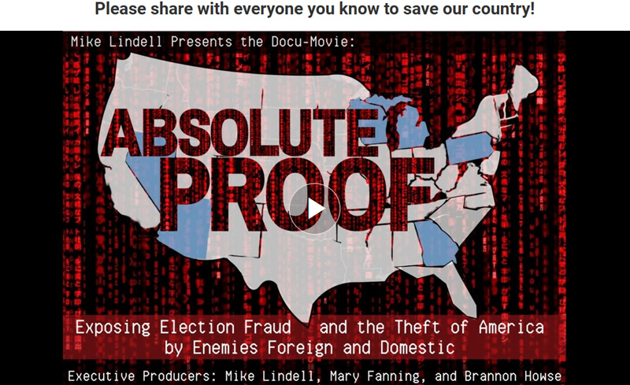
Absolute Proof
This is a 2 hour documentary interviewing 9 witnesses re. the 2020 election fraud hosted by Mike Lindell, Pillow Man/$300 millionaire.
Those being interviewed are:
- Phil Waldron a retired U.S. Army colonel (information warfare),
- Russell Ramsland (cyber forensics security Allied Security Ops Group),
- Dr. Shiva (4 degrees, inventor, businessman),
- Patrick Colbeck (former Republican Michigan Senator),
- Melissa Carone (Michigan IT contractor and whistle blower),
- Matt DePorno (Michigan Attorney Law Office – www.depernolaw.com )
- Mary Fanning (Journalist and Author National Intelligence Research)
- Major General Thomas G. McInerney (Army & Air Force Assistant Vice Chief of Staff Hdq U.S. Air Force Wash. D.C.
- Terry Turchie (Author & FBI counter terrorism division)
Some of my notes taken watching “Absolute Proof”
- USA has also been changing votes in other countries.
- Diebold 2002 version page 2-127 gives instructions for changing votes X times (@ 55 minutes)
- Government tells corporations what to do.
- The Zuckerberg Effect – funding of election operations prompts litigations
- Algorithms are the crime scene.
- Slow down in middle of election night.
- In 27 hours all votes for Joe Biden, no Trump vote, to unusual
- Melissa Carone told her boss there was a problem, boss said “I don’t want to hear you have a problem….”
- 7060 votes were flipped from Trump to Biden by the voting machines
- Failure to follow proper voting procedures of recording the votes
- CEO Dominion was lying
- 68% error rate goes to an adjudicated ballot which allows someone else to determine vote.
- Machine results don’t match with real votes
- Michigan AG threats any attorney who challenges their voting results with disbarment
- “Biggest cyber attack on America in history” – Mary Fanning
- 2900 muni’s were cyber attacked. (I think is county municipal corporations vs. city muni’ may be wrong?}
- The FBI knew our election machines were open for hacking.
Security Analysis of the Diebold AccuVote -TS Voting Machine – The Feldman Study Princeton University
Center for information Technology Policy and Dept. of Computer Science, Princeton University Woodrow Wilson School of Public and International “Affairs, Princeton University.
Click on title to this 45 page research study
Abstract
“This paper presents a fully independent security study of a Diebold AccuVote-TS voting machine, including its hardware and software. We obtained the machine from private party. Analysis of the machine, in light of real election procedures, shows that it is vulnerable to extremely serious attacks. For example, an attacker who gets physical access to a machine or its removable memory card for as little as one minute could install malicious code; malicious code on a machine could steal votes undetectably, modifying all records, logs, and counters to be consistent with the fraudulent vote count it creates. An attacker could also create malicious code that spreads automatically and silently from machine to machine during normal election activities—a voting-machine virus. We have constructed working demonstrations of these attacks in our lab. Mitigating these threats will require changes to the voting machine’s hardware and software and the adoption of more rigorous election procedures.”
The Market for Voting Machines Is Broken. This Company Has Thrived in It.
“Urosevich later left ES&S in the hands of his first hire, his brother Todd, and went to run Global Elections Systems, the voting machine arm of Diebold, a major security and financial technology company.

In 2003, Diebold’s CEO caused a controversy when he became a top fundraiser for George W. Bush and promised to help Ohio “deliver its electoral votes to the president.” While there is no evidence the CEO actually manipulated his company’s machines to alter the vote in Ohio — it went for Bush — the dispute and a host of issues involving the effectiveness of its technology led Diebold to sell off the voting business in 2009.

ES&S purchased many of Global Elections Systems’ machines and contracts, and, as a result, it controlled some 70% of the voting technology market at that time.

ES&S and the other two major companies — Dominion, which has about 30% of the market, and Hart InterCivic, which has about 15% — have similar business models. Each has a large sales force that pushes its products, services and maintenance help to counties across the country. Comparatively little of their workforces are devoted.
4.2 Stealing Votes (Continued from above - Diebold Voting Machine -The Feldman Study)
“Several of the demonstration attacks that we have implemented involve installing code onto AccuVote-TS machines that changes votes so that, for a given race, a favored candidate receives a specified percentage of the votes cast on each affected machine. Since any attacks that significantly alter the total number of votes cast can be detected by election officials, our demonstration software steals votes at random from other candidates in the same race and gives them to the favored candidate. The software switches enough votes to ensure that the favored candidate receives at least the desired percentage of the votes cast on each compromised voting machine.
Election results (i.e., the record of votes cast) are stored in files that can be modified by any program running on the voting machine. The primary copy of the election results is stored on the memory card at \StorageCard\CurrentElection\election.brsand a backup copy is stored in the machine’s on-board9While Diebold sells special-purpose memory cards for use in the machine, we were able to substitute a Compact Flash card (typically used in digital cameras) and a Compact Flash-to-PC Card adapter flash memory at \FFX\AccuVote-TS\BallotStation\CurrentElection\election.brs. Our software modifies both of these files.
Our demonstration vote-stealing software is implemented as a user-space Windows CE application writ-ten in C++ that runs alongside Diebold’s Ballot Station application. Since our software runs invisibly in the back-ground, ordinary users of Ballot Station would not notice its presence. It is pre-programmed with three parameters hard-coded into the binary: the name of the race to rig the name of the candidate who is supposed to win, and the minimum percentage of the vote that that candidate is to receive.
Alternatively, an attacker could create a graphical user interface that allows more immediate, interactive control over how votes would be stolen. We have also created a demonstration of this kind of attack. In practice, a real attacker would more likely design a vote-stealing program that functioned invisibly, without a user interface.
Our demonstration vote stealing applications can be generalized to steal votes on behalf of a particular party rather than a fixed candidate, to steal votes only in certain elections or only at certain dates or times, to steal votes only or preferentially from certain parties or candidates, to steal a fixed fraction of votes rather than trying to ensure a fixed percentage result, to randomize the percentage of votes stolen, and so on. Even if the attacker knows nothing about the candidates or parties, he may know that he wants to reduce the influence of voters in certain places. He can do this by creating malicious code that randomly switches a percentage of the votes, and installing that code only in those places. Any desired algorithm can be used to determine which votes to steal and to which candidate or candidates to transfer the stolen votes.

4.2 Stealing Votes (Continued from above - Diebold Voting Machine -The Feldman Study)
Every time a new memory card is inserted into the machine, our demonstration vote stealing software looks for an election definition file on the card located at \Storage Card\CurrentElection\election.edb and, if one is present, determines whether the current election contains a race it is supposed to rig. If no such race is found, the software continues to wait. If a target race is found, it searches that race for the name of the favored candidate. Upon finding that the preferred candidate is on the ballot, the software proceeds to poll the election result files every 15 seconds to see if they have been changed.
If the demonstration vote-stealing software successfully opens the result files during one of its polling attempts, it first checks the result files’ headers to see whether the machine is in Election mode. If not, the attack software does not change any votes. This feature ensures that the software would not be detected during Logic and Accuracy testing, which occurs when the machine is in Pre-Election Testing mode. The software could be further enhanced so that it would only change votes during a specified period on Election Day, or so that it would only change votes in the presence or absence of a “secret knock.” A secret knock is a distinctive sequence of actions, such as touching certain places on the screen that an attacker executes in order to signal malicious software to activate or deactivate itself.
If the machine is in election mode and the demonstration vote-stealing software successfully opens the result files, then the software checks whether any new ballot have been cast since the last time it polled the files. For each new ballot cast, the software determines whether the race being rigged is on that ballot, and if so, determines whether the corresponding result record contains a vote for the favored candidate or for an opponent. The software maintains a data structure that keeps track of the location of every result record that contains a vote for an opponent of the favored candidate so that it can come back later and change some of those records if necessary. Since each result record is only labeled with the ID number of the ballot to which it corresponds, the software must look up each record’s ballot ID in the election definition file in order to determine which candidates the votes in the record are for.
Once it has parsed any newly cast ballots, the software switches the minimum number of votes necessary to en-sure that the favored candidate gets at least the desired percentage of the vote. The vote-stealing software chooses which votes to switch by selecting entries at random from its data structure that tracks votes for the opponents of the favored candidate. After the necessary changes have been made to the result files, the software closes the files, resumes the Ballot Station process, and continues to wait in the background.
The steps described above are all that is necessary to alter every electronic record of the voters’ intent that an AccuVote-TS machine produces. Several of the machines supposed security features do not impede this attack. The so called “protective counter,” supposedly an unalterable count of the total number of ballots ever cast on the ma-chine, is irrelevant to this attack because the vote-stealing software does not change the vote count. “
Mathematician Says Biden Election Win is A Statistical Impossibility in Georgia.
- This algorithm allows 1 vote for Trump out of 18 votes, i.e. 1/18 = 5.5555% of the vote.
- The bars (graph below) show vote counts coming in during Nov. 4th & 5th with the time of day on top.
- These bars represent different precincts in a county being counted in Georgia as described by Mr. Solomon.
- See the total vote count on bar 1 (left) as 72 votes counted with Biden receiving 68 and Trump 4.
- 4 Votes/78 Votes = 5.5555% which is exactly what the algorithm was programmed to deliver.
- This is 11 different time samples from voting records showing all had exactly the same 5.5555% allocation for Trump.
- This is a statistical impossible event with odds so high against the likelihood they are uncountable.
- Listen to this 3.5 minute interview to understand and believe this.
- This is exactly what the Princeton U. study found analyzing the Diebold AccuVote-TS Voting Machine (Pg. 6-7)

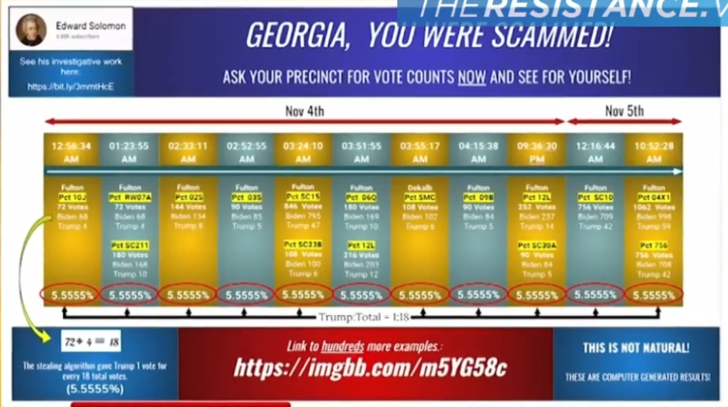

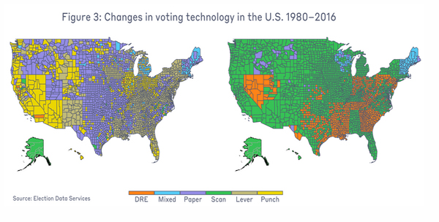
Supporting Material
- Link to https://www.banned.video/
  - Then enter "election fraud" in search engine.
- Click on this Michigan witness Mellissa Carone, December 2020 testimony below to see one of these 50 videos. Listen to this testimony to believe what went on in part re. the lies from the Dominion CEO.
Voting Technology in U.S. 1980-2016

- America’s Love Affair with Paperless Voting is Over. Here’s Why

Supporting Material (continued)

- There are 8 Registered Manufactures of Voting Systems by the U.S. Election Assistance Commission
- 16 million Americans will vote on hackable paperless machines (MIT Technology Review)
- The battle of Algorithms: Uncovering offensive AI (MIT Technology Review)
- Election Security in All 50 States
- Link here For Sidney Powell 3 Page Witness Testimony Smartmatic Voting Machine (Extract below)
  - “Smartmatic Voting technology which was a pioneer in the transmission of voting data over the internet.
  - Smartmatic created this voting technology in part for President Chavez of Venezuela. Dominion and Smartmatic did business together and this equipment has the same fundamental flaws allowing multiple opportunities to corrupt the data masking the process in a way the average person cannot detect any fraud or manipulation.
  - The fact that the voting machine displays a voting result that the voter intends and then prints out a paper ballot which reflects that change does not matter.
  - It is the software that counts the digitized vote and reports the results. The software itself is the one that changes the information electronically to the result that the operator of the software and vote counting system intends to produce that counts.
  - The software itself configures the vote and voting result changing the selection made by the voter. The software decides the result regardless of what the voter votes.”
U.S.A. Election Voting Machine Ownership – Part 1
This table below I put together based on testimony of Mellissa Carone, (pg. 10), Security Analysis of the Diebold AccuVote -TS Voting Machine – The Feldman Study by the Center for information Technology Policy and Dept. of Computer Science, Princeton University (pages 6-8) and 16 years of my life in serious research to awaken myself to this truth.
- It is obvious that two corporations are controlling the America voting machines.
- According to new information Dominion acquired ES&S in 2010.
- ES&S has acquired Diebold under its new name Premier Election Solutions.
- It is also obvious that the tricks used by one are used by all in some form or fashion.
- It is also interesting that #7 Unisyn Voting Solutions is a division of a lottery corporation.
- This thread of evidence suggests the most sacred of America Republic individual independence, individual and state sovereignty is not as sacred as we think.
- The global elite have created a Swamp of the Deep State, transnational, national corporations, lobbies & “non-profit” corporations.
- Your vote is turned into the desired political truth, i.e. a LIE.
- Link to Colonel Phil Waldron 22 minute video re. findings connecting China & George Soros to U.S. election equipment proving USA election system is under control of private equity firms & foreign money. (Added 10-2-2023)
- Patrick Byrne Breaking Biggest News Since Nov 3rd 2020 - A MUST WATCH VIDEO TO FREE AMERICA. (Added 10-2-2023)
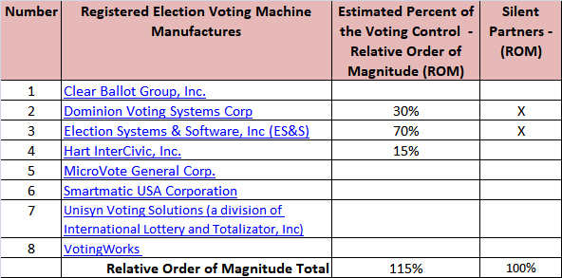
- ROUGH EXTRACTED QUOTE: "SMARTMATIC ONLY RAN LA COUNTY ONE ELECTION HOWEVER, THEIR OS SYSTEM IS IN EVERYBODYS…", @ 8:00 minutes plus. (Added 10-2-2023)

U.S.A. Election Voting Machine Ownership – Part 2
    - They think they are above the law: the firms that own America’s voting system
      - The companies are privately owned and closely held making information …difficult to obtain.
      - The software and hardware design are kept as trade secrets….difficult to investigate.
      - THE OPERATING SYSTEM IS CALLED THE SMARTMATIC ELECTION SYSTEM.
      - DOMINION, HART OR ES&S OPERATING SYSTEMS ARE SMARTMATIC.
      - VIEW THIS LINK AT ABOUT 6:00 MINUTES & ON. (TOTAL TIME IS 26:26 MINUTES)
      - Market for election vendors is small and competition is fierce resulting in near monopolies.
      - Computing security firms have been raising the red flag on voting machines since punch card disaster of 2000.
      - Mueller’s report and prior indictment of 12 Russian agents confirm they targeted private election vendors.
      - Intel agencies expect more cyber attacks to continue.
      - Federal funding helped spread voting machines in 2003.
      - Computer scientists & academics have been buying voting machines and hacking them to force transparency.
      - Voting machine companies have sent litigation threats to academics researching their machines.
      - Georgia’s governor was overseeing his own election while his Secretary of State appointed an ES&S lobbyist as his deputy Chief of Staff while the state is purchasing $150 million more of the machines!
      - There are no technical standards from the US government on voter registration security.
      - Dominion Voting Systems operates in the U.S. and Canada.

    - Election Fraud is More Common Than Not
      - American Election Turmoil: NOTHING NEW
      - 2020 Election Investigative Documentary: Who’s Stealing America? The Epoch Times
        - Dated December 14, 2020 & Updated January 11, 2021
        - 1 hour and 32 minutes video documentary
      - A Statistics Lesson to Save the Republic by Bruce
        - Voting patterns are consistent across parties.
        - For Republican States the Standard Deviation is 5.4 to 5.7
        - For Democrat States the Standard Deviation is 9.07 to 9.1
        - That is 1.5+ more variability in the Democrat States voting.
        - That amounts to 86.22% chance AGAINST that event happening.
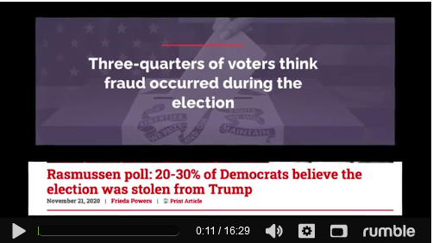
Unmasked: Have we uncovered the truth about the 2020 election? - Part 1
- Click on the this 16 minute Rumble video

- Key summary of this video follows via image capture.

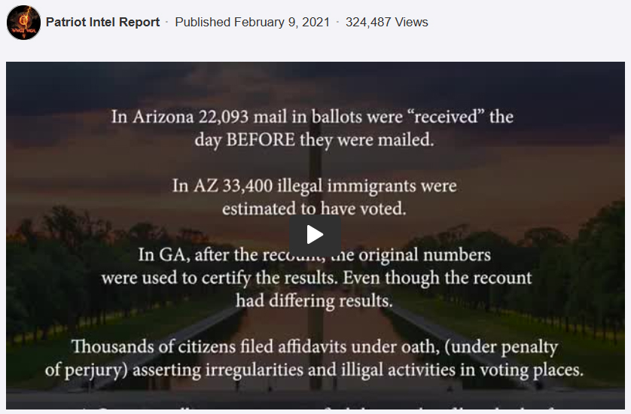

Unmasked: Have we uncovered the truth about the 2020 election? - Part 2
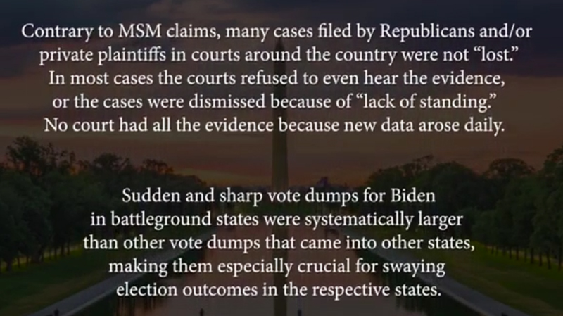
Unmasked: Have we uncovered the truth about the 2020 election? - Part 3

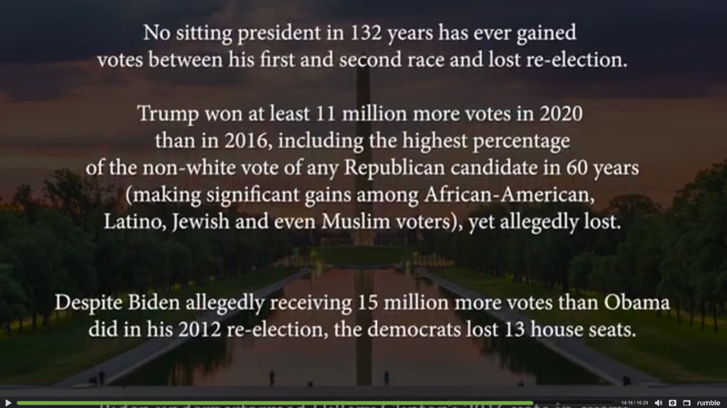
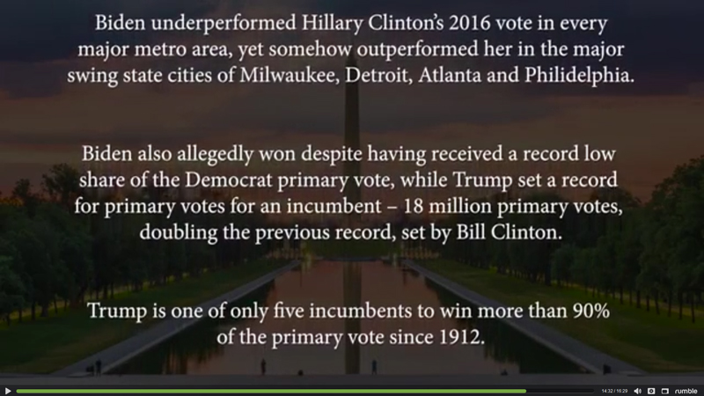
Unmasked: Have we uncovered the truth about the 2020 election? - Part 4

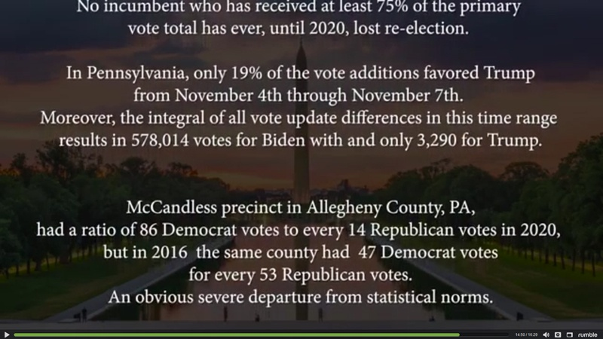
Unmasked: Have we uncovered the truth about the 2020 election? - Part 5
Unmasked: Have we uncovered the truth about the 2020 election? - Part 6
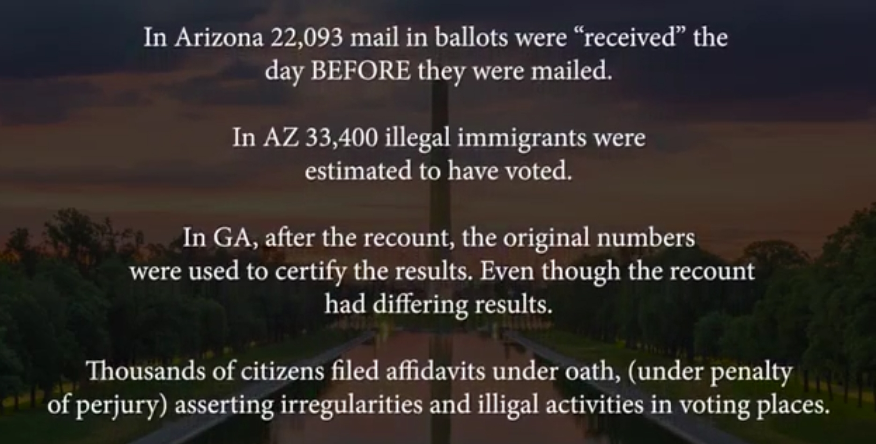
Unmasked: Have we uncovered the truth about the 2020 election? - Part 7

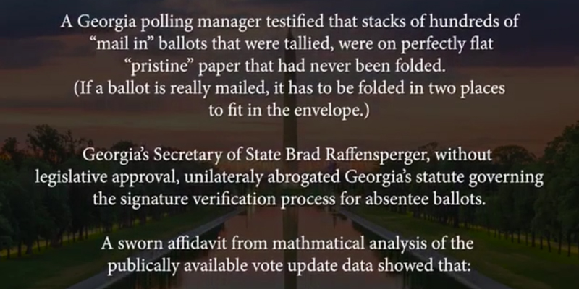
Unmasked: Have we uncovered the truth about the 2020 election? - Part 8
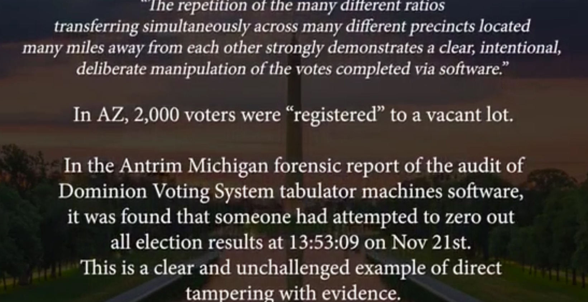

Unmasked: Have we uncovered the truth about the 2020 election? - Part 9

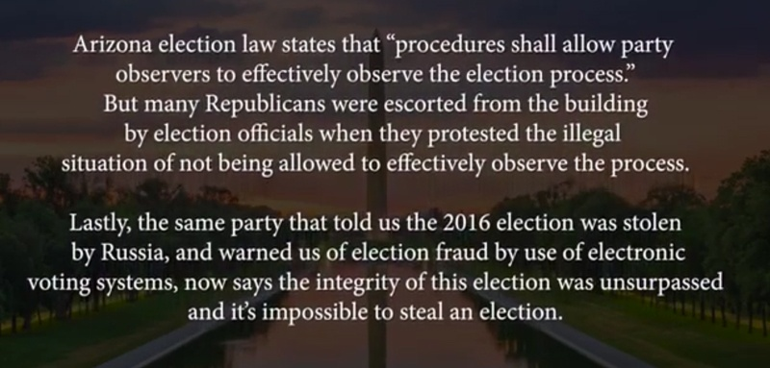
Unmasked: Have we uncovered the truth about the 2020 election? - Part 10
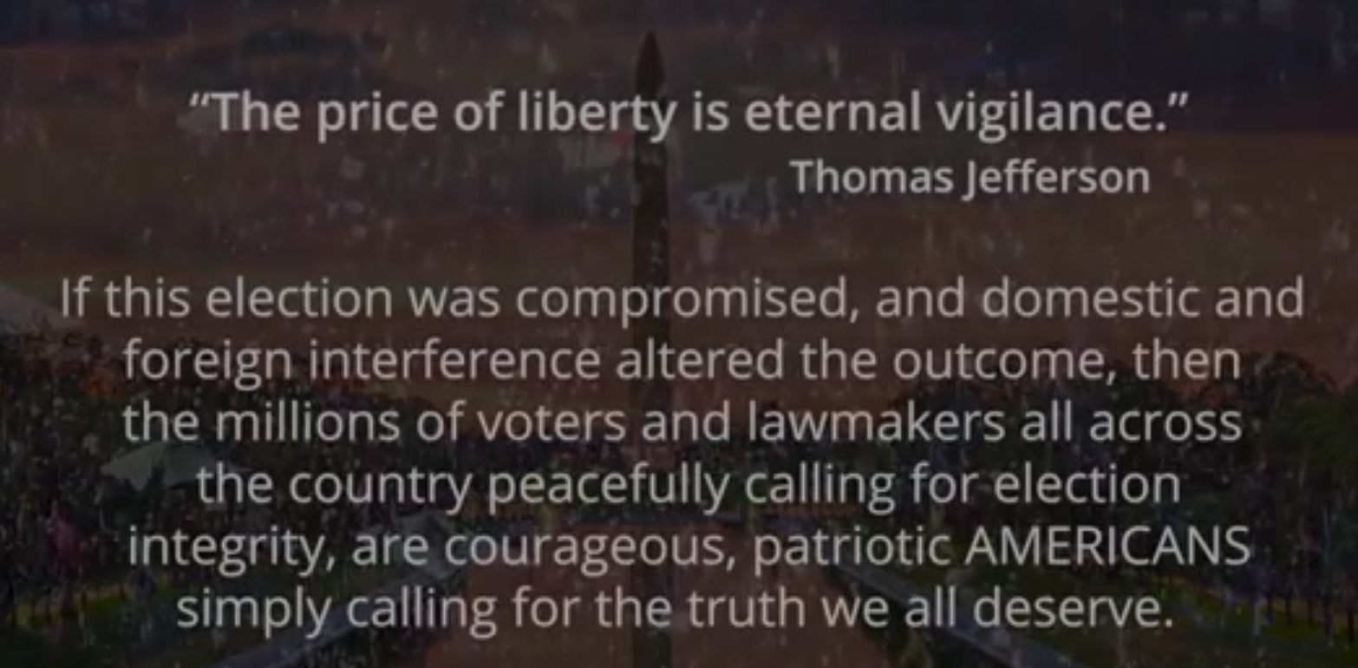
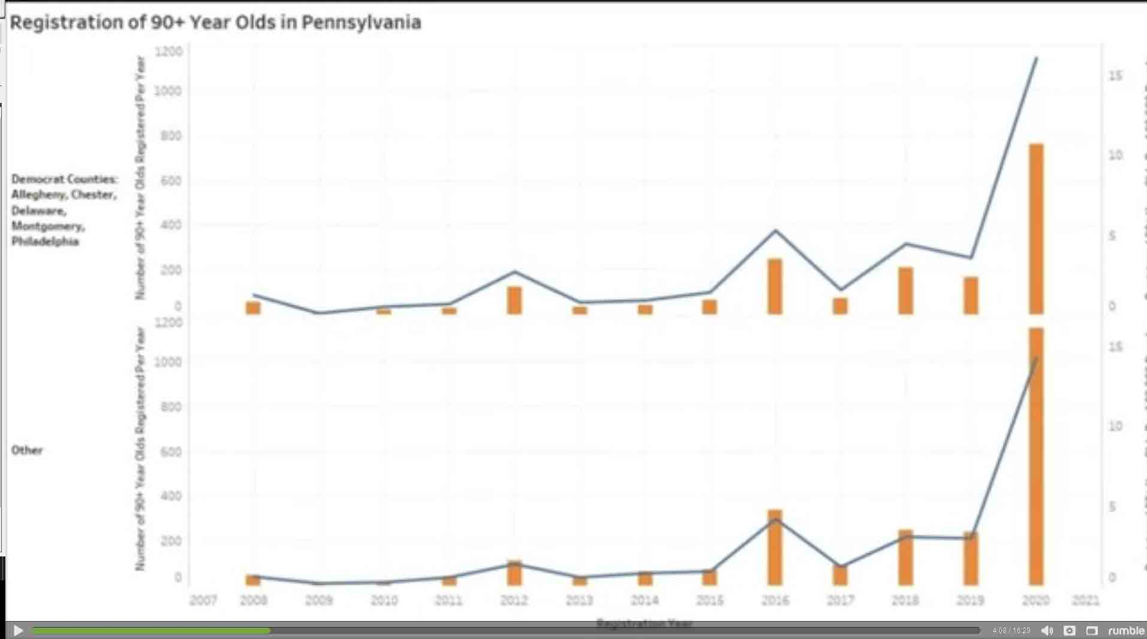
Unmasked: Have we uncovered the truth about the 2020 election? - Part 11
Guess why so many 90 year old Americans registered in these Democratic Counties in 2020? i.e. fraudulent votes

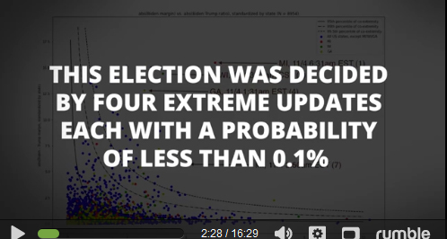
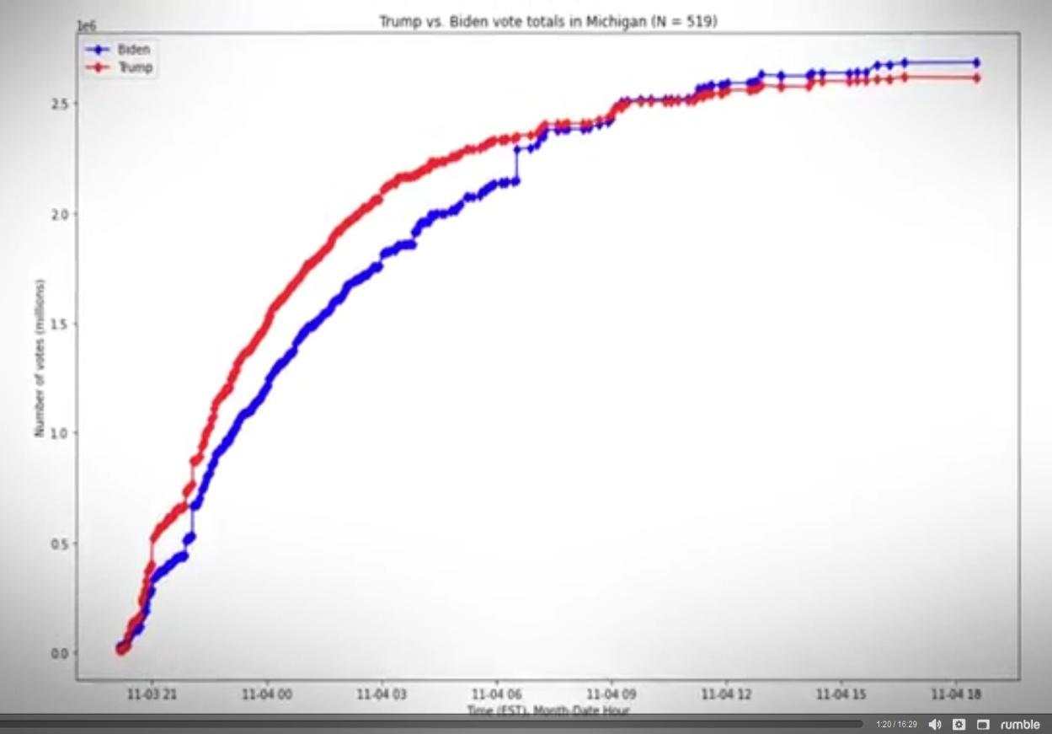
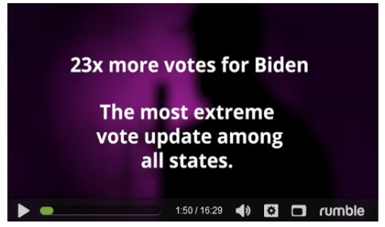
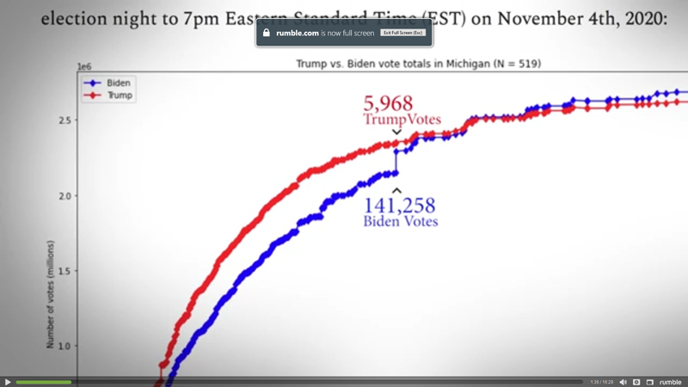
Unmasked: Have we uncovered the truth about the 2020 election? - Part 12
These extreme updates spiking votes occurred in all states most obvious in Michigan, Wisconsin, & Georgia at odd hours.
Month – Date – Hour
NOV 4 6:30AM
EST
Unmasked: Have we uncovered the truth about the 2020 election? - Part 13
- Out of 9000 updates this election was decided by ONLY 4 EXTREME UPDATES.
- See graph below of states where extreme updates took place, i.e. Michigan, Wisconsin, and Georgia.
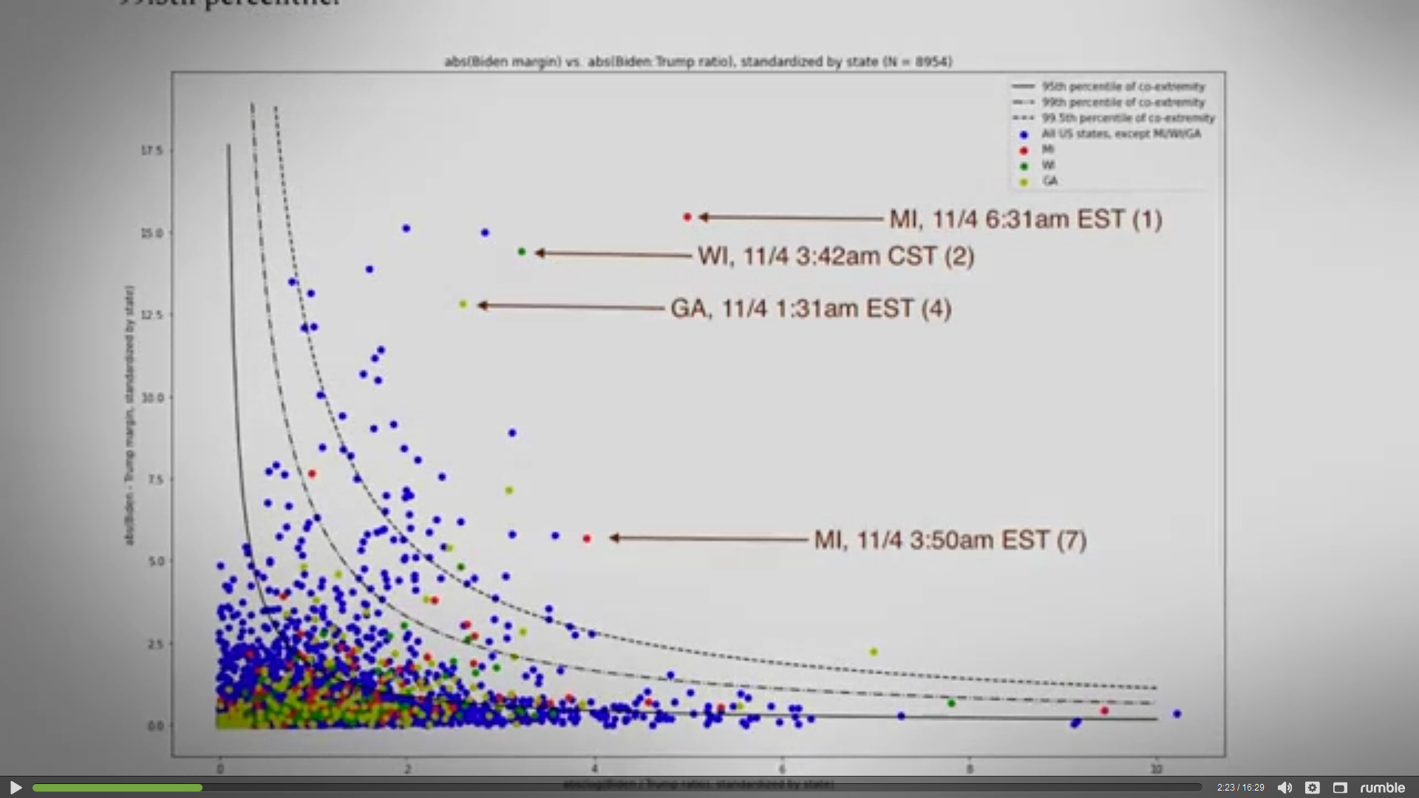

Unmasked: Have we uncovered the truth about the 2020 election? - Part 14
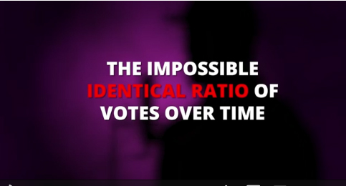
“A constantly identical ratio of Biden to Trump votes across time”.
- Which is theoretically impossible.
- Florida ratio of votes of Trump to Biden is 100% identical.
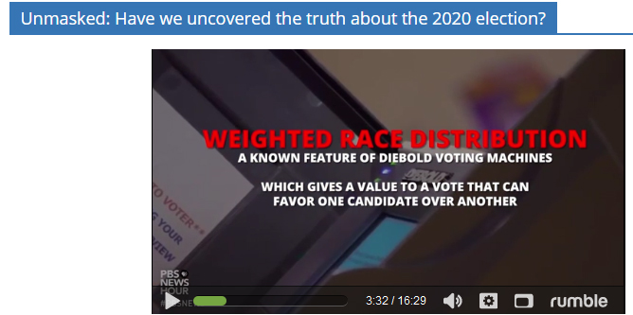
- This pattern shows up in many states.
- It appears that there is a computer algorithm is involved.
- This is a weighted rate distribution.
- This is a feature of Diebold Voting Machines.

Unmasked: Have we uncovered the truth about the 2020 election? - Part 15

  - Here you see one vote comes in and 65.9% is allocated to Biden and 32.3% allocated to Trump.
  - How can one vote go to more than one person?
  - This is the capability of voting machines, e.g. Diebold switching votes.
  - We have shown in above independent research this is very possible to do.
  - Voting machine manufactures say laboratory results would not happen in election controlled areas.
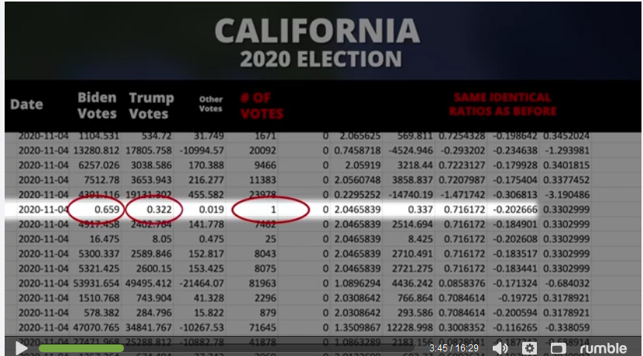
  - I say that is exactly where they are most likely done given the extreme political polarization.
- Unmasked: Have we uncovered the truth about the 2020 election? - Part 16
- Can you scan a ballot more than once – Yes
- Ruby a Georgia Elections employee posted on social media “I know for a fact that Georgia voted for Trump by the largest numbers and if we didn’t do what we did he would have won Georgia”.
- San Antonio woman arrested on election fraud charges in Texas @ 6:51 minutes into video. She admitted she was harvesting ballots for pay.
- Cyper Security experts under oath signed affidavits testifying that Dominion and Edison Research systems makes network connections ….available for scanning @ 7:40 minutes which are unencrypted and easily accessible.
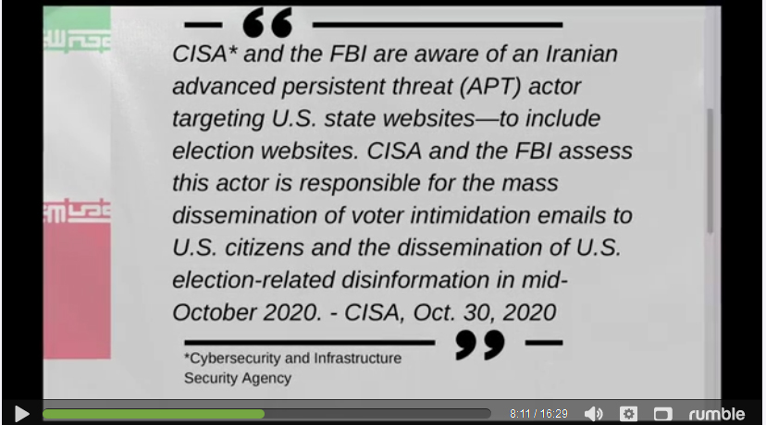
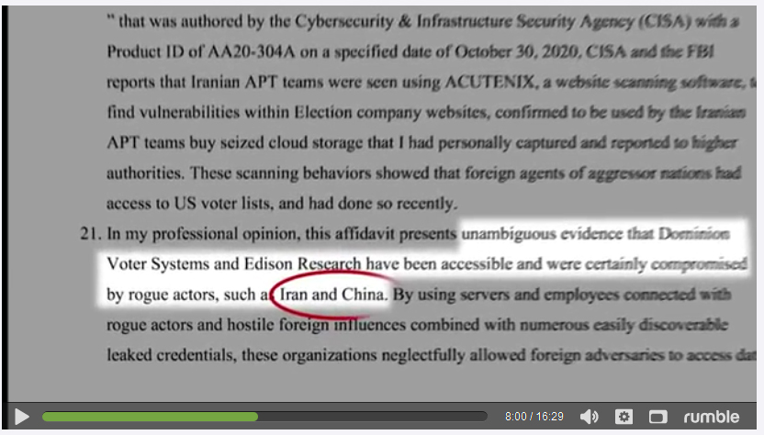
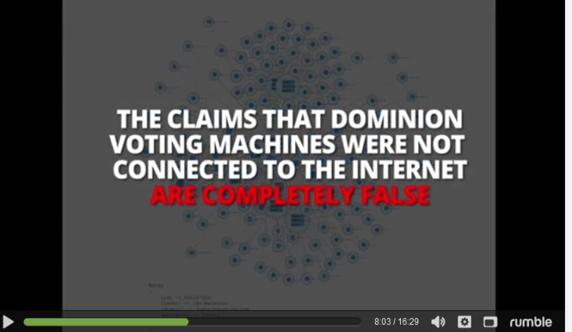
  - Dominion Voter Systems & Edison Research has been accessible and was certainly compromised by rogue actors such as Iran and China, See excerpt from video below @8:00.
Unmasked: Have we uncovered the truth about the 2020 election? - Part 17
  - July 16, 2018 Dominion Voting Systems (“Dominion Voting”) announces that it has been acquired by its management team and Staple Street Capital.
  - The party that paid the money is UBS Securities LLC, a subsidiary of Swiss investment bank UBS.
  - However, a closer look into the New York subsidiary shows that among its board members, who are appointed by shareholders, three appear to be Chinese.
  - One of them is Ye Xiang, a Chinese national who also served as a board member of Beijing’s based UBS subsidiary. The person worked at the Chinese regime’s central bank, the state-owned Bank of China, as well as the Hong Kong government’s financial regulatory agencies.
  - This facilitator of the deal is Chinese vice premier Wang Qishan, who is deemed the most finance-savvy Communist official. He was the mayor of Beijing in 2006 when he met with UBS’s then-chairman Marcel Ospel.
  - $400 Million SEC Filing Links Dominion, UBS and China
  - According to Chinese company profiling website Qixin, after the 2020 election, the Beijing UBS’s went through a major leadership turnover on November the 30th.
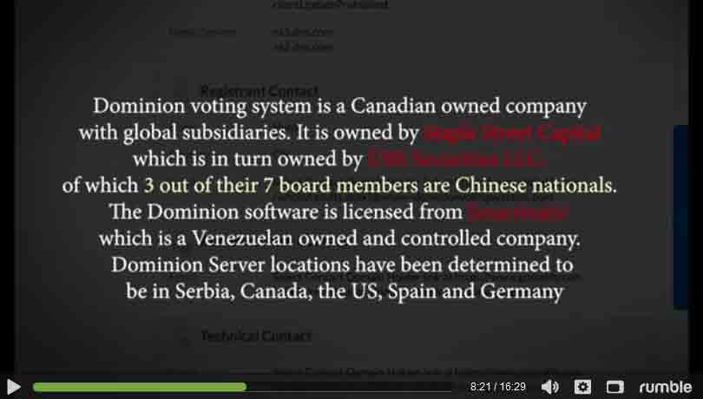
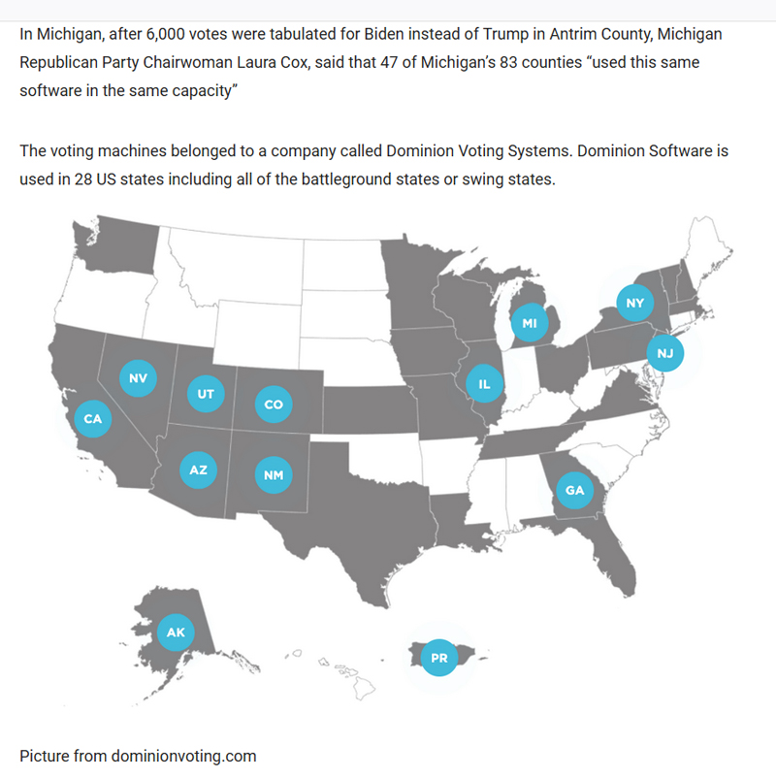
- In a previous voter fraud lawsuit filed by Sidney Powell, a former military intelligence official claims in an affidavit that Chinese operatives had access to ‘Dominion Voting Systems’ in several key states.
Unmasked: Have we uncovered the truth about the 2020 election? - Part 18
Figure 1UBS Securities LLC
Figure 2Staple Street Capital
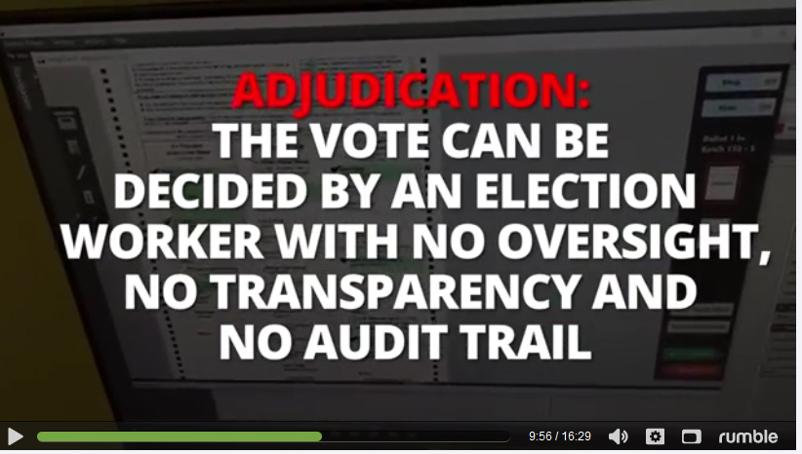
- Election workers deciding votes no audit trail
- Error rates of 68% vs. guidelines of .0008%
- All 2020 Logs are Missing
- All security logs prior to 11:03PM on Nov. 4th 2020 are also missing
- Image ct precinct cars were reprogrammed on Oct. 23 AND Nov. 5ht 2020 which violates the Help America Vote Act.
- Massive amounts of unsolicited (people receiving ballots they never asked for) mail in ballots.
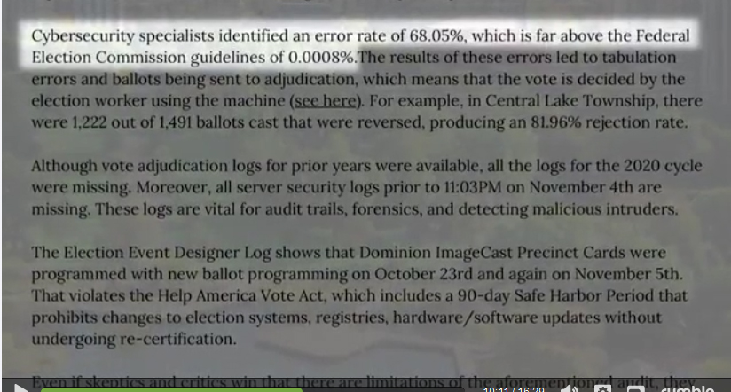
- Allowed to vote many days after election deadlines.
- Signature verification was slackening in many states.
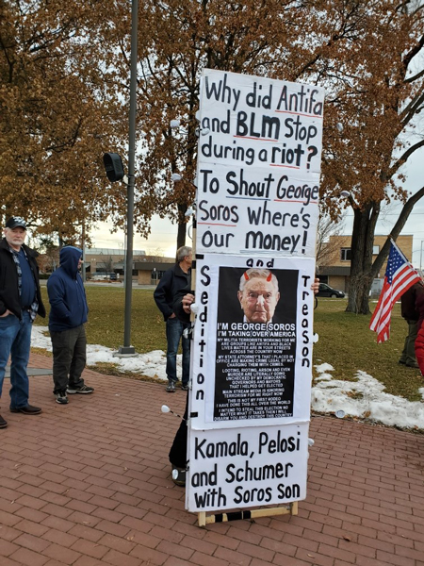
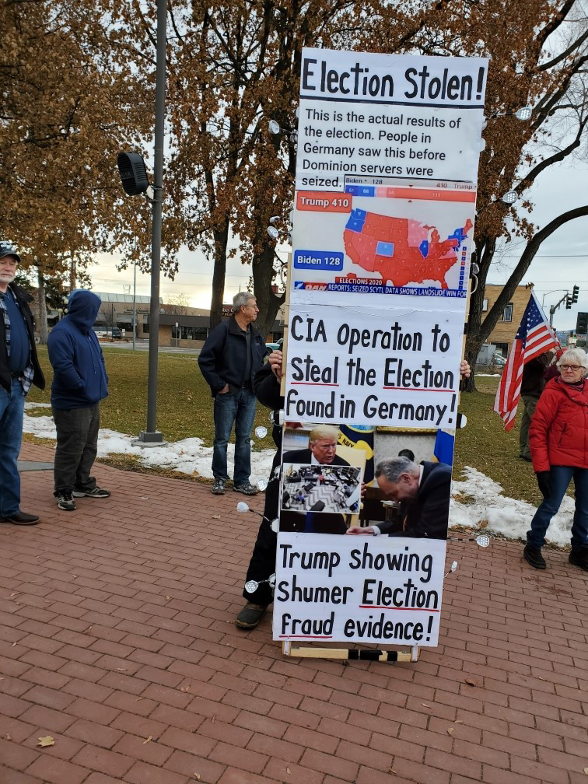
Signs Explaining Fraud at a Local Kalispell, Montana Trump Rally January 6, 2021
Vote and Election Fraud – Another Deep State & Globalist Tentacle – Part 1 of 4

- Here are a couple examples to make a point of the breadth and depth of the Deep State and Globalism.
  - National Geographic in this link claims voter fraud used to be rampant now it’s an anomaly. (Deny & Defy)
  - National Geographic touts globalism, climate change and water woes, link here to glance -key word search.
  - Vis-à-vis the American transnational corporations have an agenda to cover up & minimize vote and election fraud.
    - As well as American MSM including Fox plus Deep State leaders active in US Intel agencies, etc.
    - MSM is incapable of doing objective journalism of all sides because they have an over lording agenda.

- Here is General Flynn’s observation in an interview with Dave of the X22Report, Episode 2340B
  - He says the Dominion voting machines did not achieve results needed to get the DNC over the top.
  - So they shut down the election count Nov. 4-7 to allow the use of the corrupt mail in ballots.
  - There are at least 200 witnesses some Democrats willing to testify to all of this chicanery.
  - The Dominion system was not designed to thwart landslide elections like Trump had, but to tweak the results.

- The Point is city/county Municipal Corporation’s voter data bases have long been dirty and not kept up to date. This is the foxes counting the chickens. The municipalities are home to the Deep State and are the epitome of the Swamp to an ever increasing degree correlated to the population of the municipality.

- Voting machines are not new suspects to vote manipulation, see below old news.
  - Vote Fraud Expert Warns Of New Hampshire Chicanery – Jan 9, 2008 - Vote fraud expert Bev Harris has warned that New Hampshire's electronic voting machines are wide open to fraud and that even modestly skilled computer programmers were able to identify key vulnerabilities within ten minutes of assessing them as key Democrat and Republican primaries unfold today.
  - Errors Transposing Votes and Diebold Machines Issues – Jan. 9, 2008 - Allegations of vote fraud in New Hampshire’s primary are growing. The data from Diebold electronic voting machines is up to 5% points different than the hand-written ballots that were cast. Sutton Town has now reported an error in transposing votes and an employee of LHS Associates, whom counted 81% of the vote, has a criminal record.

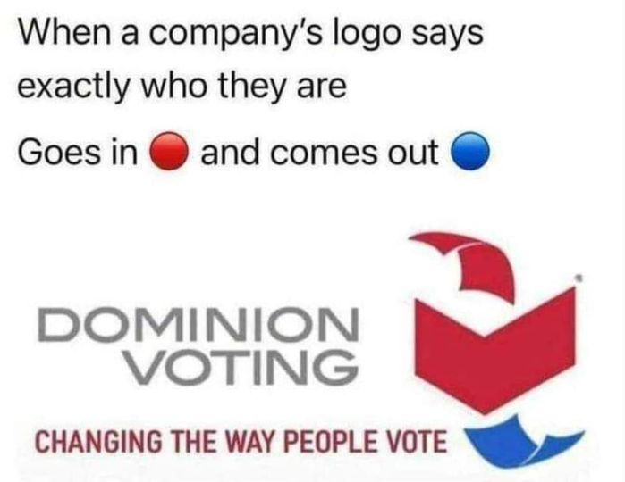
Vote and Election Fraud – Part 2 of 4
- Scanning over a key word search on the internet all the left leaning sites is denying any election fraud including the misuse of the voting machines.
- Amazing that all these sources can be so orchestrated in their “blindness”.
- This is not random; it is another sign of the global control.
- Did China Steal The Election? – Dick Morris Lunch Alert
Firm That Owns Dominion Voting Systems Received $400 Million From Swiss Bank Account Funded by Communist Chinese Gov & Companies Before Election.

The overall owners of UBS Securities Co LTD are –
Dominion acquired ES&S in 2010.
ER&S Had Acquired Diebold under Its New Name Premier Election Solutions
- Beijing Guoxiang (33%)
- UBS (24.99%)
– Guangdong Comm. Group (14.01%)
– China Guodian (14%)
– COFCO Group (14%)
- The other four owners of UBS Securities are all Communist Chinese front groups.
- Voting FRAUD and Election FRAUD is No Accident!
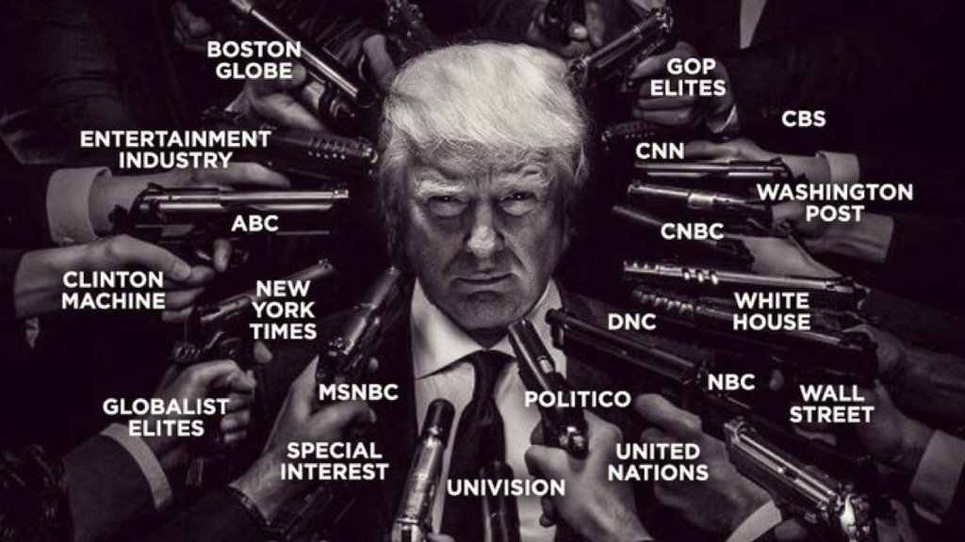
- Municipal corporations are intentionally not cleaning up their voting registration data bases and intentionally allowing OUR voting system to be sold off to foreign machine vendors including China.
- FreedomForAllSeasons has been reporting on the dark side of municipal corps for years.

Credit to The Pacification of Humanity by Emmuel S. John

Vote and Election Fraud – Part 3 of 4
The State of Georgia “vote” recount was not an honest recount of the true and honest votes.
  - Georgia does not do a full hand count.
  - They simply fed the same ballots back into the counting machines again. (Dick Morris)
  - Don’t Let Them Steal Georgia Again. (Dick Morris dated Dec. 2, 2020)
- US intelligence has the actual vote transactions that went into the Dominion voting machines to compare to the votes created at the output. (Anonymous Source)
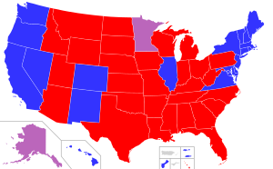
- The key states holding this election hostage are controlled by the Republican Houses, Pennsylvania, Georgia, Wisconsin, Michigan, and Arizona.
- General Flynn gives the odds on President Trump being reelected to the 2nd term 10 out of 10 = 100%. (pre Nov. 7, 2020.
- So now we know that even General Flynn was deceived by the globalist and Deep State!
1. We need mandatory uniform ENFORCED election standards nationwide at all levels, federal, state, city and county municipal corporations.
2. Also we need to move all the election functions to an independent bipartisan transparent locally monitored and audited business operation.
3. The municipals cannot be trusted to count votes which ultimately determine their own funding.

Vote and Election Fraud – Part 4 of 4
    - Facebook Mark Zuckerberg invested tens of millions into Georgia elections to left wing orgs.
      - And this funding worked well for the democrats.
      - Mark Zukerberg’ Funding Impact – Must Read
    - Link here to read below 3 page witness testimony tweeted by Sidney Powell (in PDF format)
  - In blue states & red states, marginal voting totals are close.
  - However, in the purple (red/blue) states, i.e. GA, PA, WI, MI, AZ, NV the vote total differences for the blue & red parties are huge with the blue party showing unusually high totals indicating ballot stuffing. Dick Morris Lunch Alert 12-4-20
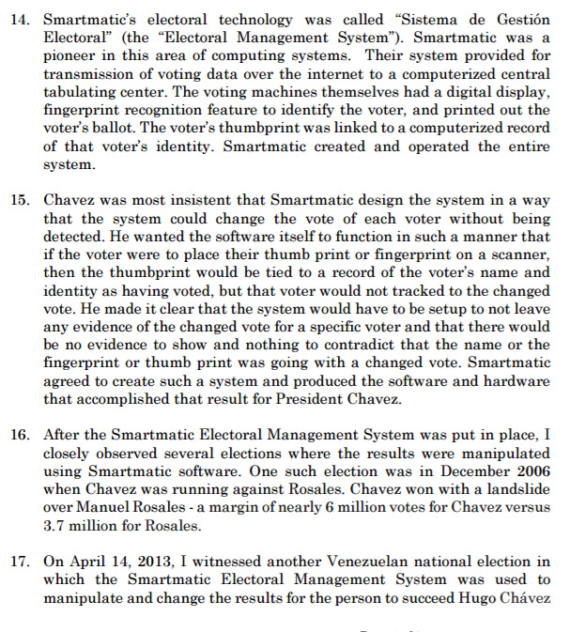
  - Stunning footage Georgia suitcases filled with ballots after poll workers told to leave.
  - Texas AG Paxton Files Election Suit Against GA, MI, PA & WI
      - Well that did not work either in hindsight.
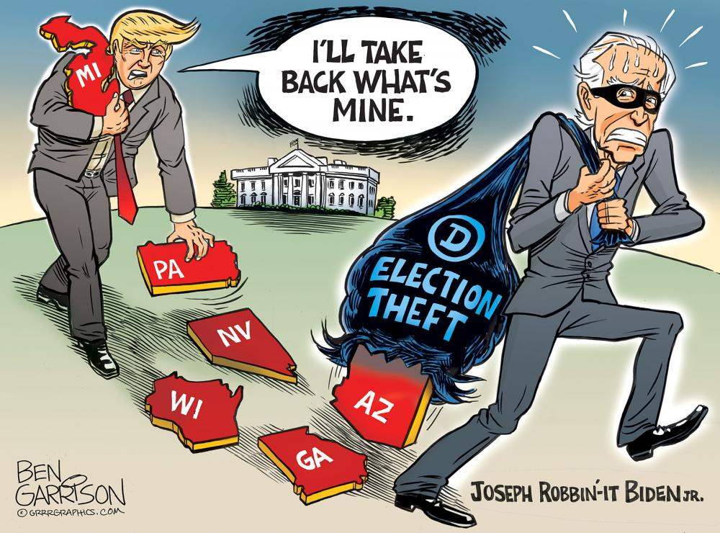
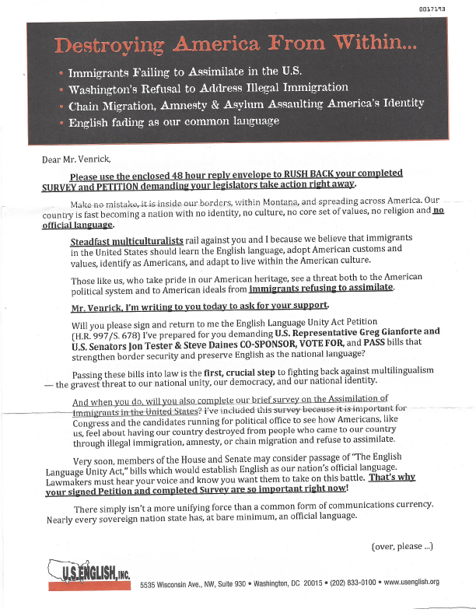
Destroying America from Within – Let Me Count the Ways
- English Not Being Enforced as a Common American Language
- Borders not being enforced & chain migration allowed
- Corporations allowed to outsource employment & import illegal labor
- Wealthy corporations and foundations allowed to connect themselves in global networks creating vast global influence laundering lies via:
- Funding green extreme radicalism targeting the taking of private and public resources based on global warming lies.
- Funding, violence, sanctuary cities, counter culture rioting, general breakdown of traditional American society
- Funding border storming caravans
- Funding “alternative energy” lies targeting destruction of basic natural resources supplying stable power 24 x7.
- Foreign voting machines connected to the internet manipulating votes go unchallenged
- Widespread panics intentionally timed to loosen strictly controlled voting processes go unchallenged
- American media 6 corporations monopolize misinformation campaigns go unchallenged
- Social media Tech giant corporations monopolize, filter, orchestrate misinformation campaigns go unchallenged
- Corporations shift the tax burden onto American wages, pensions and private property go unchallenged
- Banking interests allowed to create a fiat worthless currency system creating massive debt and inflation go unchallenged
- American education system control is centralized under one federal agency and a teachers union to further break American state sovereignty and the sovereignty of the individual state Citizen.
Dr. Shiva on the Election Fraud – Part 1
- There are 25 hits on www.bitchute.com using key words “dr. Shiva election fraud”
- Dr. V.A. Shiva Ayyadurai credentials – 4 degrees from MIT, world renowned systems scientist, inventor & entrepreneur, Fulbright Scholar, Lemelson MIT Awards Finalist, Westinghouse Science Talent Honors Award recipient, etc. AND he ran for the GOP Senate Seat in Massachusetts and unexpectedly lost. He figured out what happen!
- Red Alert: Massive Ballot Fraud & Stolen Elections!!
  - Dr. Shiva shows how over 1 million ballots were destroyed in the Massachusetts Republic primary making that election null and void.
  - The Secretary of State Key counsel has admitted this but is covering up the truth.
  - There is a history in Massachusetts which is a uniparty state showing the GOP destroying the Republican runner up to the Democrat over and over via a designated loser, read this again.
- Dr. Shiva Live: the REAL Scumbags. Case Study of Massachusetts GOP. The Not So Obvious Establishment
  - MUST VIEW TO UNDERSTAND HOW BOTH PARTIES ARE CROOKED.
  - Dr. Shiva reveals both parties are the same and shows a model how the political swamp games are played.
  - The key words he uses are elections are SELECTIONS NOT ELECTIONS.
  - The SELECTIONS are back room deals by both parties.
  - The parties do not want outsiders to their way of thinking and dealing.
  - Dr. Shiva was a very strong Trump supporter in Massachusetts but was not allowed to debate and ultimately not run because he was not a GOP insider.
  - He shows how the Massachusetts GOP committed election fraud all while raising money to stop it.
  - These selected candidates often have no braggable background or skills and just party puppets.
  - It’s all about Pay to Play, who can throw around the biggest bucks to run.
  - GOP makes sure no one else comes up from the grass roots to compete against the GOP chosen candidates.
  - I heard this GOP exclusion when a Montana local Ben Garrison of www.Grrrgraphics.com was invited to the Trump White House for a gathering. All the local Montana Republicans were excited to see one of our Montanan’s be invited. Shortly after, someone also invited to the White House gathering was “offended” by his politically incorrect conservative memes. Ben’s invitation was cancelled by the WH.

Dr. Shiva on the Election Fraud – Part 2
- In the next 6 pages I have screen captured 25 Dr. Shiva video titles –
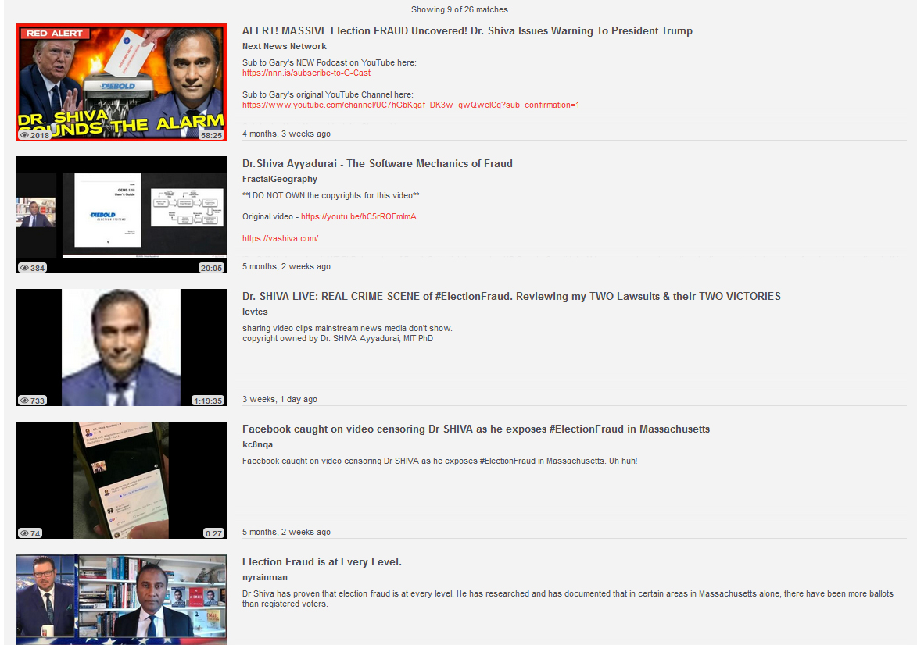
  - Just glance at the titles for an idea of preponderance of evidence of election fraud.
Dr. Shiva on the Election Fraud – Part 3
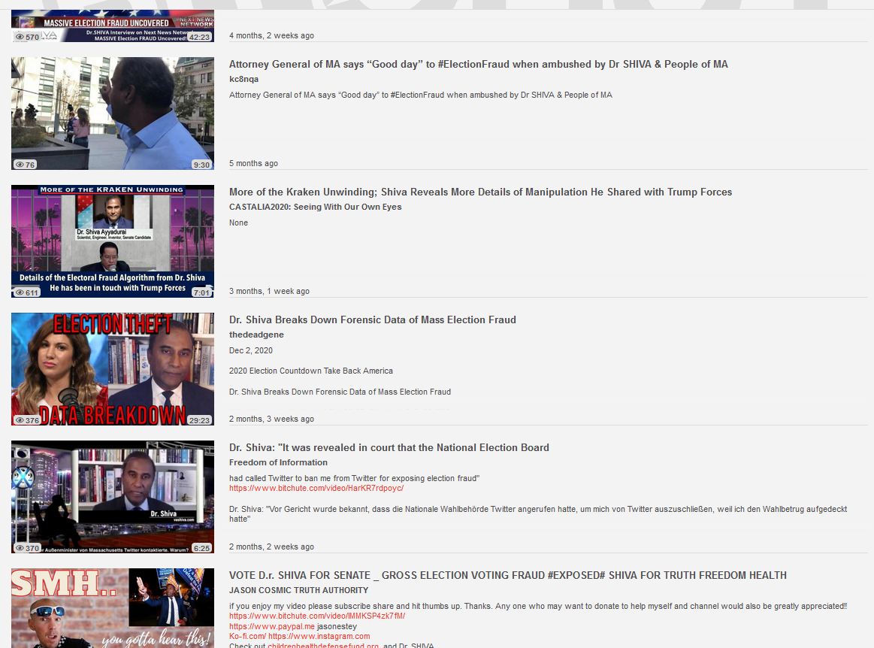
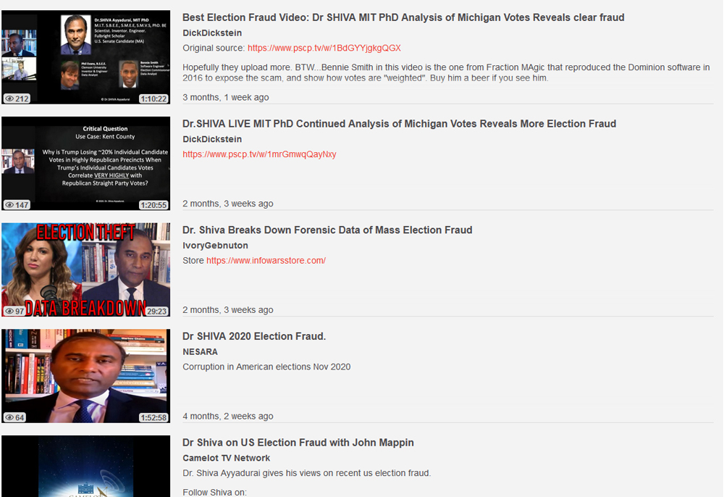
Dr. Shiva on the Election Fraud – Part 4
Dr. Shiva on the Election Fraud – Part 5
Dr. Shiva on the Election Fraud – Part 6
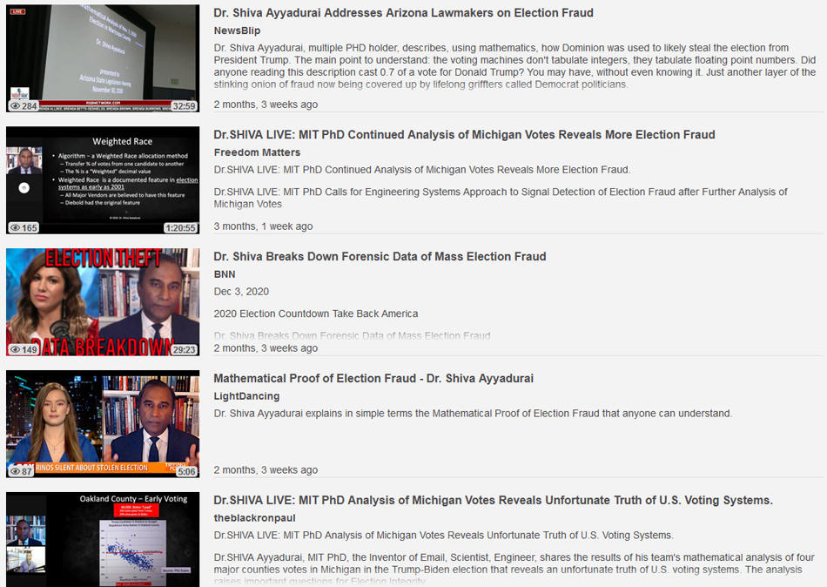
Dr. Shiva on the Election Fraud – Part 7
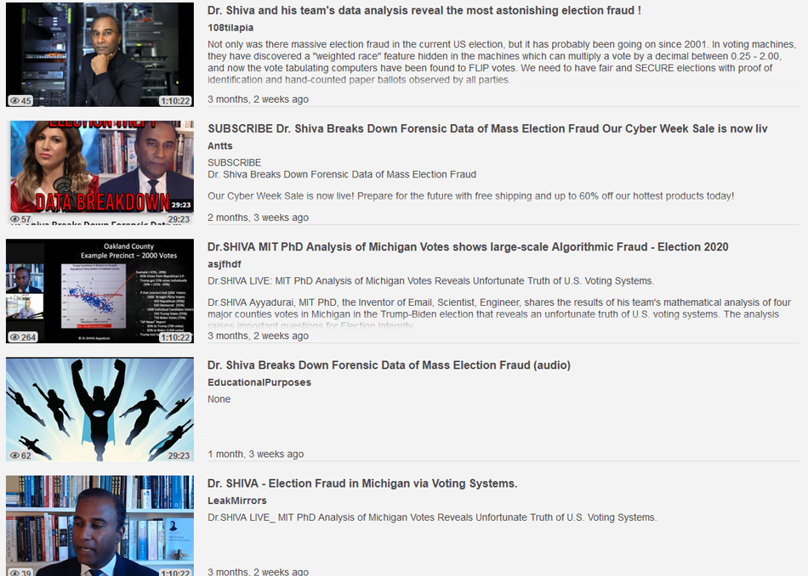

Election Related Cases Before SCOTUS Dated February 23, 2021 – Part 1
- Here is a link to The Litigation dated February 23, 2021 before SCOTUS
  - This is 48 pages of some 70 cases listed on the American Bar Association web site.
  - This data changes and appears to be increasing.
      - I get 163 hits using the word “election” and 25 hits using the word “fraud”.
- We know from the appellate court up to SCOTUS these courts refused to hear election fraud evidence.
- We now know a heavily conservative court has become crippled.
- We know that VP Pence became crippled.
- We know that all of the key swing state Republican controlled Houses became crippled.
- We know that all the Democrats held together to continually bring Trump down at any cost.
- We know that too many turn coat Republican’s did not stand up and call election fraud in their state.
- Many patriots were expecting the U.S. Military to take action; the level of fraud was so obvious.
- We know MSM media, Big Tech social media, DNC, all Democrats & courts stood together to block election fraud challenges without looking at the evidence in many cases.
- We know the GOP intentionally & repeatedly losses to the DNC in Massachusetts a bicameral state per Dr. Shiva.
- Does this mean there was no election fraud, absolutely not!
- This election was beyond a reasonable doubt manipulated especially in swing states & swing candidates.

Other Examples of Government Fraud
- We also know that both Obama & McCain were allowed to run for president and both were ineligible as they were not natural born Americans as required by the U.S. Constitution.
  - John McCain was born in Panama by two American parents and is not technically natural born.
  - Gary Kreep, Attorney and United States Justice Foundation filed a brief with the California 3rd Appellate Dist. Court of Appeal arguing that CA State elections officials not the U.S. Congress had the duty to verify Mr. Obama’s eligibility for the 2008 presidential ballot. Link
  - There were multiple challenges to Barack Obama’s eligibility including Dr. Orly Taitz, Esq. Great Patriot. Link
  - Barack Obama admitted in this video he was born in Kenya. Link
  - I have years of research proving Barack Obama, aka Barry Soetoro is NOT an American Citizen. Link
  - Yet the courts did not intervene then either! How could this happen?
- The RNC and the DNC colluded to not fight each other on this point so they could both run two illegitimate presidential candidates approved by the globalists and Deep State.
- We know that President Carter was stunned he could not pick all his own cabinet.
- We know that the so called Federal Reserve is not a federal agency, i.e. it is private central bank cartel.
- We know that there is no federal laws requiring you have to pay taxes on your wages or pensions.
  - Special IRS Agent Joe Bannister proved this in court, he pays no taxes.
  - This sets precedence for every wage earner, why is this not enforced.
  - If no federal laws require taxing wages & pensions there can be no state laws as state constitutions are subordinate to the U.S. Constitution.
- We know that the 16th Amendment was not legally passed and is fraudulent.
  - Bill Benson and M. J. Red Beckman proven this also beyond a reasonable doubt in their two volumes of research, “The Law That Never Was”, Volume 1 and 2. Here is 17 years of research corroborating this. Link
- We know that the 14th and 17th Amendments were also fraudulent.
- I know that the two State of Washington constitutions are fraudulent. Link
- Why don’t the high courts’ enforce the founding and fundamental laws?
- The reason why is the courts are part of the problem, they go along to get along.
- We have learned this over and over throughout history however, we cannot fathom this!
- The body of the government is terminally ill and THEIR cancer is contagious by their actions.
- All Presidents have been bought off by the cabal except Eisenhower, Reagan and Trump!
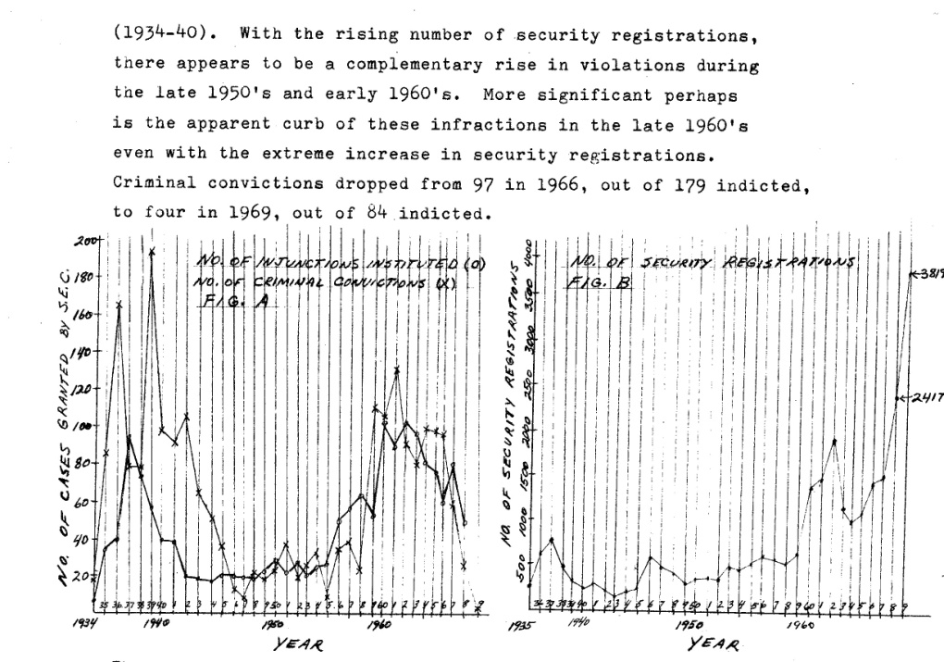
Election Ballot Fraud versus Security Fraud

I did a paper in graduate school at Montana State University, 12/11/ 1970 titled “A Report On Corporation Wealth, Power And Corruption. This was an elective course I had to take to fulfill graduate requirements for a MS in IE & Business. Link

- How does this tie into election fraud, let’s count the ways.
  - 1.6% of the population in 1962 held 32% of the personal sector assets, essentially most bonds and stocks. (Pg 1)
  - 40% of the largest corporations were controlled by one family or a number of families.
  - Another 30% of the corporations were controlled by one or more other corporations.
  - In a 1968 study by the SEC of 679 security services, 100% were found violating some security code. (p.6)
  - In a hand drawn chart on pg. 7, Fig. A, also shown right corner, during the 1950’s there was an exponential rise of injunctions and criminal convictions by the U.S. SEC against the securities industry.
  - See the infractions decrease after corporations were forced to register their securities early 1960’s, Pg. 7, Fig. A.
  - Fig. B shows the exponential rise of security registrations in the late 1950’s and 1960’s.
  - “Stock manipulators keep up with the times”, Mr. Pollack, Director of Trading and Markets for the SEC.
  - You can read all about how the manipulation is done in this old report of mine, quite intriguing.
  - 98% of the prison population was the lowest socio-economic class, less than 2% were upper class.
- We have long known there is extreme concentration of ownership of corporations and their securities.
- The second point is the SEC found a very high level of fraud up to 100% in that industry.
- The U.S. Securities and Exchange Commission (now over 4000 employees) was created following the stock market crash in the 1920’s to protect investors and the national banking system per Wikipedia.
  - Think primarily the banks and the super wealthy families that pressured $$$$ Congress
  - Mere voters would never get this respect and action.
- Even then, white collar crimes are rarely imprisoned relative to blue collar.

Questions comparing security fraud in the USA to election ballot fraud

- Does the history of financial market instability, fraud & damage compare to the history of election fraud?
- Should election ballot fraud be prosecuted as strongly as security fraud?
- Should a ballot be considered a security?
- Should public city & county municipal corporations be privatized into cooperatives?
- And should their officers be held liable for their actions like private corporations?
- Should an independent ballot and election agency like the Federal Reserve be formed to enforce the states own election standards?
- Should state’s governor & ATG be prosecuted for influence peddling in their own election processes?
- Should all voters be required to register to be allowed to vote as if they were dealing with securities?
- Should all voters be also required to present photo ID as if they were cashing a bond, stock or check?
- Should all voters be also required to present themselves in person to do this official business?
- Should all voting machinery especially those which count votes like Diebold and Dominion be prohibited in any national, state or city and county municipal corporation election?
- Should election fraud be further defined as any election which cannot produce the full trail of the vote to the original signed ballot?
- Should new laws be written and old ones revised increasing penalties of election fraud equal to or greater than securities fraud?
- Should all existing election laws be reviewed in all states with the mission to standardize the transparency, process, security and enforcement of the American election process and ballot?
- Can the states and their city and county municipals be trusted to accomplish such a mission?
- Can the federal government be trusted to accomplish this mission?
- Can an independent state appointed team be trusted to accomplish this mission?
- Can America afford to risk a revolution by not seriously stepping up to reforming our election process?
- The Antifa and BLM terror created along with the MSM lies were designed to create a revolution IF President Trump WAS elected.
The Brotherhood of Darkness
“Some of the biggest men in the United States, in the field of commerce and manufacture are afraid of something. They know that there is a power somewhere so organized, so complete, and so pervasive, that they had better not speak above their breath when they speak in condemnation of it”. President Woodrow Wilson
- In July 2011, I released the following 74 slide presentation.
- Read it, print it out, send it out, teach it too your children - Link yellow block below.
- If you speak the truth today you can be charged for a federal crime by those who do not wish to debate it because when the truth can be suppressed or not debated the political correct “truth” can be forced over a free Republic faster and easier than most can imagine.
- This is where we are at today, living a lie created by Globalism and the Deep State with 50% of Americans supporting!
A conspiracy may be a continuing one; actors may drop out, and others drop in; the details of operation may change from time to time; the members need not know each other or the part played by others; a member need not know all the details of the plan or the operations; he must, however, know the purpose of the conspiracy and agree to become a party to a plan to effectuate that purpose. Craig v. U. S., C.C.A.Cal., 81 F.2d 816, 822.
There are a number of federal statutes prohibiting specific types of conspiracy. See, e.g., 18 U.S.C.A. § 37l. See also Chain conspiracy; Co-conspirator's rule; Combination in restraint of trade; Confederacy; Seditious conspiracy; Wharton Rule. Chain conspiracy.
Blacks Law Dictionary, 6th Edition 1990
- This dynamic duo profit from controlling the narrative via media, election process, tax taking, over regulating, subsidizing, wars, debt, et al and then denying and defying it all.
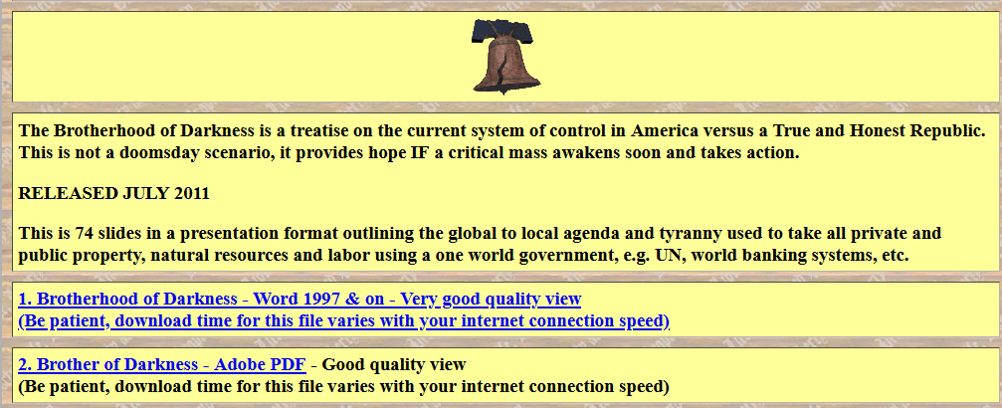

Quotes From The Brotherhood of Darkness Applicable to the 2020-21 Election Fraud
“I believe that if the people of this nation fully understood what Congress {and all the states, counties & cities} has done to them over the last 49 years, they would move on Washington, they would not wait for an election….It adds up to a preconceived plan to destroy the economic and social independence of the United States.”
George W. Malone, U.S. Senator (Nevada), speaking before congress in 1957 {FreedomForAllSeasons note}
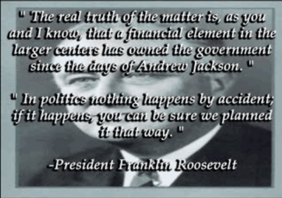
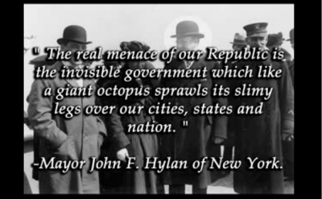
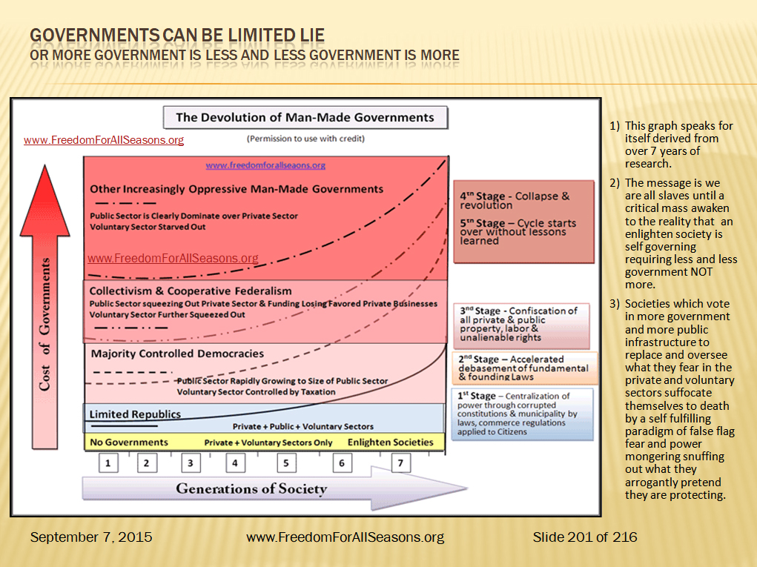
"The high office of the President has been used to foment a plot to destroy the Americans freedom and before I leave office I must inform the Citizen of his plight."
President John F. Kennedy (10 days before he was murdered)
“This system of false definitions, false assumptions, and fraud and usurpation generally, runs through all the operations of our governments, State and national. There is nothing genuine, nothing real, nothing true, nothing honest, to be found in any of them. They all proceed upon the principle, that governments have all power and the people no rights.”
Lysander Spooner
“I am a most unhappy man; I have unwittingly ruined my country. A great industrial nation is controlled by its system of credit. Our system of credit is concentrated. The growth of the nation, therefore, and all our activities are in the hands of a few men. We have come to be one of the worst ruled, one of the most completely controlled and dominated governments in the civilized world. No longer a government by free opinion, no longer a government by conviction and the vote of the majority, but a government by the opinion and duress of a small groups of dominant men.”
President Woodrow Wilson
“On July 16, 1996 the Senate Committee on governmental Affairs held hearings considering a bill to require Congress to specify for each new law which section of the Constitution gives {them} authority to pass the law. Sen. Glenn [D-OH] spoke out strongly against this requirement stating, “Why if we had to do that we could not pass most of the laws we enact here.”He stated that the Clean Water Act, Endangered Species Act, the Americans with Disabilities Act and others could never have been passed if Congress had to find authority for them in the constitution.” Glenn declared “Americans just want us to solve America’s problems of health and safety and not be concerned if they can be constitutionally justified.”
Sen. Glenn [D-OH]

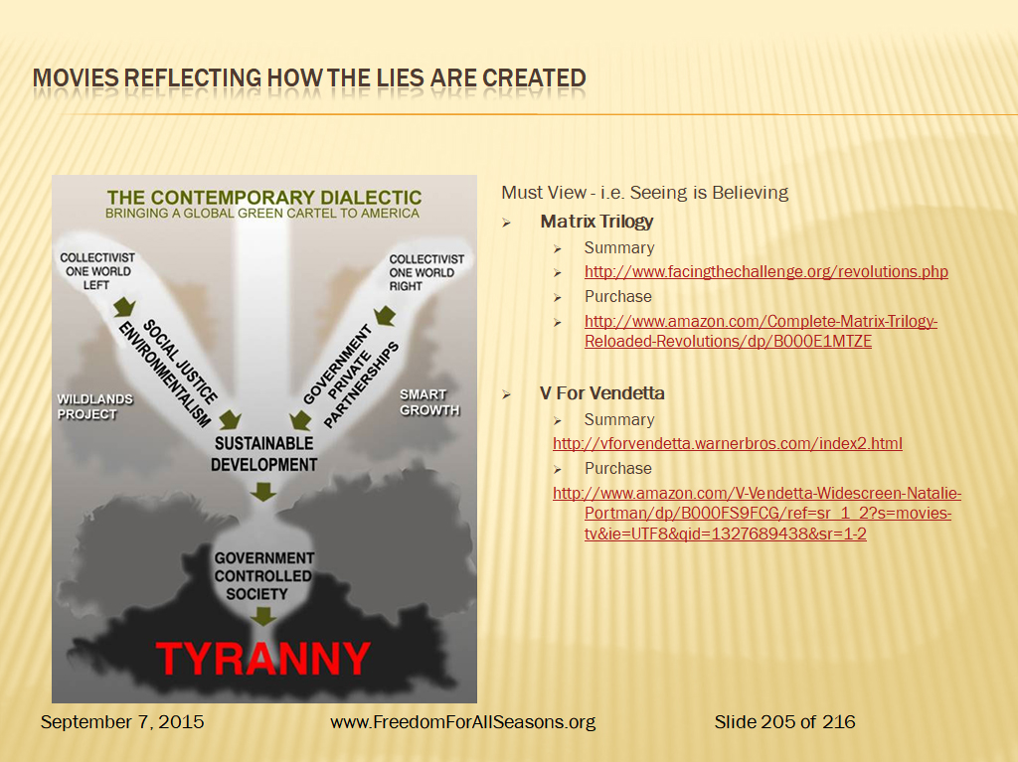
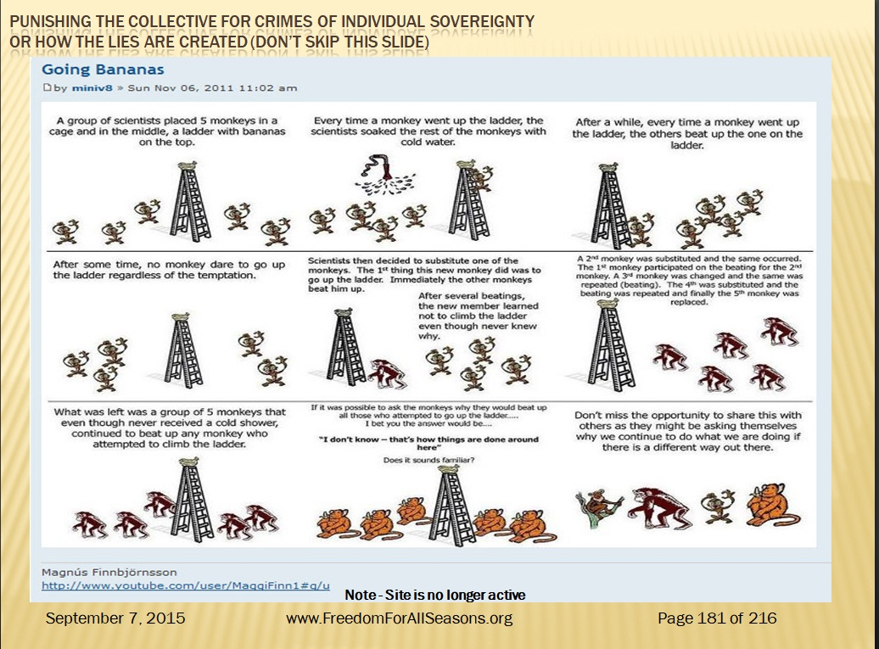
Monkeys Can Be Trained To Suppress Their Own Kind Just Like Humans
Rats Pass On Their Learning to the Next Generation –
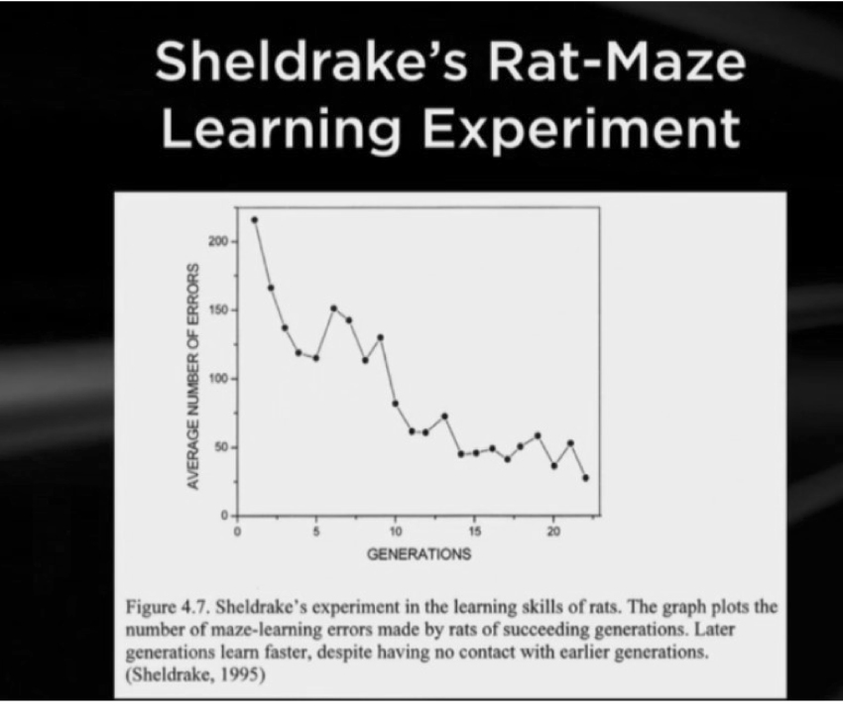
Human Election Processes and American Borders Not So Much

States with House, Senate, Governor Controlled By Same Party
- Red = 23 States
- Blue = 15
- Split =12
- Total = 50
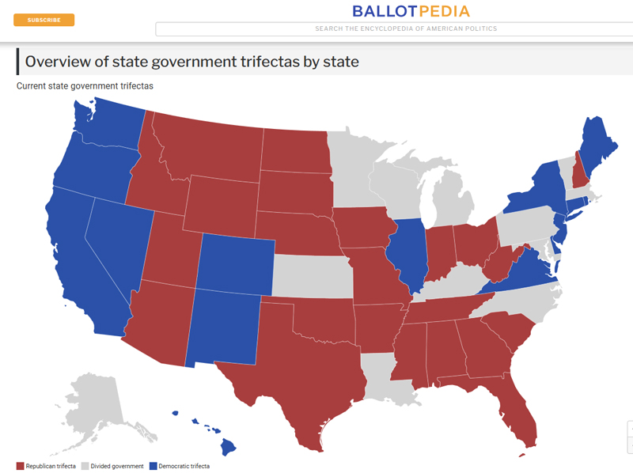
U.S. President Executive Orders History to Current - Part 1
- See summary of stats next page.
Click on graph to link to full view
- Additional backup data showing which parties use Executive Orders the most.
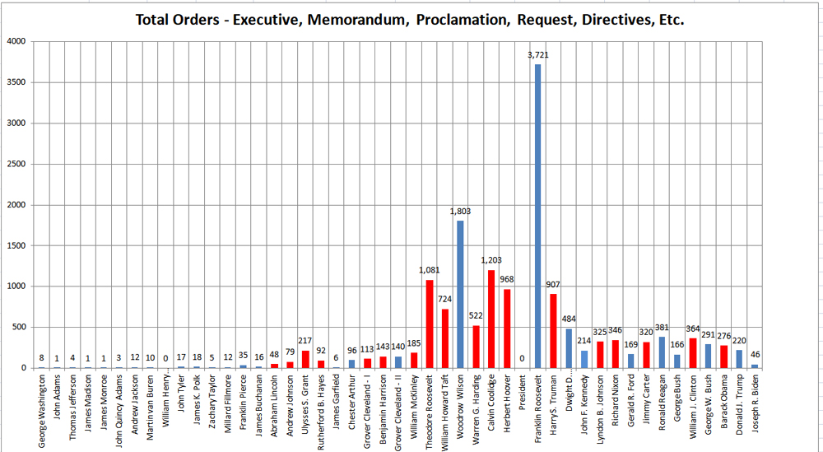
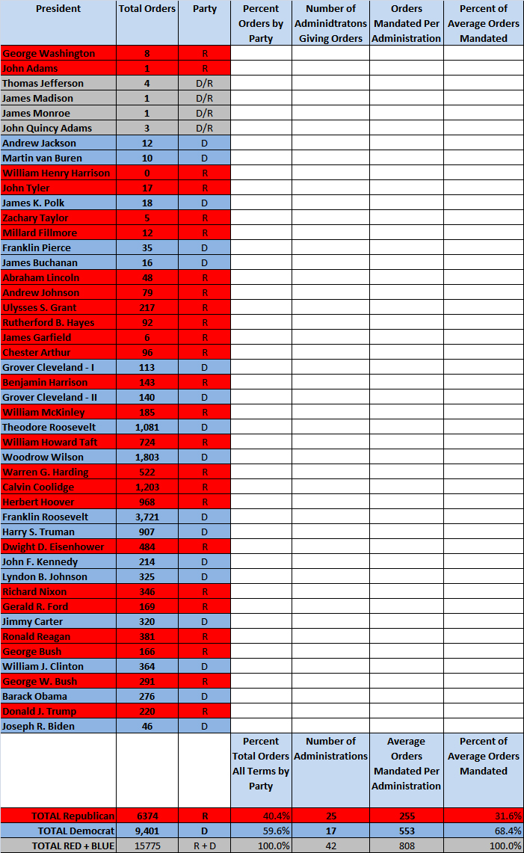
U.S. President Executive Orders History to Current - Part 2

This table of Executive Order history shows:
- The Republicans have issued 40.4% of ALL EO’s.
- The Democrats have issued 59.6% of ALL EO’s.
- The Republicans have issued 255 EO’s Avg./Admin.
Click on table to link to full view
- The Democrats have issued 553 EO’s Avg./Admin.
- The Democrats have issued 54% more EO’s per Administration over the last 232 years during their 17 administrations than the Republicans.
- Executive Orders are one man’s law for their term without debate.

Estimate of Voting & Election Fraud History
- I did these two graphs below by muscle testing.
- This an age old technique allowing your body/guides to move a yes or no answer to a question you pose.
- This technique is also described in a book The Emotion Code by Dr. Bradley Nelson
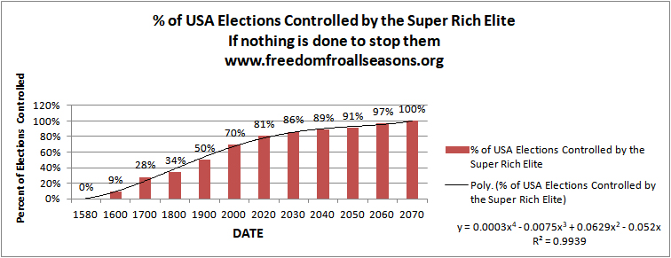
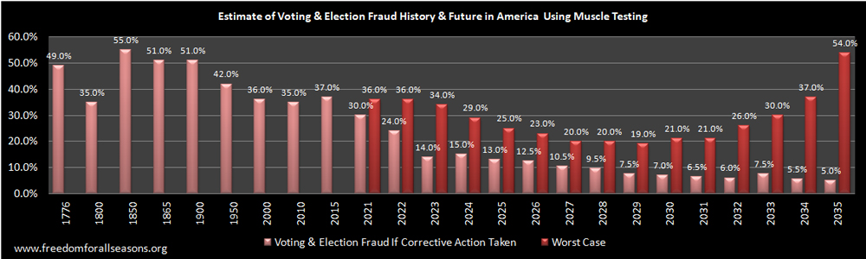

Jack’s Comments

- If there is only one ballot or one employee or one machine in any of the 3,141 country municipal corporations that is suspected or known fraudulent, then that election should be called off until the problem is fixed whether it is a local, state or national election.

- Can you imagine in a classroom of say 3,141 students if all of them were caught cheating at least once in a 4 year undergraduate program what the impact on the reputation of the college/university and the students would reflect.

- ‘We the People” now have “no vote that counts”, “no consent of the govern”, no constitutional vetting of all legislation, no off limits to the tax taking of our labor, i.e. wages and pensions and private property and no security on our borders. This is call globalism via the Deep State for profit and power.

- No candidate at any level, whether municipal, state or federal should be elected until that candidate swears under the penalty of death they will secure the election systems and their respective borders.

- No elections should be held anywhere in the USA where municipal corporation employee(s) block transparency of our elections. As we discover the last elections, swing states will defend their own fraud if it suits them.

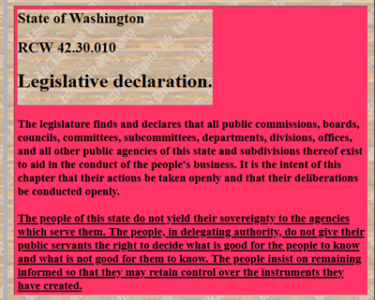
- If there are any state or federal elections which hinge on only one problematic city or county municipal corporation, then that state or federal election should be shut down and a new election held after the problem is investigated thoroughly and solved. Elections results must be accurate beyond a reasonable doubt.

- Any systems engineer knows how to design self checking feedback systems to catch errors. This is designed in all of our electronics, electrical and power systems. This self checking is largely invisible to the consumer yet without this security our communications, transportation, power, manufacturing and computing industries would not function.

- Yet we allow massive lack of security of our elections and open and close our borders at the whim of political administrations!

- Making municipal election systems error and fraud free is like having the sense to install modern security applications in computers and mobiles constantly updated to hacking threats.

- As you can see in the State of Washington RCW the people of the state do not yield their sovereignty to agencies which serve them. However, no state respects Citizen Sovereignty, votes or border security as these are political tools of power to themselves.
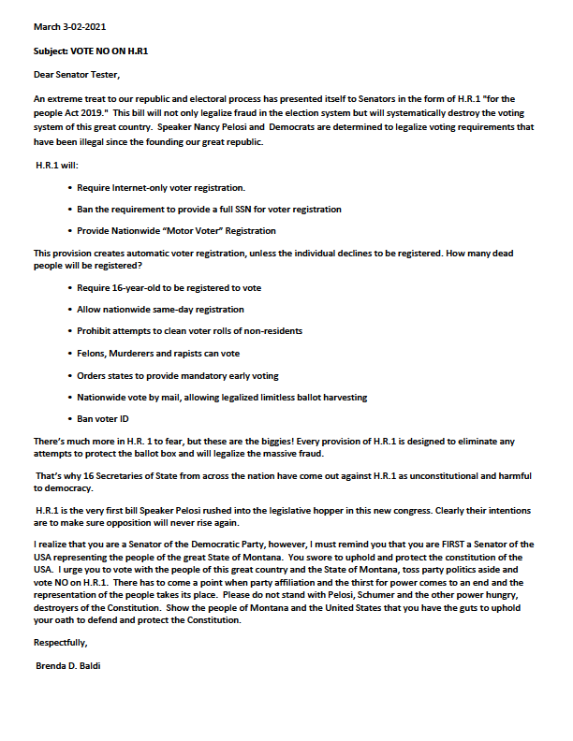A Montana Patriot Letter to
Senator Tester (D) re.
U.S. H.B. 1 –

The bill is insane desperation of the left to destroy our borders and our honest election system and totally unconstitutional. How can such garbage even be brought up for a vote? Thank you Brenda for exposing the takings!

Montana Election Fraud
- A River of Doubt Runs Through Mail Voting in Montana – Real Clear Investigations
- Voter Fraud in Missoula Getting National Attention – At Least 5% or votes Fraudulently Cast
- CPA Patty Lovaas wages campaign against Missoula elections office State & Regional –missoulian.com
- At Real Clear Investigations: Mail-in Vote Fraud in Montana – Crime Prevention Research Center
  - Dr. John Lott has an investigative piece on mail-in vote fraud in Montana. Some of the relevant documents are available at the end of this post. MISSOULA COUNTY, Mont. — A mountainous, 2,600-square-mile region with a population of approximately 119,600 does not seem like your prototypical setting for machine politics. Yet a recent audit of mail-in ballots cast there found irregularities
  - Subscribe to Crime Prevention Research Center
- Democrats 2020: Dark Money, Voter Fraud & Industry Dominance
- Was the 2020 Election Stolen from President Trump Survey?
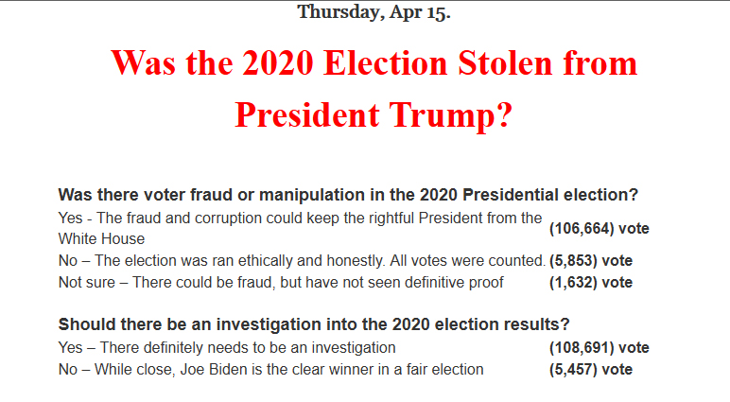
93.4%
5.1%
1.4%
Mike Lindell The Voice of Free Speech – Absolute Interference - My Notes.
- Check out www.frankspeech.com shown live April 19 through 21 on this platform
- About the FRANK PLATFORM
- The Absolute Proof Series regarding election fraud
- 2995 American counties were attacked by China during the 2020-2021 Presidential elections of a total 3143 counties.
- Cyber digital prints confirmed China interference in our election.
- Modem cards found fixed to circuit boards of voting machines
- 150 million views of Absolute Proof documentary video.
- Vimeo, YouTube and FaceBook take down documentary.
- ES&S and Dominion remote code execution discovered.
- Manufactures and politicians declare voting equipment is not connected to the internet.
- 2016 Russian cyber attack, Iran, China and other foreign country interference proven.
- 21 states hacked in2018 elections.
- Rapid foreign cyber interference.
- Democrats concerned about voting machine vulnerability in 2020.
- USA has known this since 2016.
- Verified connections with China gives absolute proof of illegal incursions to 150 Secretary of State Offices owned by TCL Chinese companies.
- IP addresses are verified to USA battleground states from foreign addresses.
- Most massive cyber attack in history on our election system in history led by the CCP of China.
- It only took 2 years to take down Venezuela.
- This is a global agenda using the same model.
- Unrestricted warfare doctrine of the Chinese Communist Party writings of General Sun Tzu to win without fighting.
- China Communist Party plan in hundreds of years in strategy so you do not see their takings.
- This attack took place in early hours of November 4, 2020.

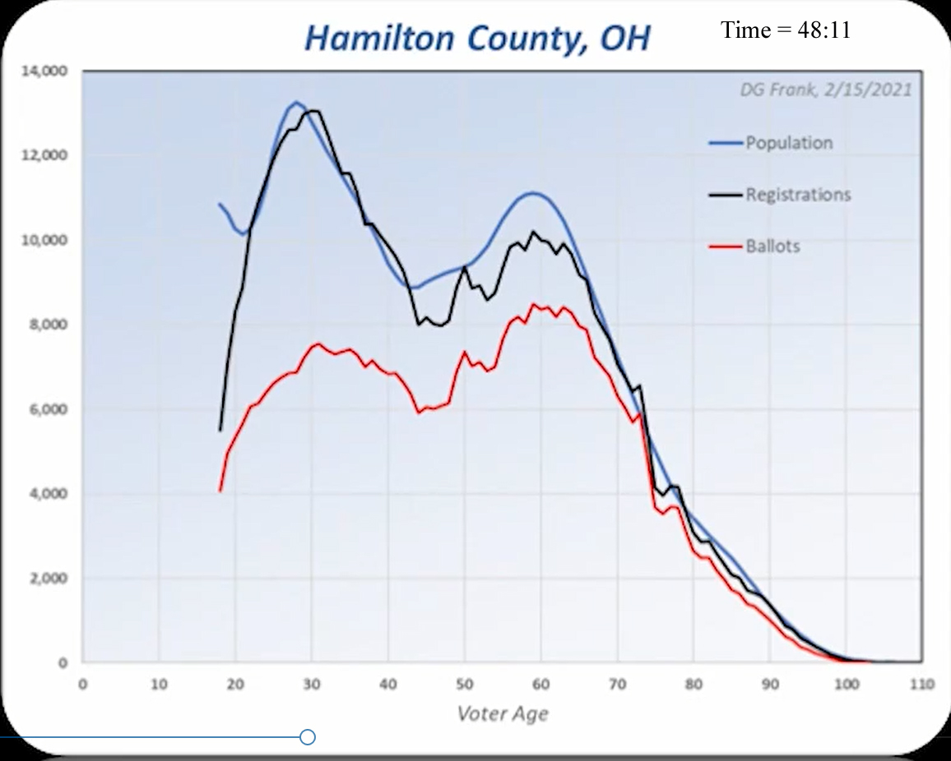Mike Lindell The Voice of Free Speech – Absolute Interference - My Notes
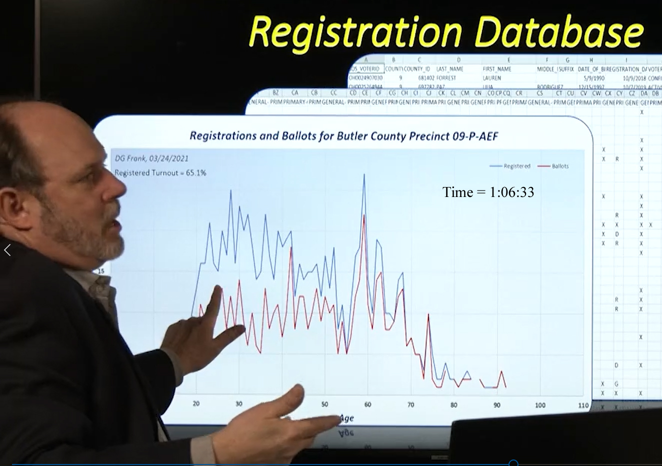
- See the pattern of Population, Voter Registration versus Ballots counted in the above two graphs.
  - The blue line is the population by age in Hamilton County Ohio from real data from the US Census.
  - The black line is “registered voters” in that county showing nearly everyone registered.
  - ISN’T THAT ODD? WAIT A MINUTE THAT CANNOT BE TRUE!
    - Most of the time only 70 to 80 % of a local county voters register!
    - This pattern of voter registration appears to be machine generated as it is too correlated to the population.
  - This is the work of Dr. Douglas E. Frank shown in the Mike Lindell 3 day series covering the second documentary exposing additional evidence proving foreign interference in the U.S. 2020-2021 elections.
  - He found this same pattern over and over in other states. His work is still in process.
  - From what I understand being said here is that this has been going on since at least 2008.
  - At 40:40 Minutes/seconds into this documentary you can listen to how Dr. Frank discovered the machine algorithm manipulating one election of one Congress women in Pennsylvania.

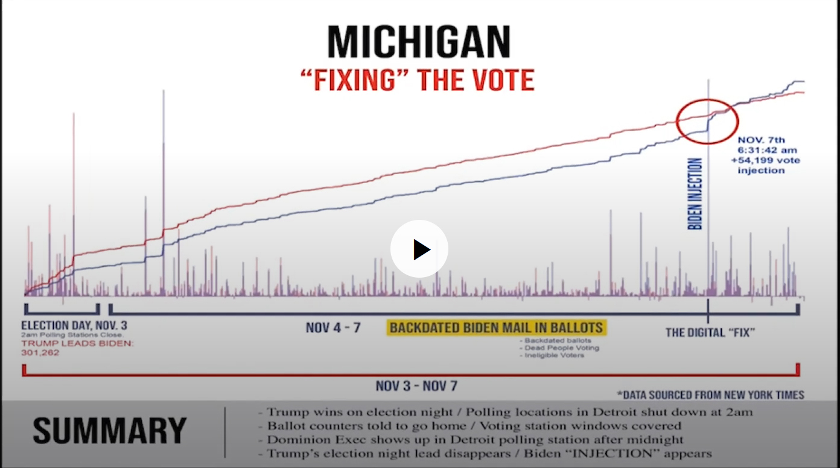
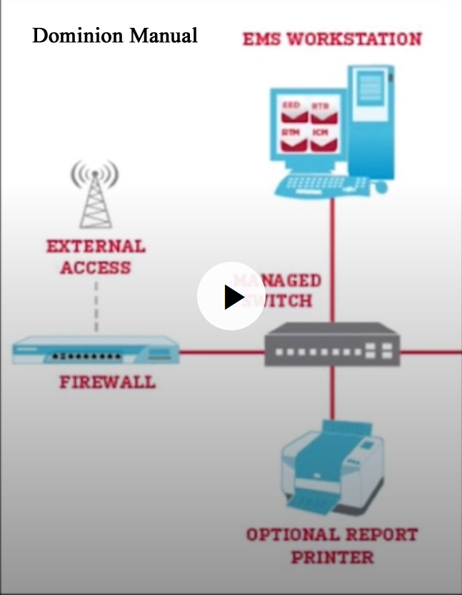Mike Lindell The Voice of Free Speech – Absolute Interference - My Notes

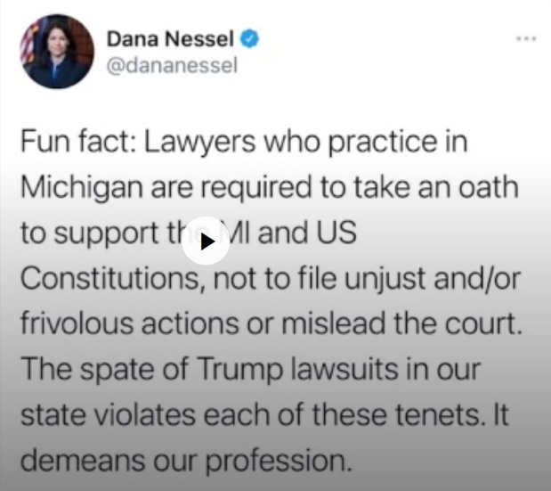
1. Trump wins Michigan election nights –
- Polling locations in Detroit shut down at 2AM
2. Ballot counters told to go home – Voting station windows covered.
3. Dominion Exec shows up in Detroit polling station after midnight
4. Trump’s election lead disappears – Biden ”INJECTION” appears.
Mike Lindell The Voice of Free Speech – Absolute Interference - My Notes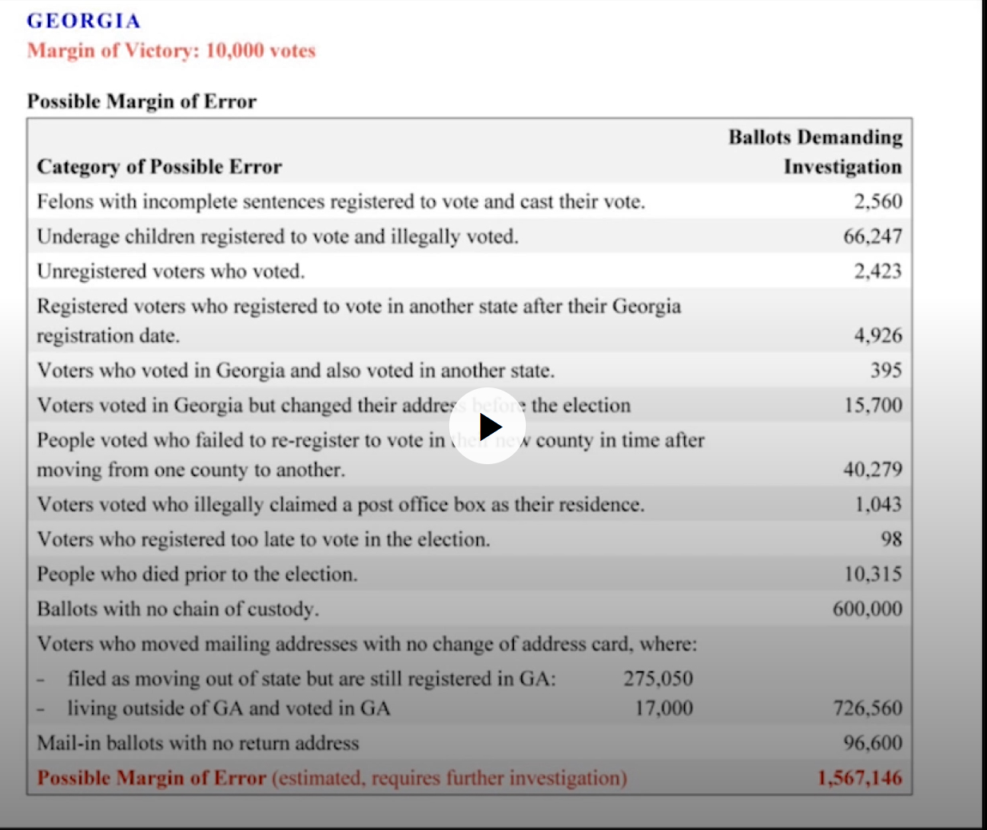
Mike Lindell The Voice of Free Speech – Absolute Interference - My Notes
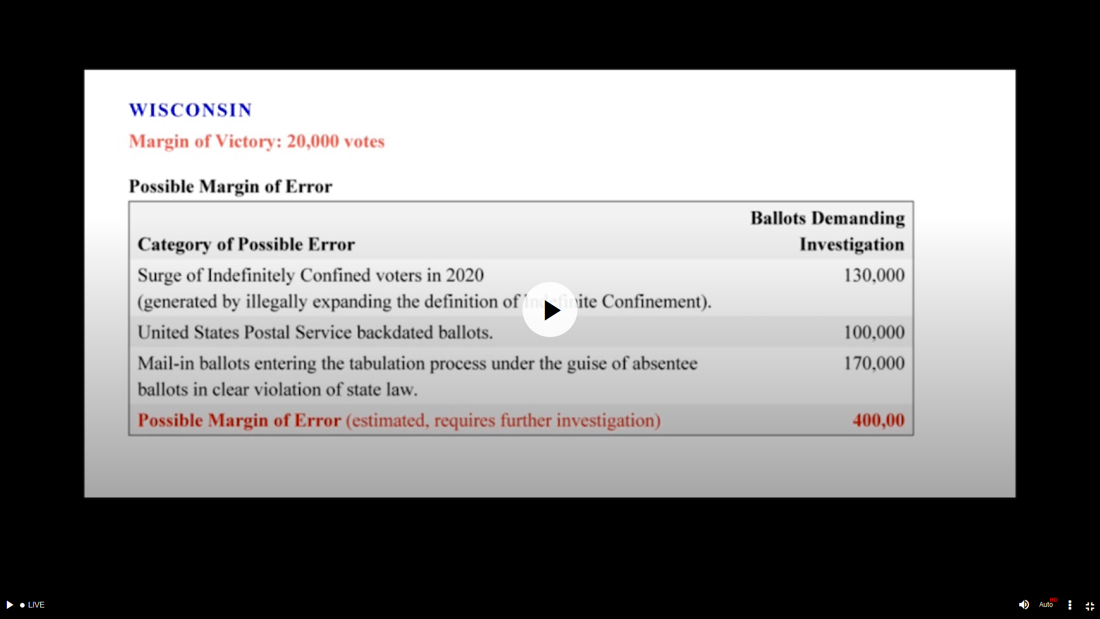
Mike Lindell The Voice of Free Speech – Absolute Interference - My Notes
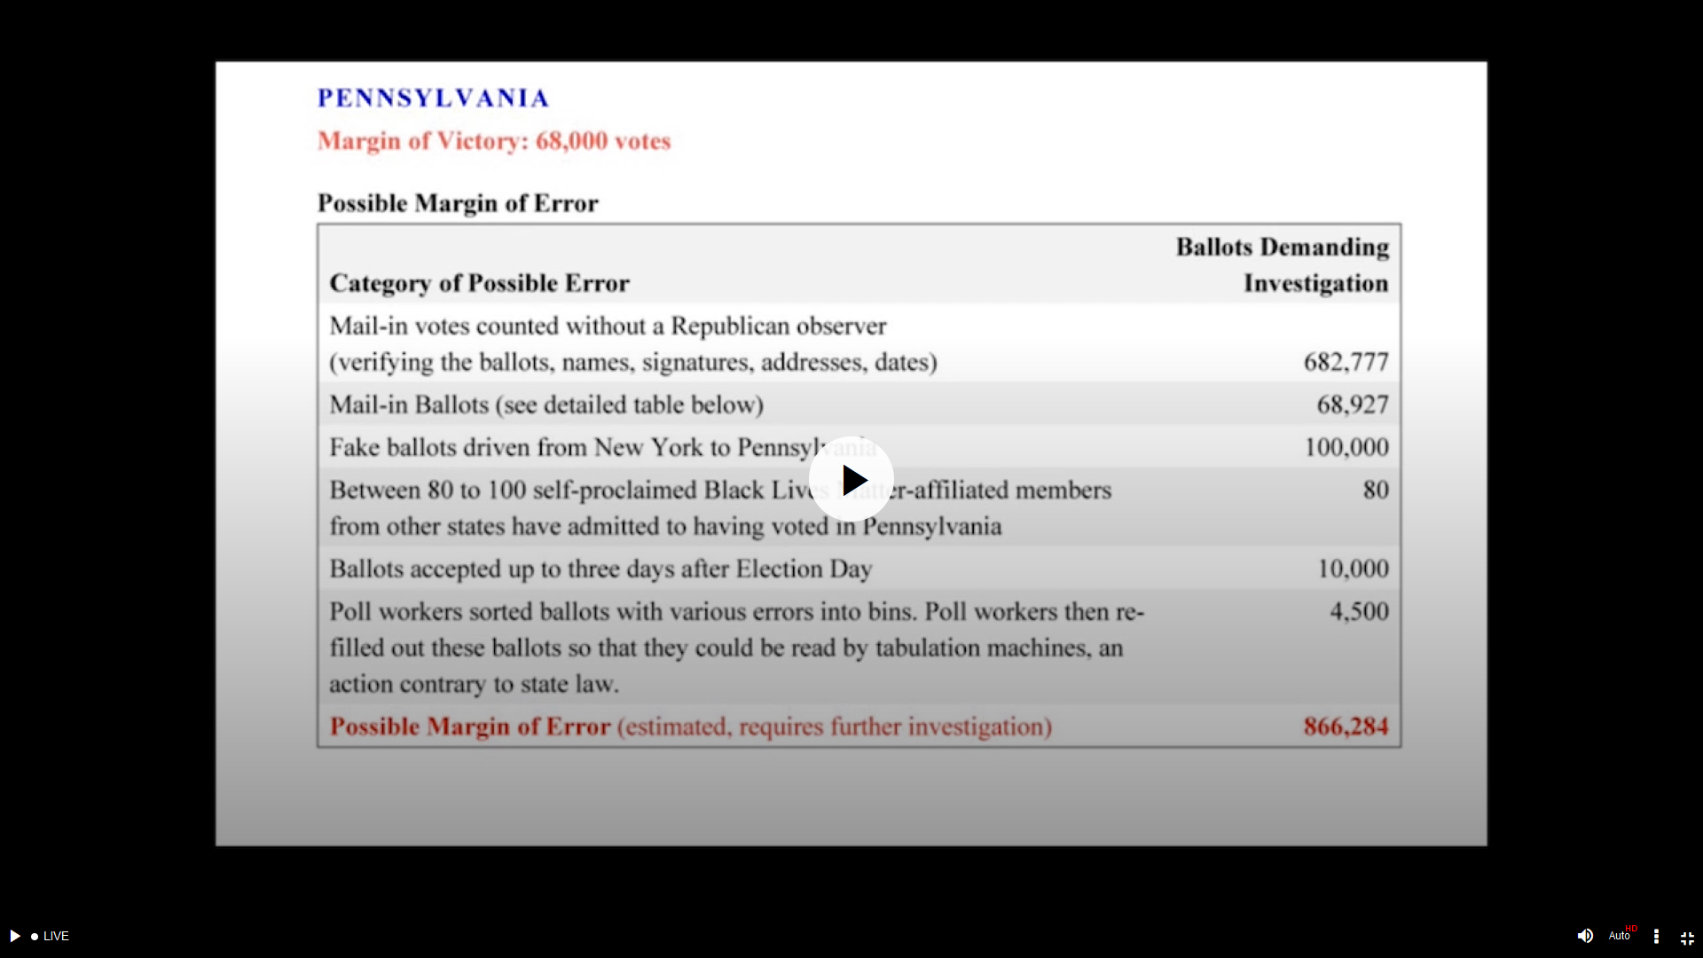
Mike Lindell The Voice of Free Speech – Absolute Interference - My Notes
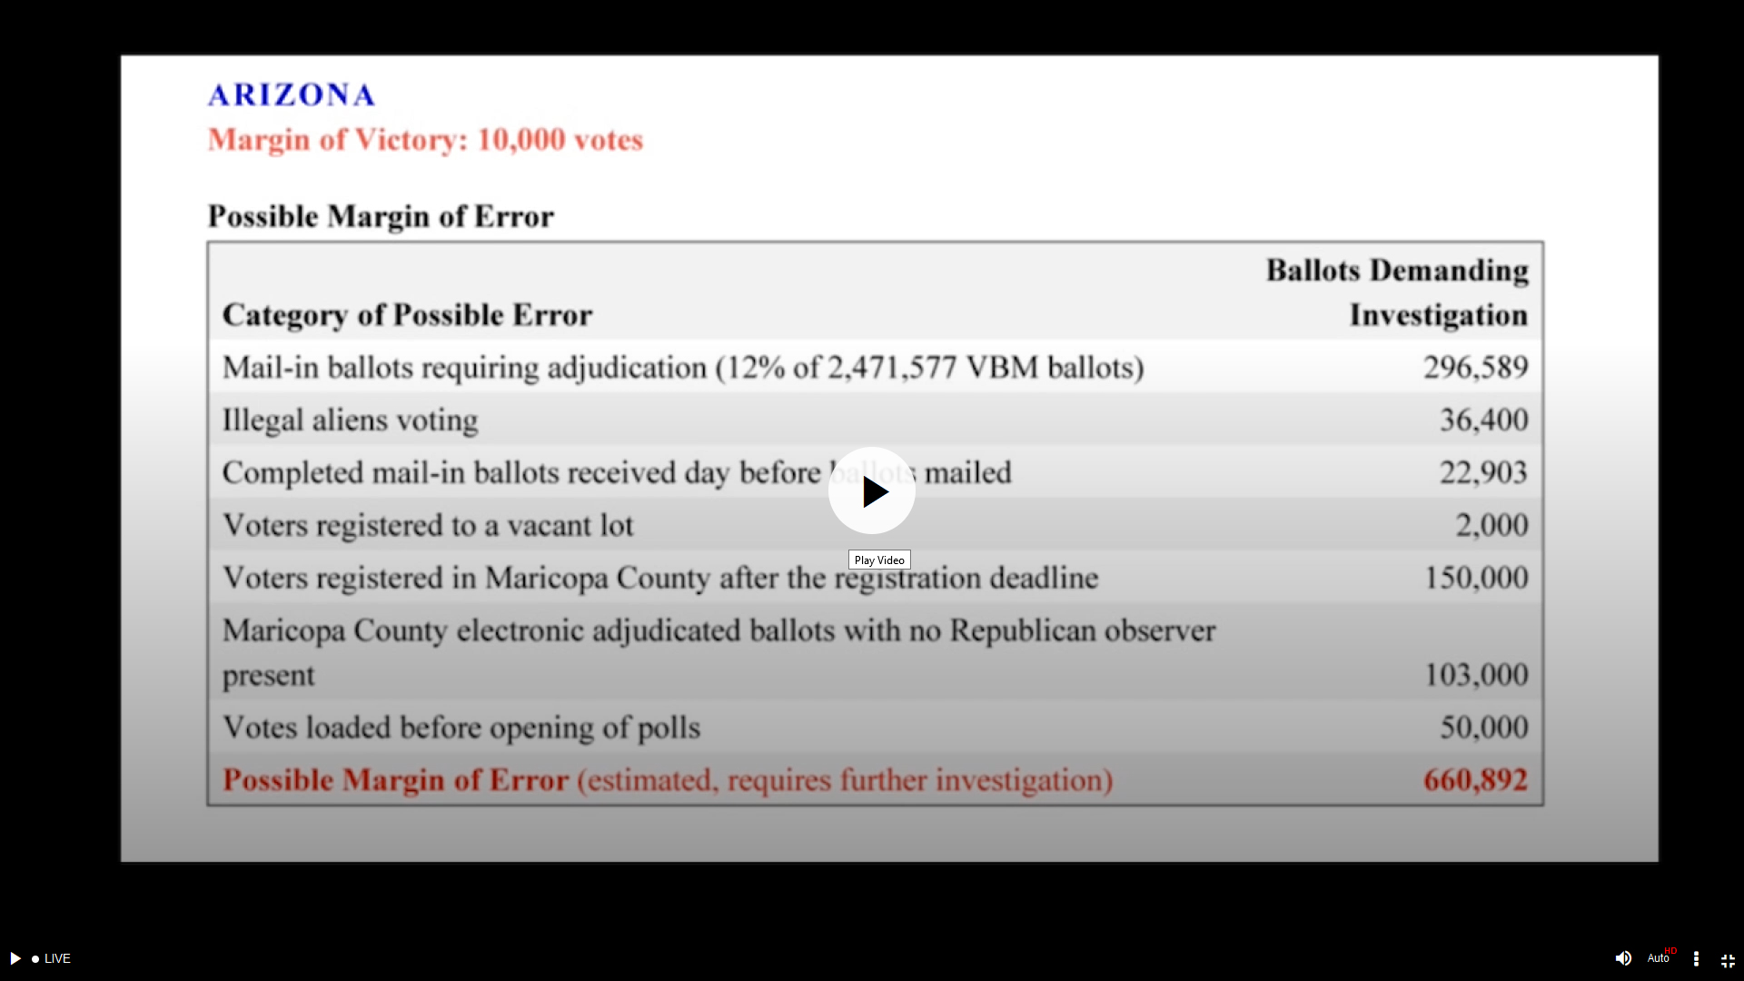
Mike Lindell The Voice of Free Speech – Absolute Interference - My Notes
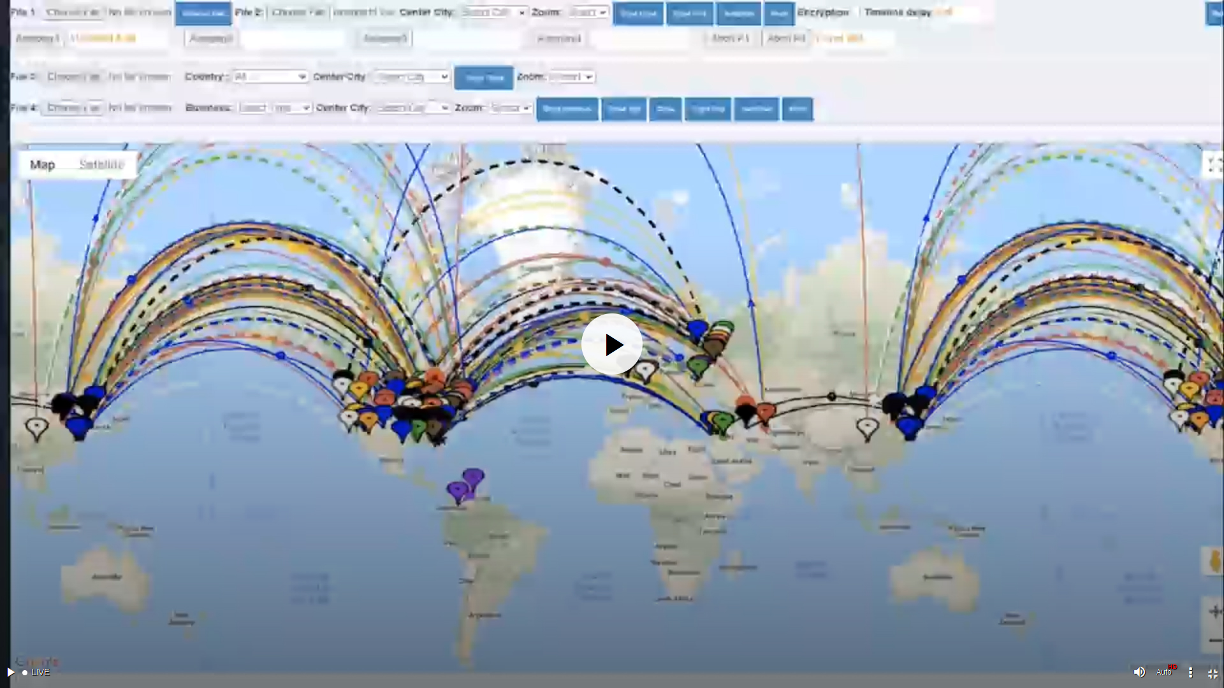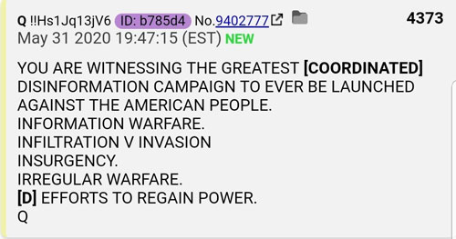
Mike Lindell The Voice of Free Speech – Absolute Interference - My Notes
- Data tabled below is the summery of a government expert witness appearing on Mike Lindell 3 day series.
- The first two rows are the vote totals reported for each state after the foreign interference vote switching.
- The middle yellow row is the votes switched from Trump to Biden.
- The last two rows are the real vote totals by state not reported.
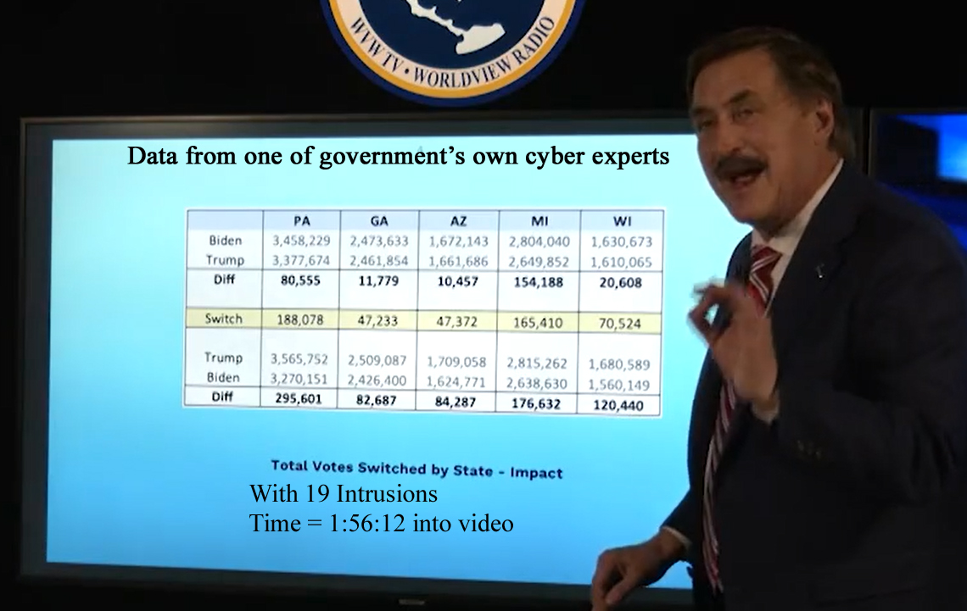
Mike Lindell The Voice of Free Speech – Absolute Interference - My Notes

- The top graph showing 518,617 total votes switched in 5 states with 19 foreign intrusions.
- The lower bar chart shows the total votes switched in 5 states for these 19 foreign intrusions only.
- This government expert stated 2995 counties in 50 states were intruded.

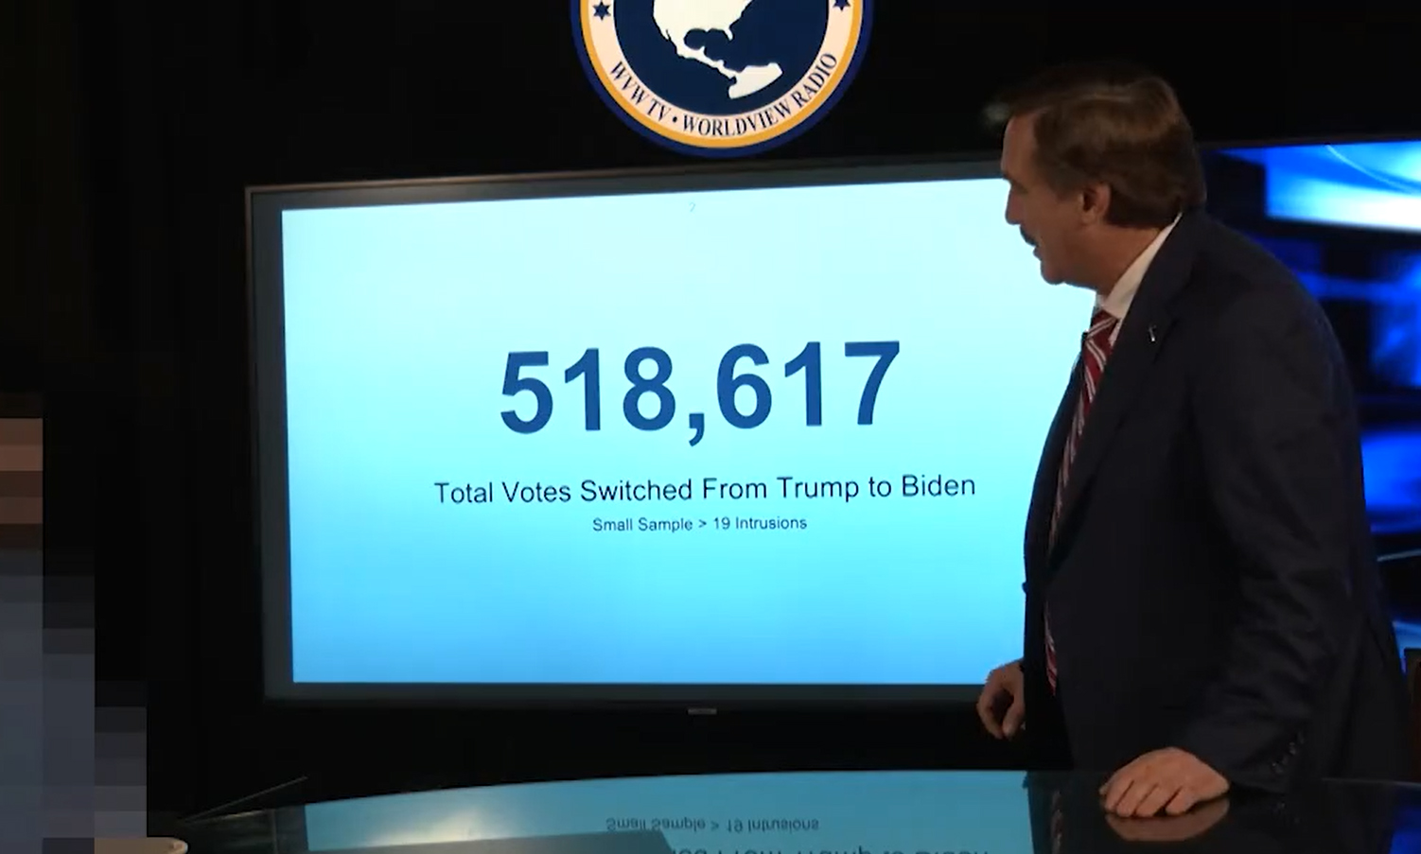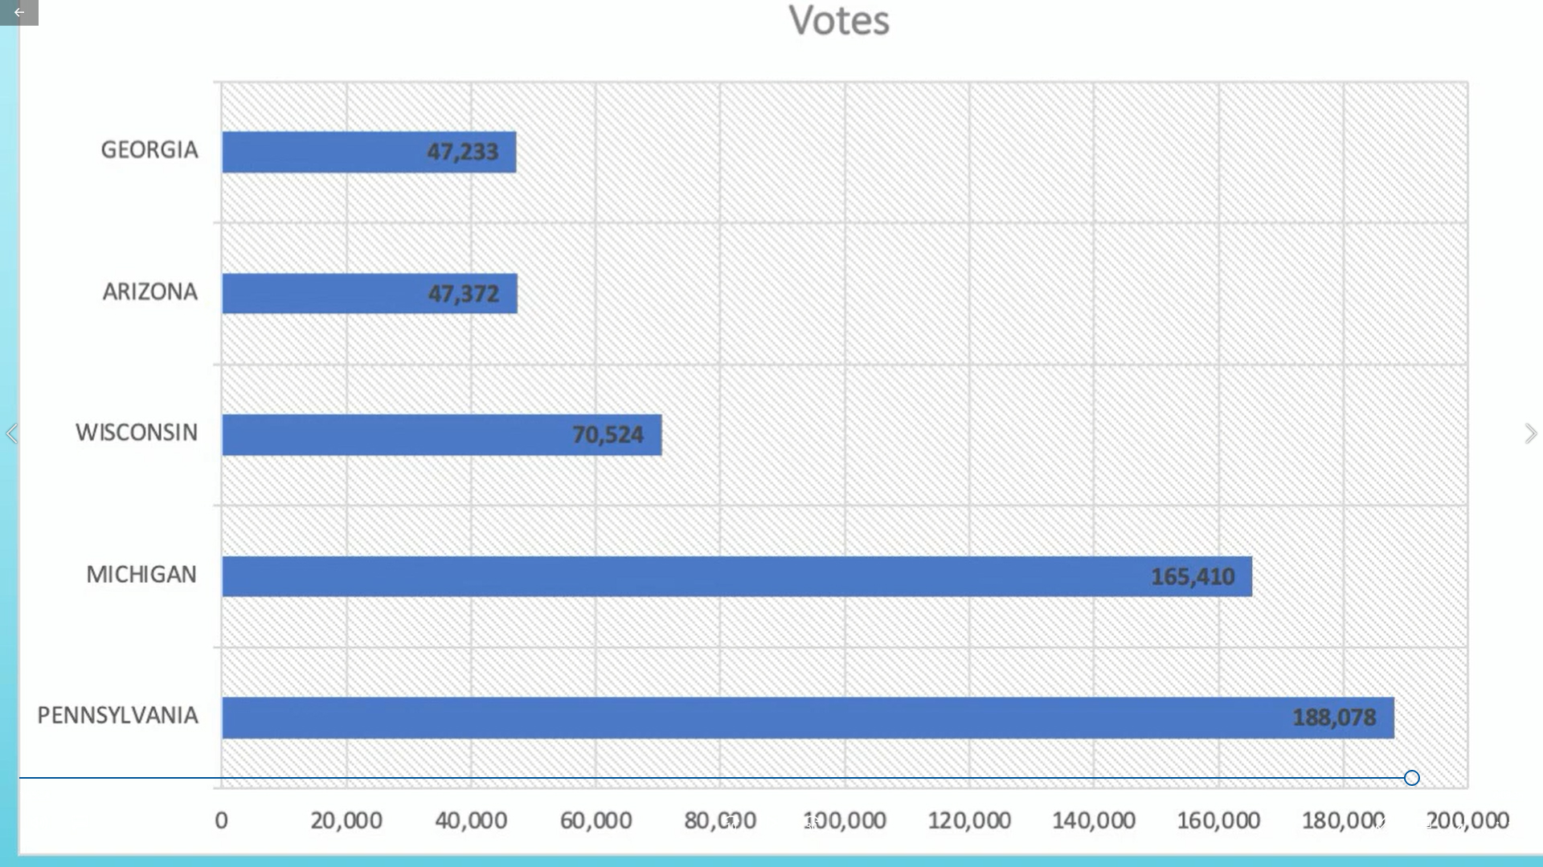
Mike Lindell The Voice of Free Speech – Absolute
- LOCATIONS TARGETED BY THE FOREIGN INTRUSIONS OF THE 2020 USA ELECTIONS
- This frame shows the foreign intrusion data targets by latitude, longitude, State, County, network used, intrusion type, and success of the intrusion, result caused and the number of votes the intrusion drove took from Trump.
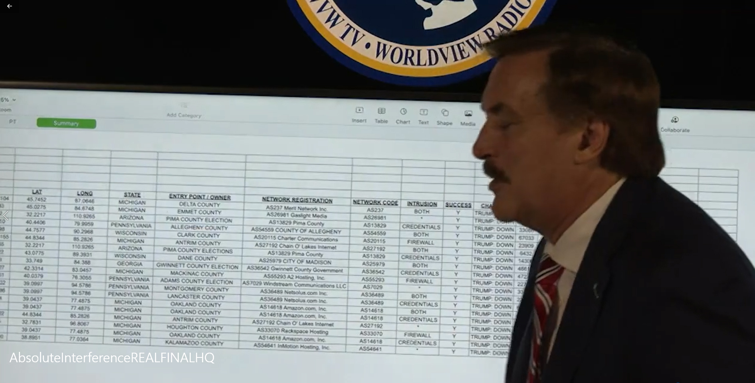
Mike Lindell The Voice of Free Speech – Absolute Interference - My Notes
- LOCATIONS TARGETED BY FOREIGN INTRUSIONS OF THE 2020 USA ELECTIONS
- Each line of this data log presented by the government expert cyber witness shows one of the 19 total foreign intrusions he recorded in real time and translated into a readable result. 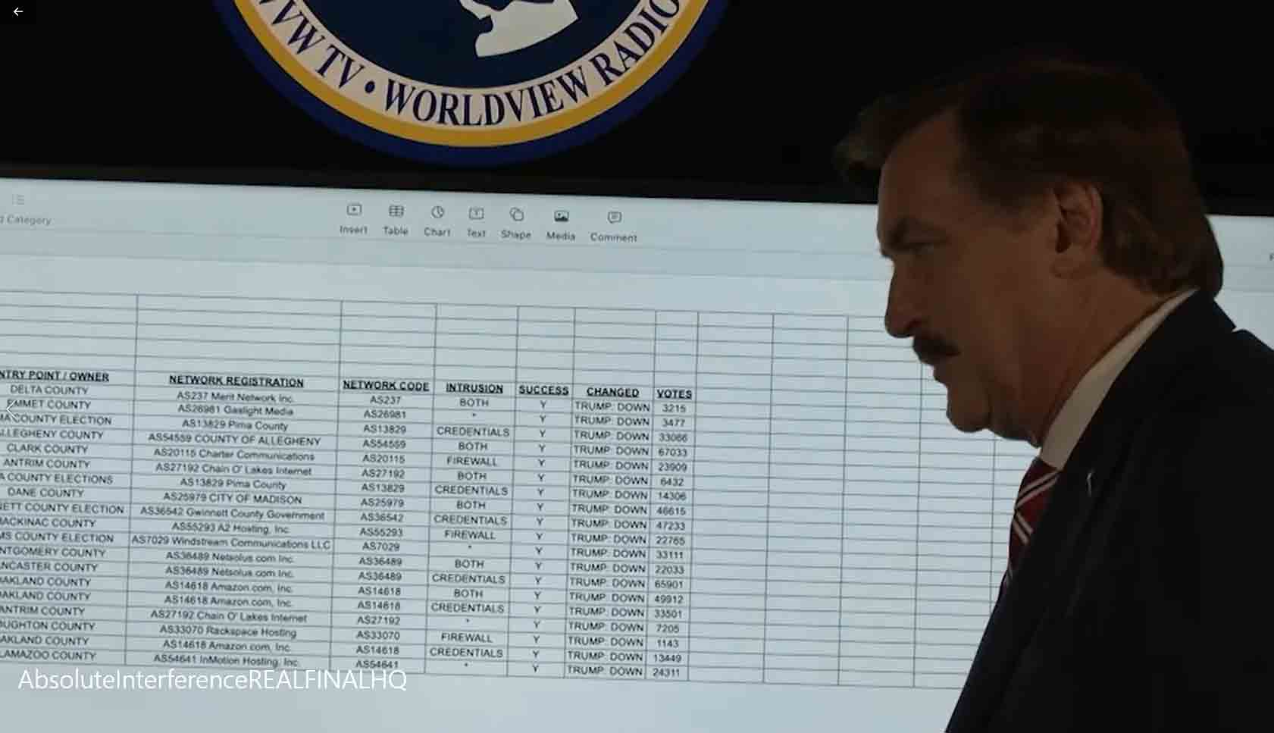
Mike Lindell The Voice of Free Speech – Absolute Interference - My Notes
- SOURCES OF THE 19 FOREIGN INTRUSIONS INTO THE USA 2020 ELECTIONS.
- See the source countries of the 19 intrusions are from China, S. Korea, India, Iran, Brazil and Germany.
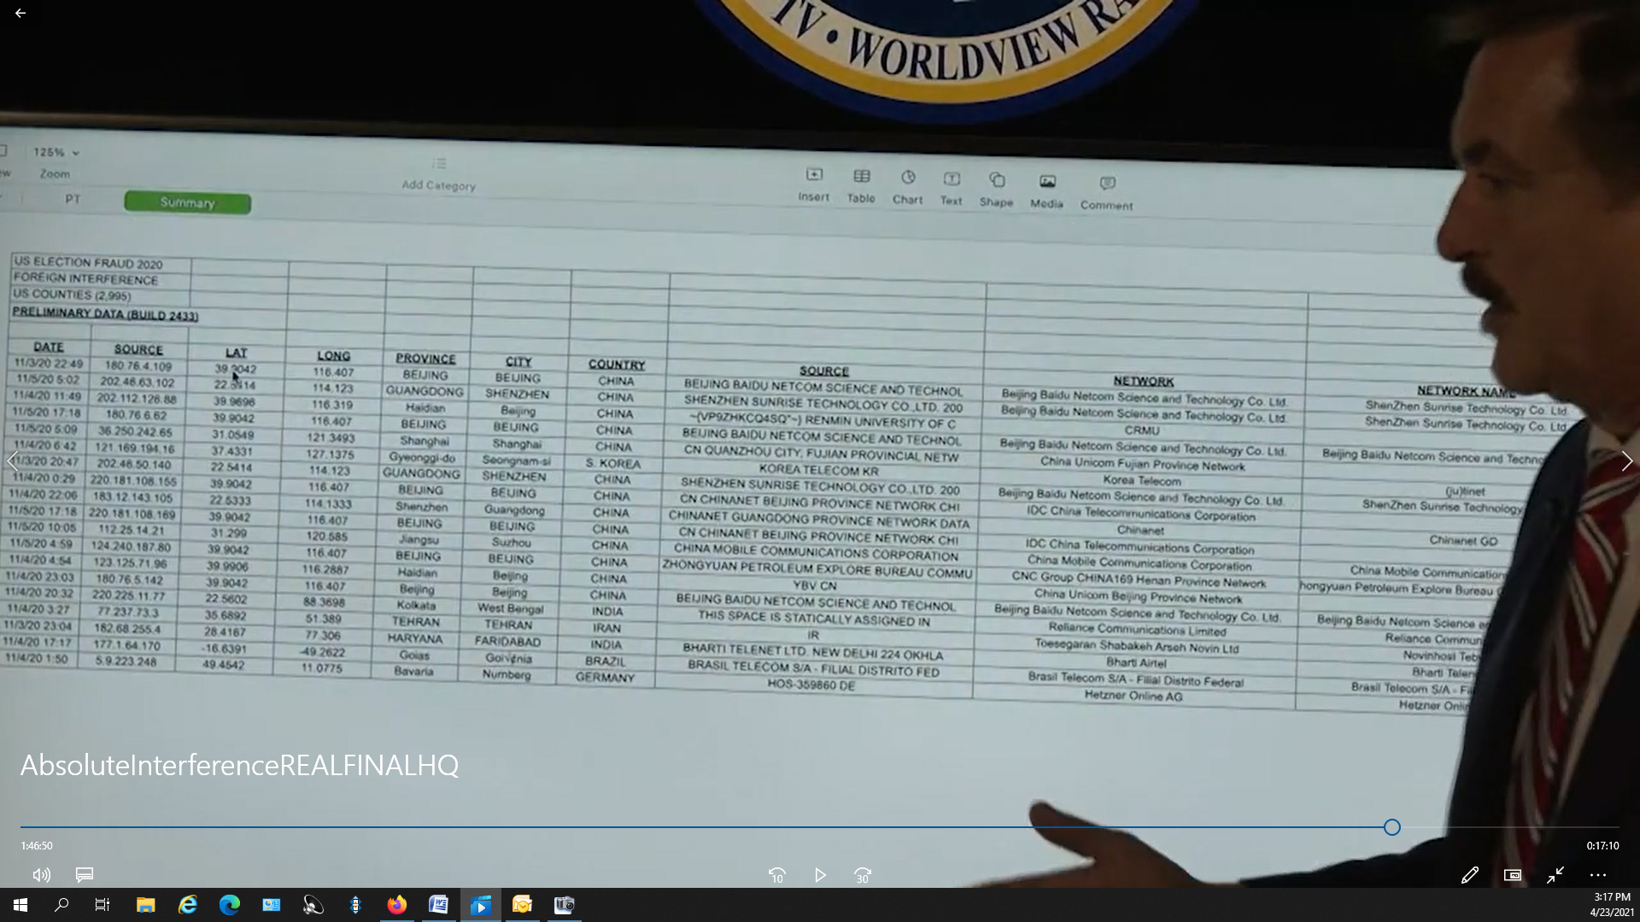
Mike Lindell The Voice of Free Speech – Absolute Interference - My Notes
- 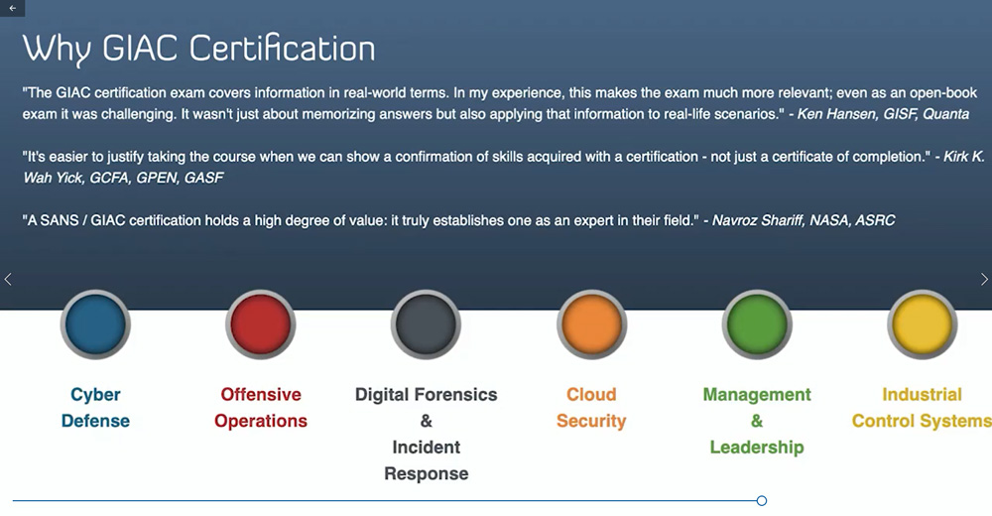These are two outline charts of the level of certification and workforce categories and the areas this government cyber expert specializes in. (Pages 68 to 73)
- His voice was filtered and his picture was pixelated so he was not recognizable.
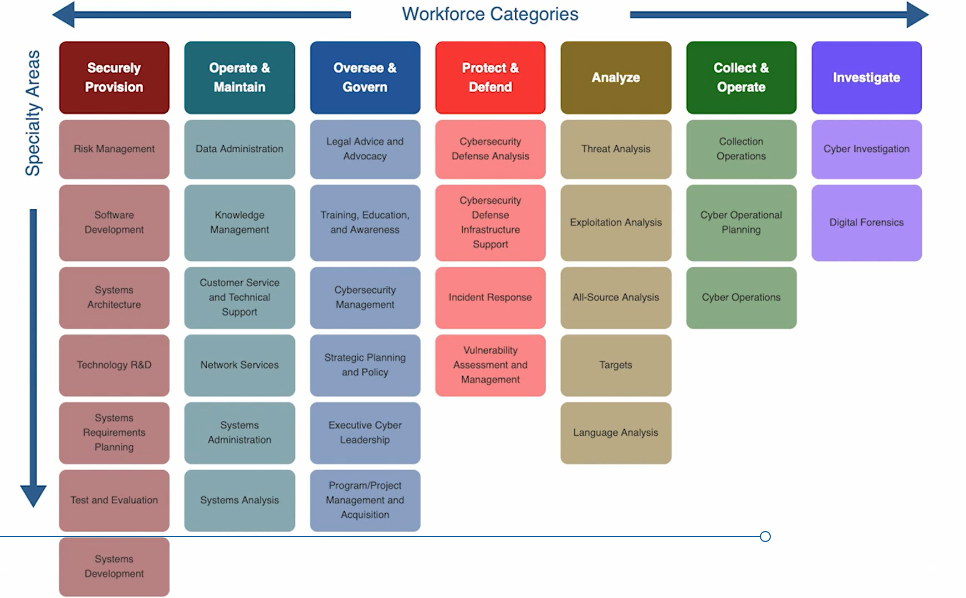
Maricopa County Judge denies Democrat's request to stop the election audit. The audit continues!
- Why would the Democrats not want the truth of the marginal states to be recounted and made public?
- This costly act of denial alone tells all to support this research.

Here Is the Evidence – Web Site Showing and Gathering the 2020 Presidential Election Irregularities
- Click on the title or image below and check out your own state.

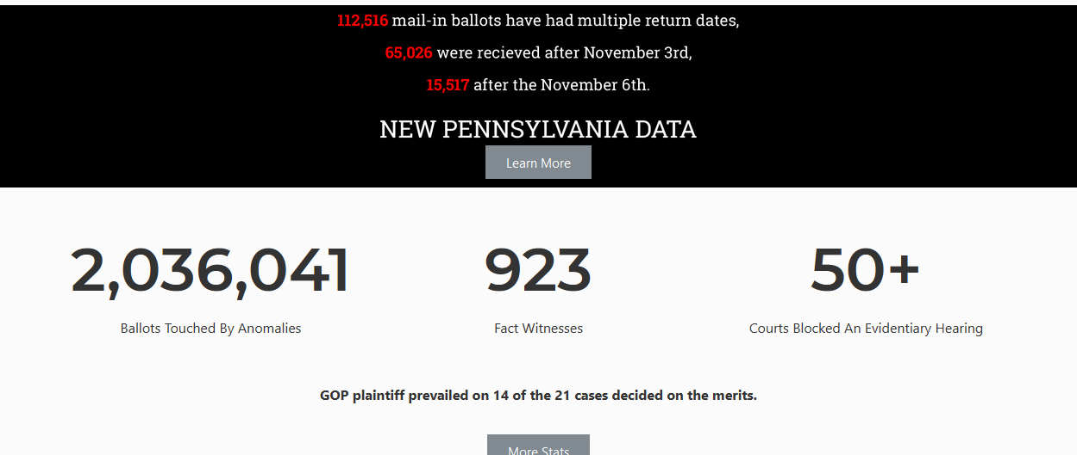
- Judicial Watch – Records Show Iowa State Coordinated with Big Tech to Censor Election

- Swiss Billionaire Pumps $208 Million Into Left Wing Groups that Help Democrats Win Elections

- Voter Fraud Probes Don't Happen Overnight
  - Investigations into election and voter fraud were crammed into just weeks after the presidential election, but the months following will ultimately bring forward "overwhelming evidence" of fraud and criminality, according to former NYPD Commissioner Bernie Kerik to Newsmax.
  - Must read and watch this interview.
  - "Two to three thousand sworn affidavits from people who witnessed criminal conduit in these voting polls in Georgia, Michigan, Wisconsin, Pennsylvania, Nevada, and elsewhere…"

- Vote by Mail: The Unintended Consequences - Must read 4 pages.
  - "…with pre-paid postage (meaning there's no date stamp on the envelope) who will prevent cheaters from printing and mailing ballots after Election Day?"

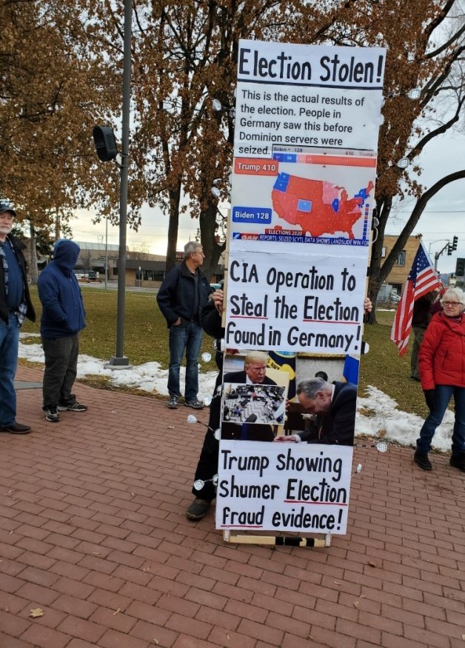
USA Agencies Controlled by the Deep State
- The Deep State is real.
- A high level of federal, state, top county and city elements remain in office through elections or are replaced with another Deep State agent.
- President Jimmy Carter found this out to his surprise during his term 1977 – 1981 and stated so publically.
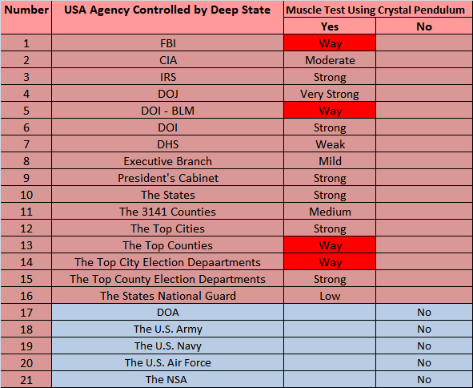
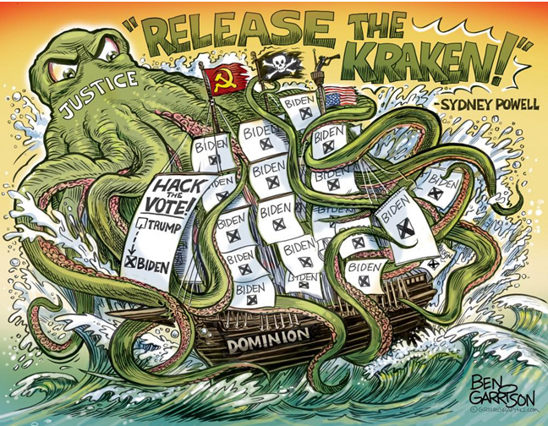
- Arizona investigation Confirms Systematic Fraud – Trump Clear Winner
- An election is being audited – the reaction to this is key
- Project Veritas takes on the lying MSM
- Voting by mail and absentee voting - MIT Election Data Science Lab
  - Do you see a problem in the chart below?
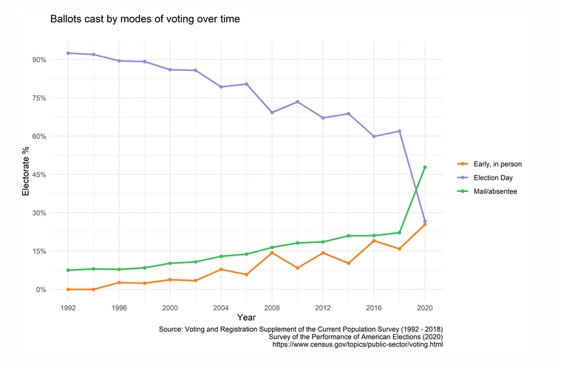
  - The party that won does not and everyone else does.
Green LIne is Mail in (Think phantom voters) & Absentee Voters
Blue Line is traditional voting in person at poll
- A Statistics Lesson to Save the Republic re. Voting Pattern Spread
  - Voting patterns are consistent across parties.
  - The data spread should be as tight to each side of either Republican or Democrat.
- Jack Letter to Montana State Secretary of State re. Election Voting Machines
  - All voting machines in Montana must be pulled from the county and city municipalities.
  - All voting equipment is vulnerable including tabulating machines in Lake County Montana.
- Jack Letter Responding to Montana Representative French re. Election Fraud
  - No the courts did not decide the election was legal.
- CEO Mike Lindell breaks down how Supreme Court will rule 2020 Election fraud (MUST SEE)
  - This 2020 election fraud impacted more than just the Presidential level.
  - SCOTUS VOTED 7 TO 2 TO NOT LOOK AT THE 2020 ELECTION FRAUD CASE.
  - End of July 2021 Mike Lindell will serve the U.S. Supreme Court a Quo warranto
Quo warranto. In old English practice, a writ in the nature of a writ of right for the king,
against him who claimed or usurped any office, franchise, or liberty, to inquire by what authority he supported
his claim, in order to determine the right. It lay also in case of non-user, or long neglect of a franchise, or
misuser or abuse of it; being a writ commanding the defendant to show by what warrant he exercises such a
franchise, having never had any grant of it, or having forfeited it by neglect or abuse. 3 Bl.Comm. 262.
A common law writ designed to test whether a person exercising power is legally entitled to do so. An extraordinary
proceeding, prerogative in nature, addressed to preventing a continued exercise of authority unlawfully
asserted. Johnson v. Manhattan Ry. Co., N.Y., 289 U.S. 479, 53 S.Ct. 721, 77 L.Ed. 1331. It is intended to
prevent exercise of powers that are not conferred by law, and is not ordinarily available to regulate the
manner of exercising such powers. An ancient prerogative right through which the state acts to protect itself and the good of public generally
through its chosen agents as provided by its Constitution and laws, though sometimes it is brought at instance of
and for benefit of a private individual who may have a special interest. Lewis v. Drake, Tex.App., 641 S.W.2d
392, 394. Legal action · whereby legality of exercise of powers by municipal corporation may be placed in issue.
People ex rel. City of Des Plaines v. Village of Mount Prospect, 29 Ill.App.3d 807, 331 N.E.2d 373, 377.
In the law of corporations, quo warranto may be used to test whether a corporation was validly organized or
whether it has power to engage in the business in which it is involved. The federal rules are applicable to proceedings for quo
warranto " to the extent that the practice in such proceedings is not set forth in statutes of the United States
and has heretofore conformed to the practice in civil actions." Fed.R. Civil P. 81(a)(2). Any remedy that
could have been obtained under the historic writ of quo warranto may be obtained by a civil action of that
nature. U. S. v. Nussbaum, D.C.Cal., 306 F.Supp. 66.
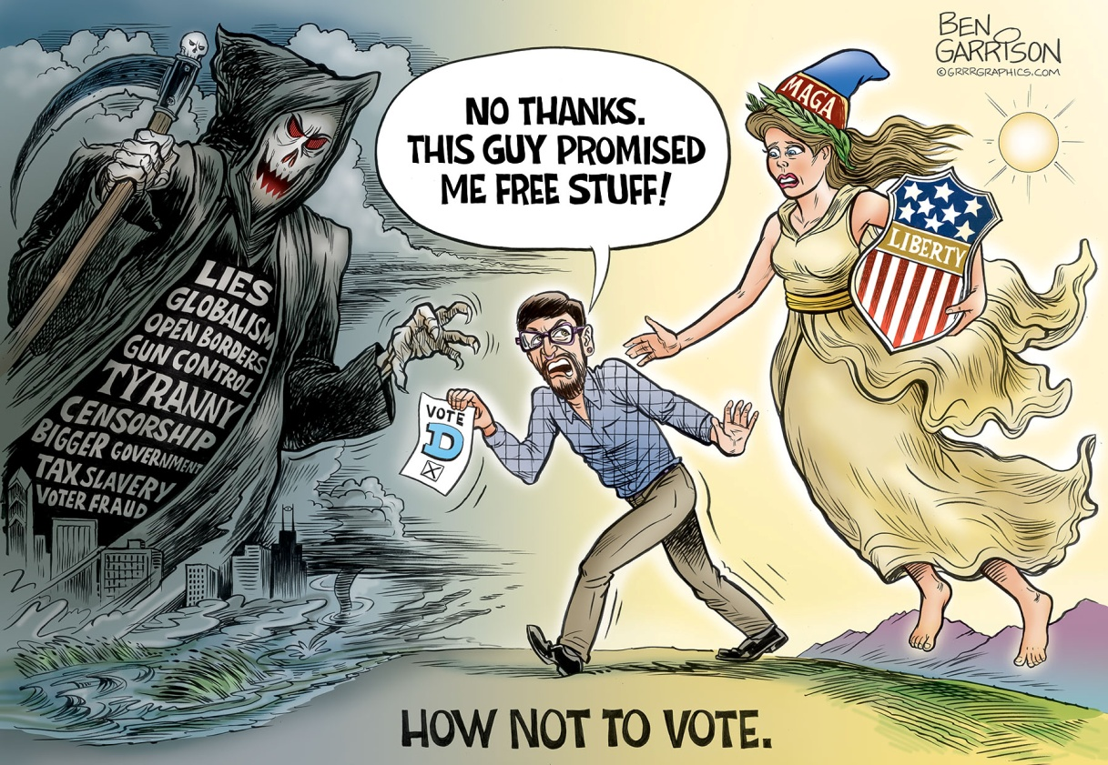
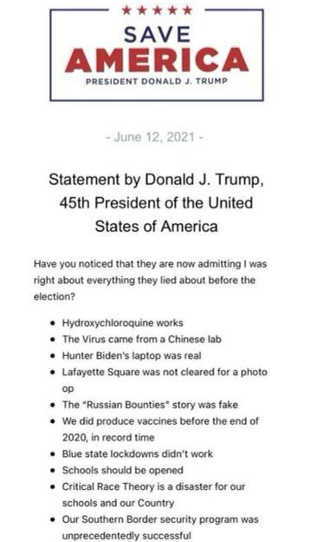
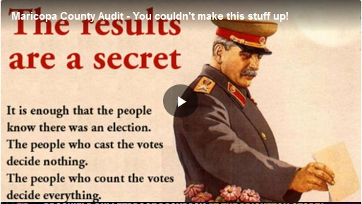
Click below to see what is happening in Maricopa County beyond fiction
Click here to view 2 Hour Video
Government Launders Censorship Though Twitter to Silence Political Speech Silently
- Governments across the world silencing free speech through Big Tech (19 minutes to see the big picture)
- Created in Massachusetts by State officials, Twitter Legal and a National organization architected at Harvard University.
- Political forces have a backroom channel into Twitter, i.e. they can tell Twitter what to do.
- Dr. Shiva lawsuit is the tip of the spear that government launders censorship through Twitter. (12:20 Minutes/19:04)
- Government silences free speech through Twitter silently.
- This is a Technology Infrastructure that allows government to have a pipeline to Twitter (Trusted Twitter Partnership).
- Go to https://vashiva.com/first-amendment-twitter-galvin-lawsuit/
- Look at the players in the Royalty MOSSAD cartoon figure, i.e. same ole government team!
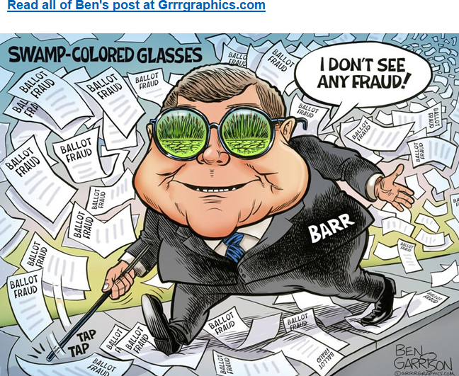
"Bill Barr, I Didn't See Any Voter Fraud!"
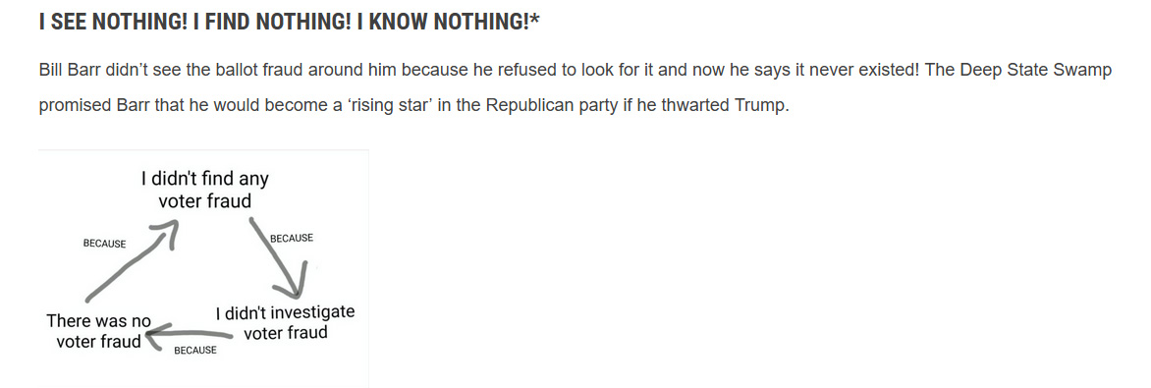
- Bill Barr, I Didn't See Any Voter Fraud!
Bill Barr didn’t see the ballot fraud around him because he refused to look for it and now he says it never existed! The Deep State Swamp promised Barr that he would become a ‘rising star’ in the Republican party if he thwarted Trump.
Backstabber Barr tarnished his own Attorney General star by doing so.
Barr belongs in the Swamp along with the rest of the RINOs who readily and eagerly backstabbed the president.
—Ben Garrison
- Support Ben - www.grrrgraphics.com

Trump Unloads On Biden Over Pennsylvania Trip ‘To Stop the Forensic Audit
Donald Trump released a statement about Joe Biden’s plans to visit Pennsylvania just before Republicans appear poised to launch an audit of the 2020 presidential election.
“Joe Biden is going to Pennsylvania today in a rush in order to stop the Forensic Audit that the Pennsylvania Republican Senate is in the process of doing. Philadelphia was a cesspool of corruption, which will soon be revealed by the audit,” Trump said in the statement.
“Why are they so concerned that a President, who never goes anywhere, would hop onto beautiful Air Force One and head to Philadelphia if it were an honest election? Why not let the audit go forward and make everybody, on both sides, happy? The results will be the results,” he added.
“But they know it was not an honest election, Philadelphia was one of the most corrupt cities in the Country — and so it Detroit, and so is Milwaukee, and so is Atlanta, and Pittsburgh, and Oakland, and Baltimore,” he said. “Corruption has gone on for years, but in the 2020 Presidential Election Scam, with the mail-in ballots and the use of Covid to cheat, corruption reached new levels.”
“Remember the poll watchers being thrown out, the windows being sealed so nobody could look in, the ballot drops, and all of the other events that took place that changed so rapidly the Big Trump Win on election night,” he said.
Trump added, “Joe should say go forward with this, with all of these audits. His visit is a joke. He doesn’t need to visit, all he needs to do is let them do an audit and find out what happened. Who knows, maybe they’ll say the election was on the up and up, but many people would be shocked.”
“Let the audit go forward like it is in Arizona, despite 107 Democrat lawyers trying to stop it and failing,” he said.
Trump concluded by saying, “Let the Forensic Audit go, Joe. Don’t fight it. Show them how honest it was.”
What Do You Have to Hide, Joe? pic.twitter.com/C9qtsGCeNi

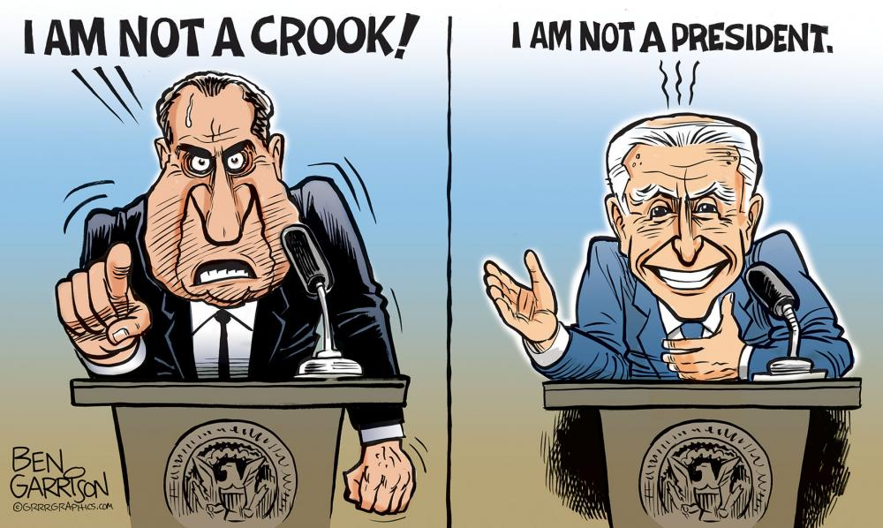
Montana Audit Sign The Petition
www.grrrgraphics.com
- Demand Full Forensic Audit of Missoula County and All Montana Counties 2020 General election Results.
- Click on title link to sign.
- Zukerberg funded 30 of the 56 Montana Counties.
- 46,000 Excess Votes over the Voters Registered.
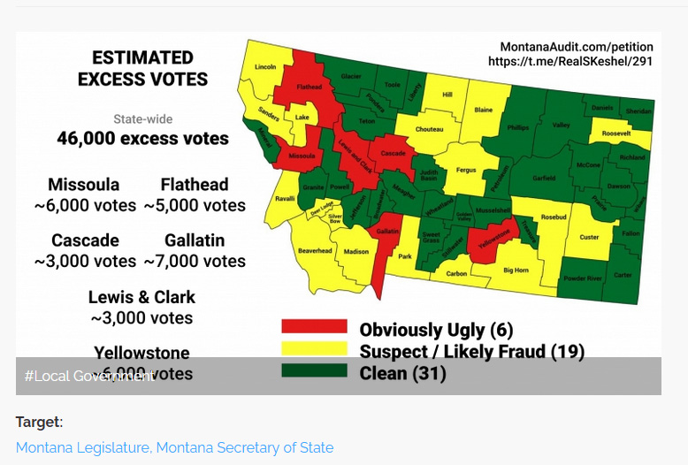
Link to Read Jack's Letter to Missoula Montana Representative French
- The courts only ruled on 3% of the election cases evidence.
- The courts did NOT decide on 87% of the election cases evidence.
- The courts went both ways on 10% of the case evidence.
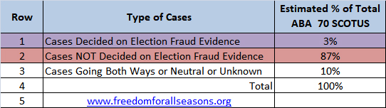
- Link here to check out this new web site and analysis of SCOTUS

How the Ballot Box Becomes a Weapon
"By 1992, there were more people working for government than for manufacturing companies in the private sector. There are more citizens receiving government checks than there are paying income taxes. When it is possible for people to vote on issues involving the transfer to themselves from others, the ballot box becomes a weapon whereby the majority plunders the minority. That is the point of no return. It is a doomsday mechanism."
"The Creature From Jekyll Island", pg. 534-535, Edward Griffin

Colorado confirms serious voting systems breach
- A "serious breach" of one county's voting operations has been reported, and is being investigated, according to a report from Colorado Newsline.

Mike Lindell's Cyber Symposium August 10, 11 & 12
- Dr. Douglas G. Frank - physicist, chemist and mathematician
- Analyzing The 2020 Election
  - 58 minute video proving the election was absolutely stolen.
- Dr. Frank: 2020 Election Data Research reveals Troubling Patterns
  - "Frank said that, based on his calculations, he estimated a significant percentage of the votes cast in the 2020 election were actually “phantom votes.” Phantom votes, he said, are legally invalid ballots because they are attributed to people who, for example, died before the election, have moved out of state, already voted, are convicted felons, are underage or who say they did not actually vote. To corroborate his estimate, he assembled a team of canvassers who went door to door in Pennsylvania with a randomly selected list of people who supposedly (according to election results) cast a ballot in the 2020 election. The canvassers found, according to Frank, not about 20% as he initially believed, but over 30% of the ballots cast were from phantom voters."
- Dr. Douglas G Frank: Audit The Vote PA
South Dakota Governor Kristi Noem Bottomline
- "The blue state, big city politicians went into lockson for months with no discernable difference in COVID-19 places that remained open for business. Except now after crashing ther economies; they have their hand out and are seeking a bailout from Washington. I'm proud of the fact that South Dakota is the only stte in America that never ordered a single business or church to close."

- A monthslong investigation into 2020 presidential vote found that Democrat-run cities and states used the COVID-19 crisis to change the rules that likely helped Joe Biden’s ascent to the White House.

Dr.Shiva at Mike Lindell’s Cyber Symposium reveals how BigTech is really GOVERNMENT Tech
- Arizona Bombshell New Subpoena Panics AZ Dems
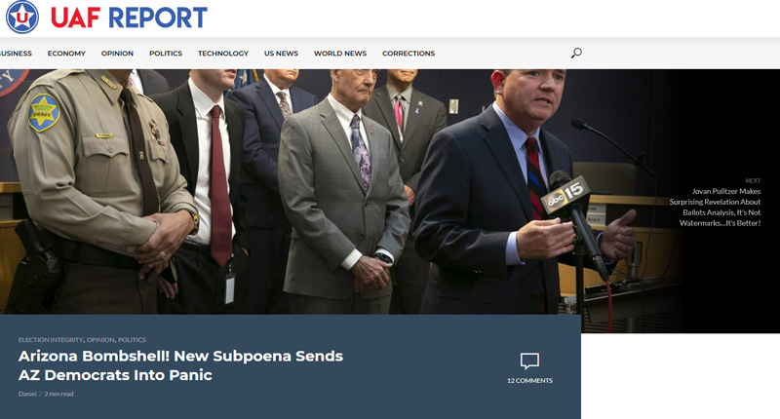
  - AZ Maricopa County Board of Supervisors are begging court for mercy.
  - Link title or picture below to read the truth.

HITCHHIKER'S GUIDE TO ELECTION FRAUD ANALYTICS (Link here for report)

- Table of Contents
  - Link above for 39 Pages of Must Know Operational Voter Data.
  - Dealing with how to determine the integrity of voting data.
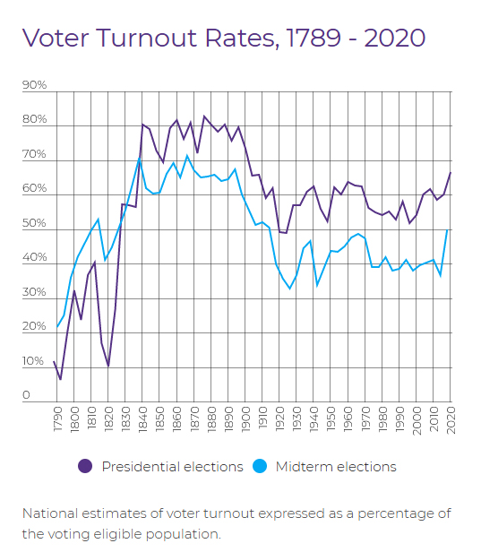
•State Data
• Voter Registration File
• Ballots Cast File
• Rejected Ballots File
• Voter History File
• State Demography Population Data over Time
•Analytics Resources
• Software
• People
•Targeting Precincts
• Voter Opportunity Score
• Making Statistical Assertions
•Data Analysts
•Software and/or Database Developers
Statistical Sampling Table to Give You a Visual on Number Sampled vs. Confidence Level.
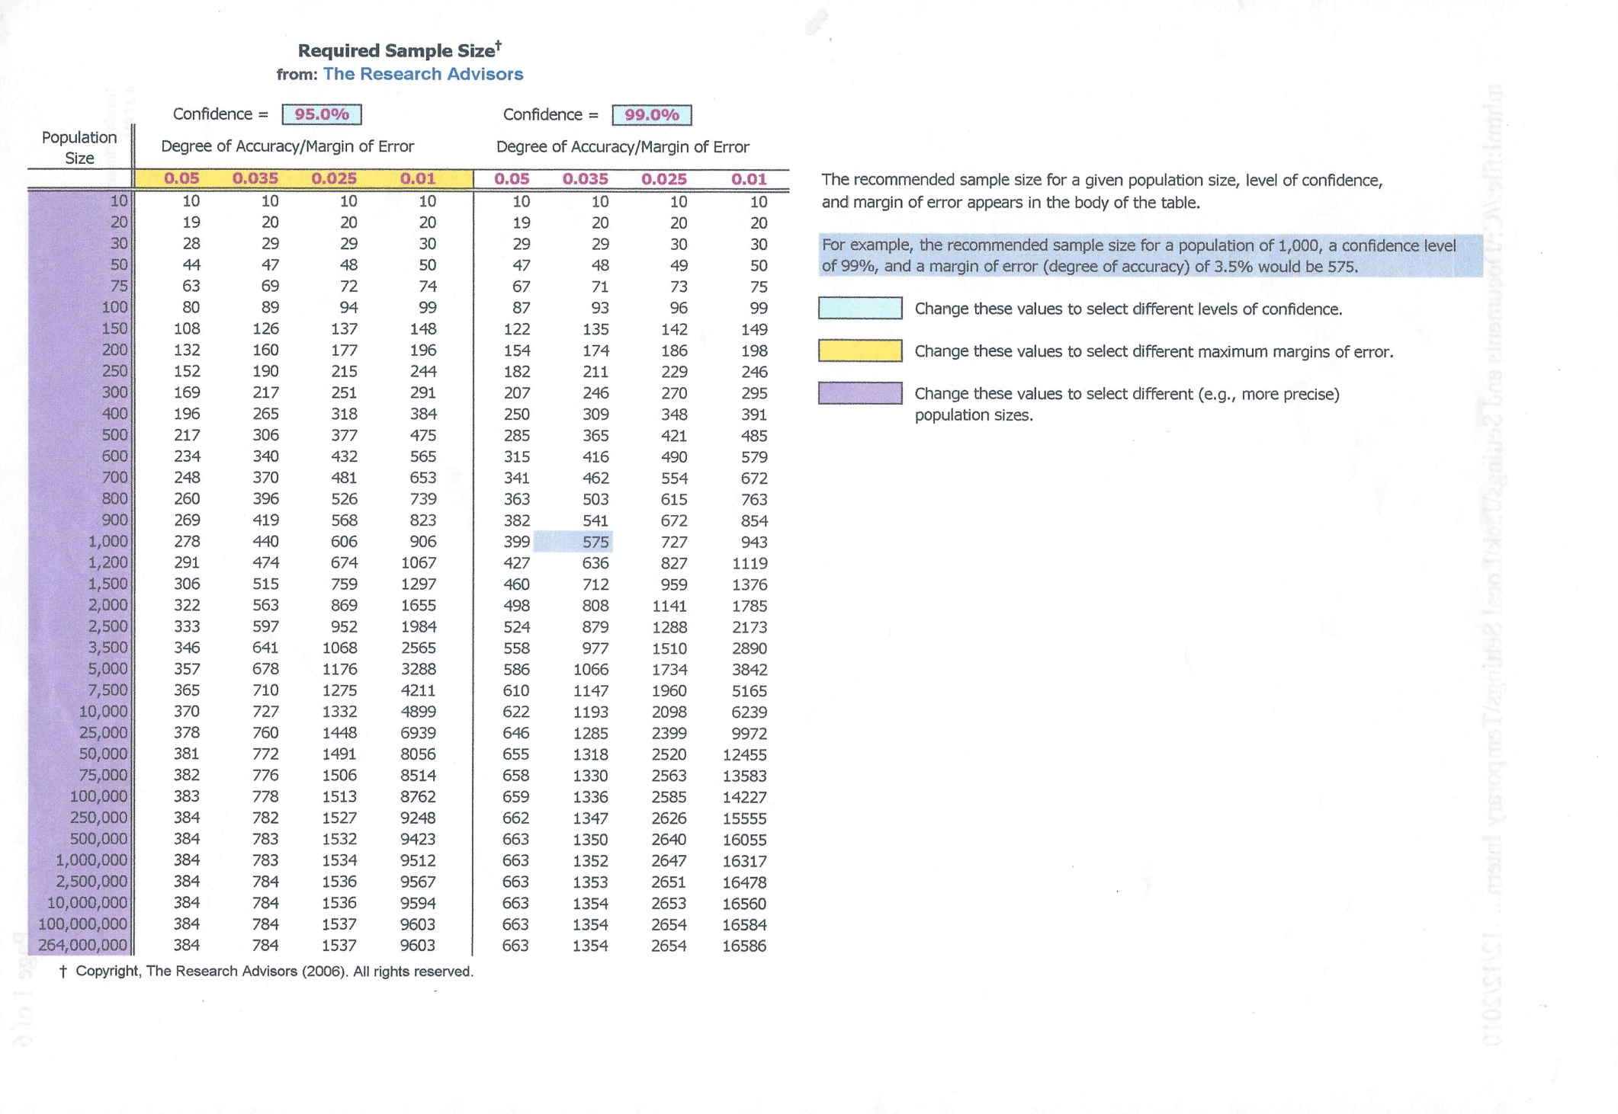
This table is the best visual example to understand statistical sampling sizes.
The more you sample the more confident you can be about your data.
At the same time if you get your sample size right the sample size is relatively minimal to seek a high Degree of Accuracy and Confidence level. Comments by Jack. Table source found on the web.
Bombshell Report Proves State and Federal Election Crimes Were Committed - County Commissiner Leaks to Press Instead of Reporting Crimes. Link on title.
- "Mesa County Colorado Clerk and Recorder Tina Peters in good faith delivered an initial forensic cyber security report covering election machine analysis to County Commissioners. The report proves destruction of evidence. One or more Commissioners misrepresent report to the press -fail to report crimes."
- More proof that county politics are overruling correcting the fraud.

Forwarded from Transparent Elections NC (Received via Telegram)
- The NC State Board website on Voting Systems states, "All voting systems used in North Carolina are certified by the federal Election Assistance Commission (EAC) and the State Board of Elections after undergoing mandatory testing by nationally accredited laboratories. All systems used in North Carolina have been tested, used, and audited in other states."
- Nope. Not True!
- NC certified an ES&S system: Version 3.4.1.1, but this system was NEVER certified by the EAC.
- The EAC did certify 3.4.1.0. The only difference between these two systems is that 3.4.1.1 was never EAC certified - the DS200s for that system HAVE MODEMS!
- This is the version that Wake County & many other counties in NC are still using. When counties purchased DS200s years ago, they came with wired modems - it used to be legal to send results via modem, but is now banned.
- NC should remove modems from all DS200s.
Voting Equipment by State
- Link above to see a table of all 50 states ballot marking methods and tabulation methods
  - 11 states do optical scan and Direct Recording Electronic systems (DRE).
  - 24 states do optical scan only.
  - 14 states do hand count and optical scan including Montana.
  - 1 state does direct recording electronic only.
- Link here to see Verified Voting letters to some states urging them not to pass bad legislation further risking true and honest elections in the USA. Verified Voting is a nonpartisan nonprofit organization of computer scientists.
- Bottom line Verified Voting is telling the states that electronic return of voted ballots is a slippery slope to vulnerable and insecure elections.
- Verified Voting Letter to Council of the District of Columbia
"We know that there are vendors of online and mobile election systems that make bold statements about how safe and secure their systems are. Unfortunately, these vendors do not reliably assess the security risks of the products they sell. Their public relations, marketing, and lobbying efforts consistently downplay the inherent risks of internet voting. Multiple studies have been performed on these types of systems and the conclusion is always the same: the risks are significant and no good solution yet exists to mitigate those risks.³
Washington, D.C. is uniquely positioned to reject internet and mobile voting. In 2010 the District of Columbia held a mock election using an internet voting system and invited participants to try and compromise the security of that system. According to researchers who successfully compromised the system, “Within 48 hours of the system going live, we had gained near-complete control of the election server. We successfully changed every vote and revealed almost every secret ballot. Election officials did not detect our intrusion for nearly two business days—and might have remained unaware for far longer had we not deliberately left a prominent clue.”⁴ The internet is the same today as it was then. By rejecting Bill 24-353, you will prevent anything like this from happening during a real election."

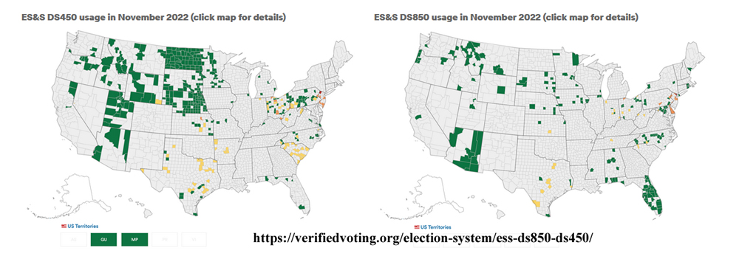

Map above shows ES&S projected usage for two digital scan ballot tabulators - DS450 & DS850.
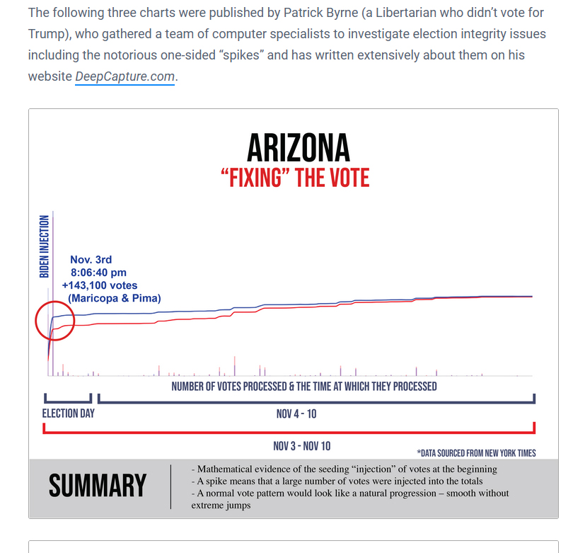
Electionfraud20.org - Unusual Vote Dumps and Spikes During Tallying
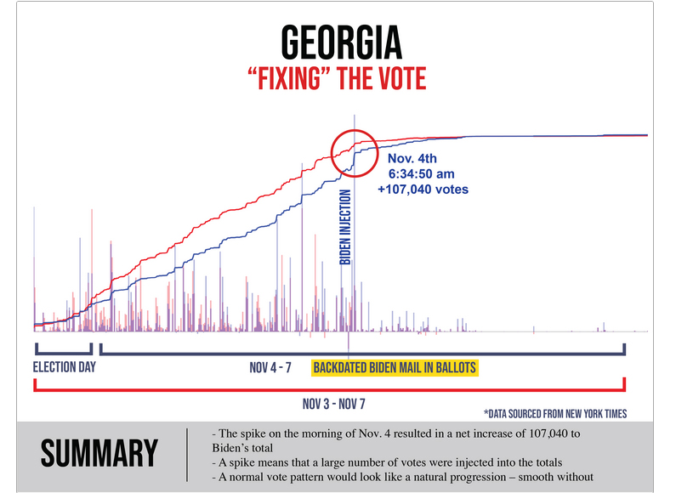
Link on The Vote Spikes Report below to read and visualize entire report by a Libertarian who did not vote for Trump.
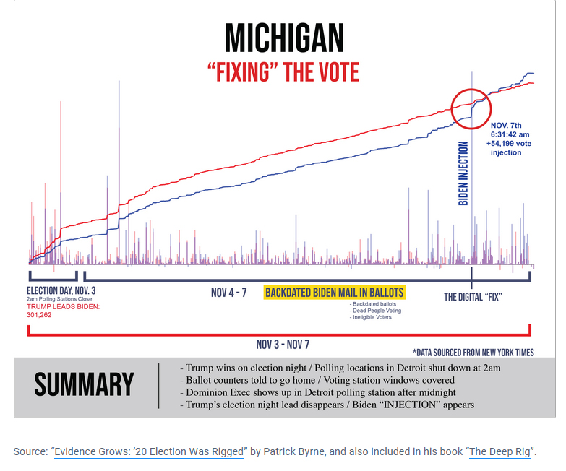
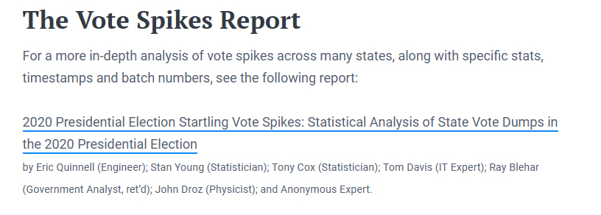
Electionfraud20.org Battle For Largest Counties

Clear evidence of Big Tech search engine bias by overwhelming liberal hits
- TRUTH is much different from the "facts".
- "FACTS" are often repeated lies or gross misrepresentations of the truth.
- Do a search on any subject on the internet by your favorite search engine.
  - First, do a search with a keyword as a liberal would think, & you will see many hits.
  - Second, do a search the same keyword in a conservative sense & you will see less hits.
  - Then review the often outrageous titles of the hits with the liberal bias.
  - That is to say it appears to me that Google so dominates the search engines that they have mastered the demonization of conservative independent thought while accentuating liberal thought beyond what 99 & 2/3% of the victims can imagine.
  - This POLITICAL AGENDA lines up with the chronology of dictionary definition changes including leading law dictionaries like Black's Law Dictionary tracked through each edition change.
  - While you can say that definitions change as awareness changes;
    - The next obvious revelatory question is, in whose favor?
  - Globalist publishers control by sharking out the nonconforming.
  - Exactly like Mainstream Media 6 corporations.
  - The standards for the globalist/Deep State world are profit & power not the truth.

Election Fraud At A Glance
- Incredible must see web site revealed by Captain Seth Keshel, MBA on Telegram
- "The evidence of fraud during the US 2020 elections has been often overlooked or minimized by mainstream media and news outlets. This site aims to summarise the allegations of fraud, as presented in governmental hearings, courts, and investigative reports, by state, to provide an easy reference and portal for further research. Was the election fair and legitimate? Decide for yourself."
- Link below and check how the 2020 election was stolen IN YOUR OWN STATE.
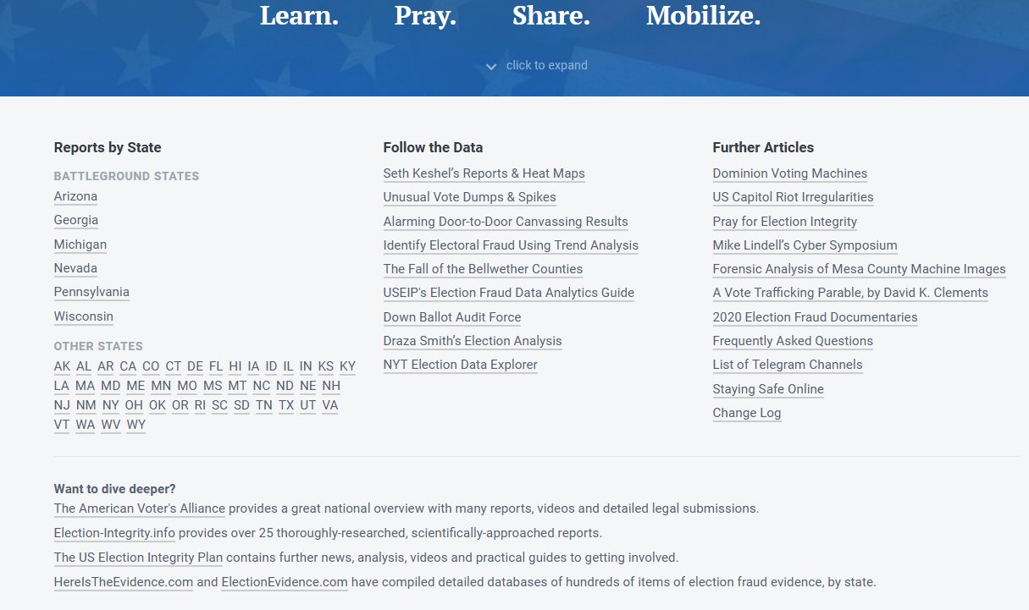

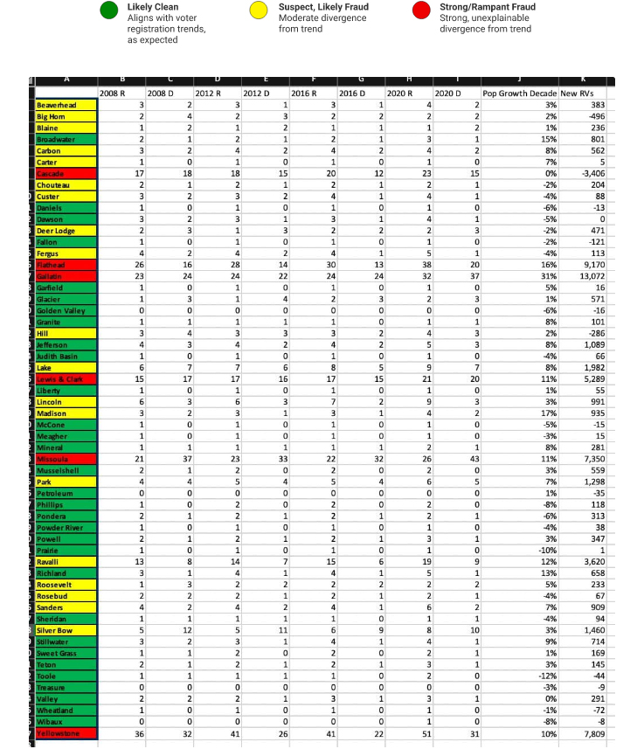
Montana Election Analysis by Seth Keshel

Estimated vote fraud in Montana = 46,000 votes.
46,000/612,075 = 7.5% of the voter turnout
46,000/752,538 = 6.1% of registered voters

1% x 752, 538 registered voters = 7525 voters.
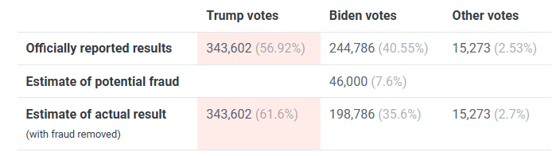
Try to imagine this level of fraud in a state that has elections decided within a few hundred!

State elections are gamed more than gambling industry in this state however, don't tell anyone because the county councils will not believe it because the transnational corporate voting equipment is funded by your globalist federal government who constantly redefine truth!
Captain Seth Keshel, MBA accounting of Maricopia County, Arizona At-A-Glance

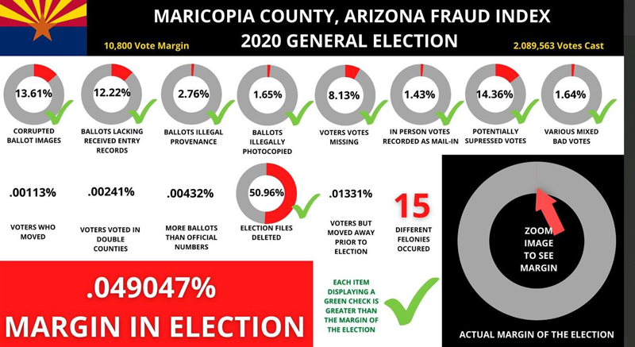
Pima County Arizona Needs a Full Audit AND Decertification of Arizona's Election Now
- AZ House Rep (Dist 11) Mark Finchem statements in an email to me follow.
  - The first is that in Pima County, the total number of mail in ballots that were returned was over 100% of what was sent out.
  - The second is that there were multiple other precincts that had return rates in the high 90’s, when the average was in the 70’s nationwide. Statistical outliers like these are just as much an indicator of fraud as having more ballots returned than sent out to begin with!
  - Additionally, the President cites evidence from the Maricopa Audit which I helped lead which absolutely proves that the election should be decertified:
- 6,545 ballots with no envelopes
- 2,580 bad signatures
- 1,919 mail-in ballots without signatures.
  - This is more than the margin of Biden’s so-called “victory!”

- "Make no mistake, there has been substantial progress ….. in Arizona while I have been leading the Election Integrity movement! " AZ Rep Mark Finchem
- We have demonstrated and proved that there has been substantial election fraud in Maricopa County
- We have found statistically accurate results that show that President Trump actually won the election.
- Attorney General Mark Brnovich has just recently began to investigate the Maricopa Case, in particular those who fraudulently deleted election files.
- We have now gathered tens of thousands of signatures to Audit Pima County
- I am meeting with Election Integrity Patriots and Experts from around the country to help them push for audits in their state.
- I have worked with third party firms to develop currency-level authentication processes with ballots – a technological innovation that simply has not been seen and we can apply to our elections here in America!
Comments Sent to Lady Draza (Engineer several times over & just shy here PhD in Computer Science) on Telegram October 27, 2021
- Seth. Don't know if you saw this.
- My wife and I went for early voting in Virginia today, and something very disturbing happened.
- We were both told we couldn't vote since we had requested and been sent absentee ballots. Since we had done nothing of the sort, we raised hell and they finally produced affidavits we could sign saying that we had lost the ballots we requested. We demanded affidavits saying that we had never requested absentee ballots and absentee ballots had never been received by us. We were told there was no such thing. We could either sign the affidavits saying we had lost the ballots we had requested or go home without voting. We signed.
- During the time we were there and engaged in this dispute, a matter of about fifteen minutes, I overheard THREE other people going through exactly the same thing.
- We live in a heavily Democrat-controlled precinct in a Democrat-controlled state in which the Republican candidate for governor is running even with the Democrat candidate. A not inconsiderable number of people in just one precinct during a very brief period of time were complaining that the voter rolls showed they had requested and received absentee ballots they did not request or receive.
- Are you getting the picture here?
- When the election process becomes an endemically corrupt process manipulated by the Democrat Party to retain power at all costs, we are finished as a free nation. It appears to me that has already happened.
- The above message was sent to Captain Keshel regarding the Virginia governor election. This means that the voter rolls have been cleaned up too much to cover the needed margin for an unpopular candidate win. In order to cover the deficit, they have to steal the vote of REAL voters to meet the mail-in vote partisan margin!!

Comments from Seth Keshel on Telegram
- Seth Keshel, [12/7/2021 10:54 AM]
  - Dem vote trend from 2004 to 2016
  - 60mm, 69mm, 65mm, 66mm... "81mm"
  - They have established a new threshold for voting trend line, and it is around 80mm. That is only achievable with mass mail-in voting to inflated voter rolls full of phantom voters.
  - And in conclusion, the above is why the fight to clean up elections is unending and ongoing. To go back to 62-65mm in the next election would undo the validity of 2020 for those few who remain deceived.

- Seth Keshel, [11/29/2021 12:22 PM]
- Why did the 2020 election have to be ripped off?
  - It was not about Trump, conservatives, or Republicans. It was about his agenda. Had he pulled an Arnold (Benedict Arnold - American Military officer who fought with distinction rising to rank of Major General before defection to the British side in 1780) blended into the political establishment in short time, he’d have had his re-election recognized and a second term.

  - This (election taking) had to do with the realignment of American industry to support American workers, cessation of endless warfare that profits the military industrial complex at expense of American lives, elimination of corrupt trade deals and pacts, immigration controls to benefit the legitimate needs and interests of the country, among other things.

  - China was being bent over the barrel by these trade realignments. Trade is the issue that put the Midwest on a hard Republican trend. Another four years of that would have put the world on an irreversible course with America as the dominant power.

  - The global interests could not allow that. Hence, the 2020 election conspiracy.

      - Not anti-Trump.
      - Not anti-Republican.
      - Not anti-conservative.
      - Anti-America First.

MEDIA ADVISORY
PHOENIX, December 8, 2021... FOR IMMEDIATE RELEASE
House Majority Whip Representative Leo Biasiucci (LD-5), Senate Majority Whip Senator Sonny Borrelli (LD-5) and Representative Mark Finchem (LD-11), announce a Public Hearing on Election Integrity.
DATE: December 13, 2021 TIME: 0900-1700 MST
LOCATION: Hilton El Conquistador Hotel and Convention Center, 10000 N. Oracle Road, Oro Valley, AZ.
ACCESS: By ticket only, the event will be live-streamed for all to watch.
“On November 7, 2020, an anonymous report of election system fraud was made to the United States Department of Justice and ALL members of the Arizona House and Senate. The allegation that 35,000 fictitious votes had been entered into the Pima County election was related by an individual who claimed to be in the room when the plan was revealed to lower-level Pima County Democratic Party leaders.
“Over the last 12 months a few Members of the Legislature and resources from various election integrity organizations have conducted a quiet, but fruitful investigation into the substance and reliability of the allegation.
“Our elections are a system, and systems require active maintenance. Without attention to detail, the bureaucratic machine inevitably runs amok. We are elected to identify defects and fix them.” Rep. Biasiucci
“We found significant discrepancies in the Maricopa County Election through the audit, which gives us all pause to consider what has happened in other counties? To think that we would not find similar problems in other counties is not a credible position for any elected official to take.” Sen. Sonny Borrelli
“With consent of the Governed goes the right of the Governed to to examine, and if warranted, conduct an audit of the elections that they participate in. Elections belong to the People, not the government.” Rep. Finchem
On November 30, 2020, we held a Public Hearing on Election Integrity that gave the public an opportunity to present evidence and sworn testimony to the joint panel of Members of the State Legislature regarding the 2020 General Election. The mission of the Public Hearing on Election Integrity was to, “receive evidence and testimony that could serve to prove or disprove alleged discrepancies in the 2020 General Election.” Arizona citizens and expert witnesses submitted sworn affidavits, under penalty of perjury, to the panel detailing inconsistencies they encountered during the election process.
Pima County voters who have first-person knowledge of a violation of Arizona elections law, a violation of the Arizona Elections Procedure Manual, and who may have physical evidence are asked to contact Sen. Kelly Townsend (LD-16) at 602-926-4467.
https://www.eventbrite.com/e/breaking-pima-county-public-investigative-hearing-election-integrity-tickets-218543177527
This hearing will be held with the same objective. Press organizations may contact 602-826-7300 for information on access.
The 5 Steps of Phantom Votes by Lady Draza 12/1/2021
There are 5 types of Phantom Voters.
1) Traditional fraud – Person doesn’t exist, yet someone created a fake identity.
2) Split Person into multiple voters using same first and last name; diluting your vote. Bobby Piton, Bob Piton, Rob Piton, Robert Piton across county or State lines
3) Moved out of or intra State – they are in voter registration files in different counties and/or states, voting from multiple locations across county / State lines.
a. It might be very difficult to catch if voter registration files are withheld or have limited viewability across county lines.
4) Children or other family members are registered at a family house but are not actually living there.
a. In some cases, they are children off to college, in extreme cases, the parents knew their children had moved out of the home and they still received and possibly voted their ballot; they knowingly committed voter crimes on behalf of their political party.
5) Dead Voter – Identity of someone who died voted across county lines in a different part of the State or the Coroner doesn’t file the paperwork in a “timely manner”, helping his friend the county clerk out. A good way to find out which clerk / coroner might be involved in this fraud is to focus on the ones that have held office across election cycles or for over a decade.
a. In many cases, the “coroner” stays within the same family; look for family relationships of coroners through time.
The goal of the cabal was to flood the system with “Real Ballots” that were generated as a result of these “phantom voters” in the voter registration rolls.
Real Ballots are very difficult to counterfeit, so coming up with a way to get the government to issue this voting currency was essential to pulling off this fraud.

This Fraud would have been very difficult to effectuate if it wasn’t for the mail in ballot push that was so heavily fought for and implemented by the communists (the UniParty) within the Republican Party (RINO’s) and the Democrat Party.

Step 1) Inflate the Voter Registration Rolls with Phantom Voters that don’t exist and motivate everyone to register, or automatically register as many as possible, counting on most not actually voting.

Step 2) Mail out “Real Ballots” to Voter Mules at locations that have a disproportionate amount of registrations. (New Construction sites, Nursing Homes, Apartment Buildings, Government Buildings, PO Boxes, etc.)

Step 3) Mail Back “Real Ballots” and have them separated from the envelopes. Don’t enter these “Real Ballots” cast votes onto the “Phantom Voter” Files, but rather assign them to “Real People” that didn’t vote. Assign a very Real Ballot to a Non-Voter. This is still illegal as someone who exercised their Right NOT to Vote is still afforded the same rights as someone who did vote.

Step 4) If you run out of “Real People” that didn’t Vote, because the real people that “own that spot” show up to vote, tell them they already voted and give them a provisional ballot.

Step 5) If the cabal still can’t make the numbers work, start flipping votes by using an algorithm that calls on names in the voter registration files that are the inverse of real people’s names. (For example, Bob Jones is also registered as Jones Bob, etc). Countless voting records show this insane relationship, and these fictitious voters are created to “tag” how to flip votes if necessary.

Step 6) Destroy entire classes of Last Names across a particular precinct or county.
Say there is a family that would vote 70% Party A and 30% Party B in the past and now votes 30% Party A and 70% Party B, or a 100% swing. Just delete all of the votes that were cast for both Party A and Party B by “Last Name”. This is very quick and efficient and makes it easy to manage a targeted outcome since millions of voters are involved.

Election Fraud At A Glance - Election Data Inquiries
We aim to assist genuine and honest inquiries into what happened during the 2020 General Election.
After spending over 8 months collating information and analyzing all the election data we can find, there is no doubt in our minds the election results were compromised.
We are bipartisan — not affiliated with the Democrat nor the Republican party, nor any party for that matter. We simply stand for Truth, Justice, Honesty and Transparency.
The analysis and reports on this website are done by unpaid volunteers in their free time. Before making any inquiries please familiarize yourselves with the following articles first. They will help establish some common understanding before initiating a conversation:
- The Fall of the Bellwether Counties
- The Battle of the Largest Counties
- The Curious Case of the 2020 “Voting Rate” Blowouts

Conclusion
We have looked at every imaginable scenario to build a case for the Democrat party winning the 2020 election based upon how our “trusted” counties voted. With each new section we relaxed the constraint, to include the most friendly Democrat voting counties in the country (based on the 2008 election). We highlighted the counties that voted the highest for the Democrat party in 2008 as it is a clear indicator of their propensity to vote for the Democrat party.
Have you looked at the results of these counties? If you’ve done your research and found the 2020 results for each of these counties, you should find the results extremely puzzling.
So did we.
Georgia Ballot Harvesting Whistleblower is a Game Changer Potentially 1 Million Illegal Ballots
- Georgia Ballot Harvesting Whistleblower Is a Game Changer - Potentially 1M Illegal Ballots | JF Radio (https://t.me/LibertyOverwatchChannel/6255)
- John Solomon joined John Fredericks again today to review additional details about the Georgia ballot trafficking investigation (https://t.me/LibertyOverwatchChannel/6254).
- Video footage and cell phone data acquired by True the Vote (https://t.me/LibertyOverwatchChannel/5334) suggests there were 242 ballot harvesters who made 5,662 trips to Georgia drop boxes, primarily between the hours of 12AM and 5AM.
- True the Vote was able to secure the cooperation of one of the harvesters they discovered on the video tapes thanks to encouragement from his mother. This ‘John Doe’ claims that he was paid $45K by a non-profit group to deliver roughly 4,500 ballots. He reported that many others participated and laid out the names of the people and groups that were involved, describing a large mass-harvesting operation.
- This “human corroboration” was the critical piece of evidence for Raffensperger and his investigators, Solomon noted. Having a whistleblower who actually admits that he was paid to harvest ballots “makes all that data, all that video footage not only all the more believable, it provides a very specific roadmap of people and names and organizations and dates and times and financial transactions.”
- Fredericks points out that if 242 people each delivered 4,500 ballots, that would suggest $11M in payouts and more than a million harvested ballots between the November election and the Georgia Senate runoff.
- Despite the scale of the scandal, True the Vote was only able to acquire (via FOIA request (https://t.me/LibertyOverwatchChannel/6250)) about 15% of the drop box surveillance in Georgia. It turns out many counties defied federal election records law and discarded their tapes.
- Liz Harris (https://t.me/VoteLizHarris) told Liberty Overwatch that True the Vote has similar evidence of organized ballot harvesting in Arizona.
- Watch 📺 John Fredericks and John Solomon (https://t.me/LibertyOverwatchChannel/6255)
- Learn more🔦🧵 GA Thread - Multi-State Ballot Harvesting Investigation (https://t.me/LibertyOverwatchChannel/6254)
- Source Telegram
- https://www.truethevote.org/ttv-statement-regarding-georgia-ballot-harvesting-investigation/

An Estimated 24 Million Voter Registrations Are Invalid Or Significantly Inaccurate
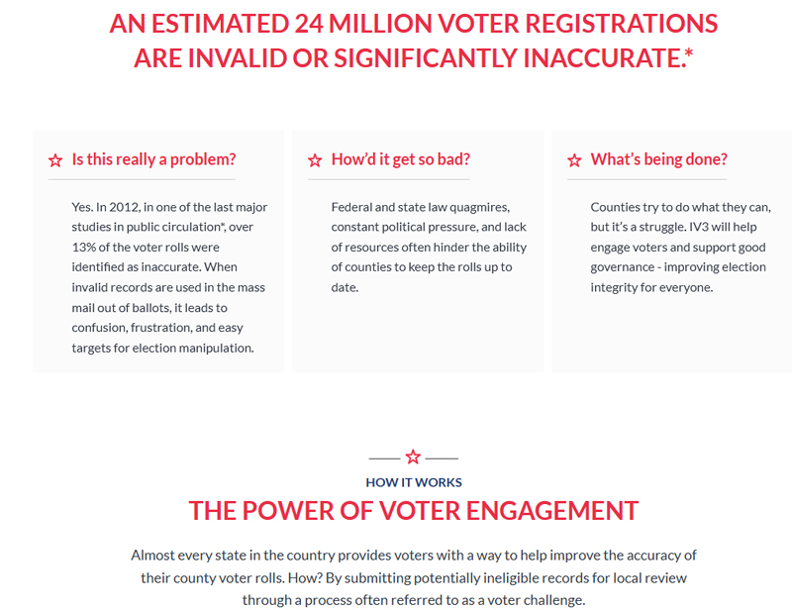

The Left's Voting Machine by Capital Research - Link here to Download 13.2 MB report

Montana Senator Theresa Manzella Action Alert for Election Integrity

Date: Thu, Dec 2, 2021 at 4:09 PM
Subject: State Senator Theresa Manzella: Action Alert for Election Integrity
Good Morning Dear Friends, Colleagues and Citizens.
I wanted to send quick email to update you on the issue of Election Integrity in Montana.
On Nov 10th, I facilitated a meeting between our AG, Austin Knudsen, and Mike Lindell, Dr Doug Frank, Lindell's Attorney- Kurt Olsen and a Cyber Ninja. Rep Brad Tschida was also in attendance, as was Mr. Lindell's and Dr Franks personal assistant, Michele. The purpose of the meeting was to present evidence of election irregularities and vulnerabilities to the AG for consideration, with the goal of having him sign on in support of the lawsuit Mr. Lindell intended to drop on Nov 23rd. Ultimately, our AG did not sign onto the lawsuit. His reasons for not signing on to the lawsuit were given to me secondhand, so I’ll have to refer you back to him or his office for specific details. I was told second hand that the reason for the resistance was that the 2000 page lawsuit was too large to throughly vet in the allotted time frame, which was Nov 10th - Nov 23rd. On Nov 21, the lawsuit was streamlined to 81 pages containing only evidence that had been previously heard by the courts, but still, not a single State AG in the country would sign onto the case.
This Mon, Dec 6th, Rep Brad Tschida and I will go before the Legislative Council seeking appointment and funding of the Special Select Legislative Committee for the purpose of investigating our election process and laws in Montana. If you would like to support that effort, please send respectful emails expressing your desire to the following committee members:
Senate President Mark Blasdel - Mark.Blasdel@mtleg.gov, Senator Jason Ellsworth - Jason.Ellsworth@mtleg.gov, Rep Rhonda Knudsen - rhonda.knudsen@mtleg.gov, Sen Cary Smith - cary.smith@mtleg.gov, Rep Casey Knudsen - Casey.knudsen@mtleg.com, Speaker Wylie Galt - wyliegaltformt@gmail.com , Rep Kim Abbott - kim.abbott@mtleg.gov, Rep Laurie Bishop - Laurie.Bishop@mtleg.gov, Sen Jill Cohenour - Jill.Cohenour@mtleg.gov, Sen Pat Flowers - pat.flowers@mtleg.gov, Rep Derek Harvey - derek.harvey@mtleg.gov, Sen JP Pomnichowski - jp.pomnichowski@mtleg.gov

Additional details about the committee can be found here - https://leg.mt.gov/legislator-information/roster/individual/7056
Despite Republicans holding large majorities in the Montana State Legislature, the Legislative Council Committee is equally split, 50/50 between Republicans and Democrats. To attain success, we need a Democrat to vote in support of our proposal.
Thank you for your commitment to the worthy cause of fair and free elections. We will press on in our endeavor to honor our Constitutional obligation as provided in Article IV, Section 3 - The legislature shall provide by law the requirements for residence, registration, absentee voting, and administration of elections. It may provide for a system of poll booth registration, and shall insure the purity of elections and guard against abuses of the electoral process.
Faithfully For Freedom,
Sen Theresa Manzella

Soros Founded and Funded ERIC Now Used in 31 States
- Blue states left wing voter registration drive disquised as a voter clean up role.
- Must read to believe this clever deception.
Dr. Frank Follow the Data - Extract from Telegram
- "Hacking"
- Cities get hacked.
- Hospitals get hacked.
- Businesses get hacked.
- Power grids get hacked.
- Credit cards get hacked.
- Phones get hacked.
- Some of officials admit that the usernames and passwords to all their county systems are on the dark web.
- Yet our elections, run by technically incompetent people, are "the most secure in history."
- But the thing that just blows me away is that some of our election officials actually believe that their systems are secure.
- And the people believe them too.
- And the media promotes this silliness.
- Sooo stupid. Intolerably so.
- In order to believe something so obviously stupid, people must really want to believe it.

American Citizens & candidates Forum for Election Integrity
2000 MULES NEW SURVEILANCE FOOTAGE OF GALLOT DROP BOXES
- "Highly respected Dinesh D'Souza, working together with Catherine Engelbrecht of True the Vote, just released a trailer to their new movie, "2,000 Mules," that shows the world exactly how the 2020 Presidential Election was Rigged and Stolen. The movie exposes the lies of the Democrats, RINOs, and Fake News who say it was the "most secure election in history." It was, perhaps, the least secure in history. The ballot box was stuffed, and stuffed like never before—and it's all on video. Ballots were trafficked and sold in a massive operation in each Swing State. The evidence is so damning, what will the cowards who sat and did nothing about the stolen election say now? The way our votes were taken away is a disgrace to our Nation. It must be fixed." Link above and enter your email address to wake up.

- ONE DAY ONE PERSON ONE ID ONE VOTE
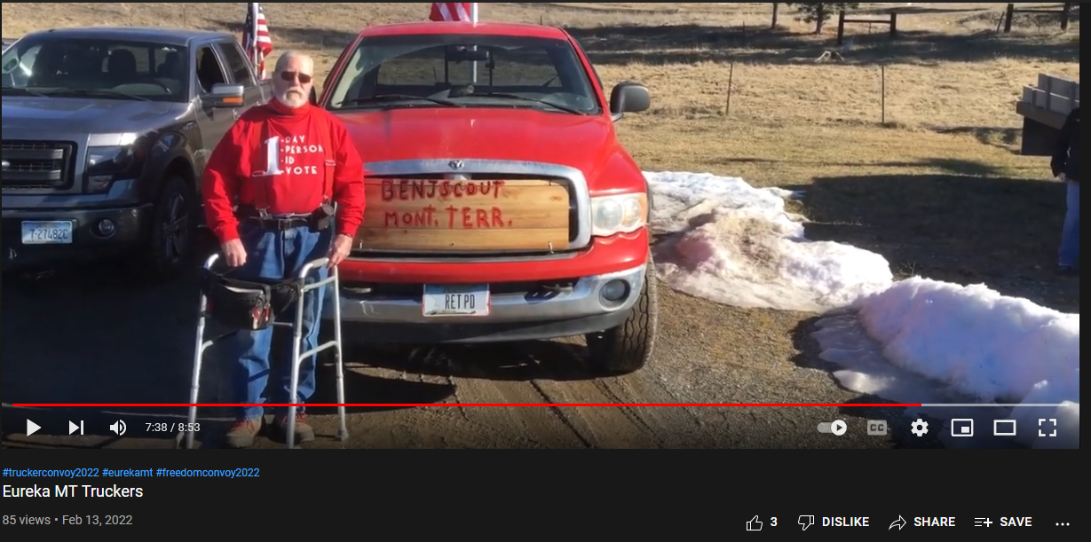
Promoting American Election Integrity
- Our team of authors of 2020 election-related analyses are unpaid volunteers, whose expertise covers a wide range of fields (Cyber Security, IT, Statistics, Physics, Economics, etc.). Our main interest is in assuring election integrity, which is when American citizens legally express their preferences for their representatives. Since last November, we have generated multiple 2020 election-related studies. Our main reports (in chronological order) are:
  - Pennsylvania Report,
  - 2- Michigan Report,
  - 3- Election Spikes Report,
  - 4- Claudia Tenney Report (NY-22),
  - 5- Edison Timeseries Distribution Analysis,
  - 6- List of 2020 Presidential-related Election Lawsuits (plus Text Summary),
  - 7- Critique of MITRE Report,
  - 8- 2020 Presidential Election Contrast Analysis,
  - 9- Election Integrity: Recommendations Report (plus one page digest of State recommendations), and
  - 10-Post Election Audits: Verifying Election Integrity. (Here is a short video about our Audit Report.)

Election Fraud Summary by State - Link to find your state fraud report.

Vote Manipulation in St John County, Flordia
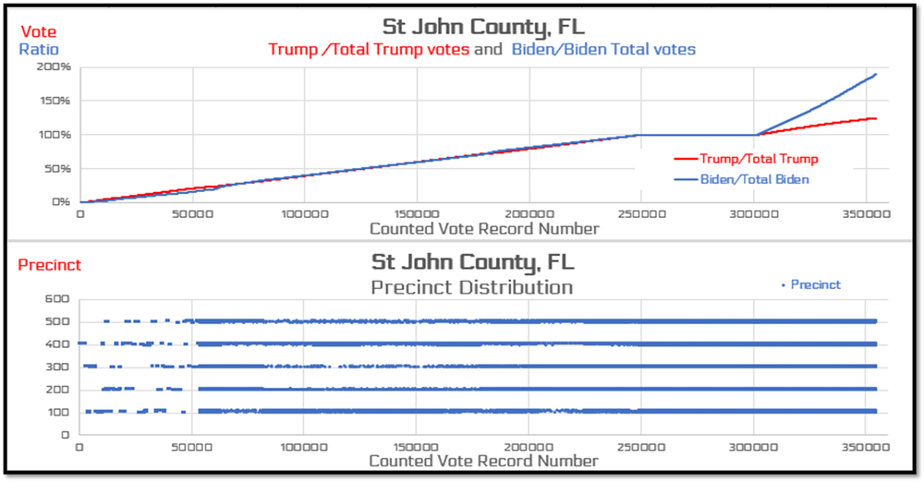

- Now notice, the distribution of those last 50k votes seems to come from ALL of the precincts, not from a single precinct that may be more Democratic than the others. And still, they are structured from ALL the precincts in the county to produce the LINEAR decline in the CUMULATIVE ratio at the END of the election.

- What this looks like to me is some one knew what the real votes were because they had a count going on (possibly from reporting from pollbooks who is voting? -This kind of pre-knowledge is WHY early voting is BAD!) and and phantom votes were CRAFTED in this manner to produce this effect as a high-tech, mail-in ballot stuffing endeavor - without the knowledge or participation of the local clerk, Lady Draza via Telegram
- Link here to sign up for Telegram.

Minnesota Presidential Trend 2004 - 2020
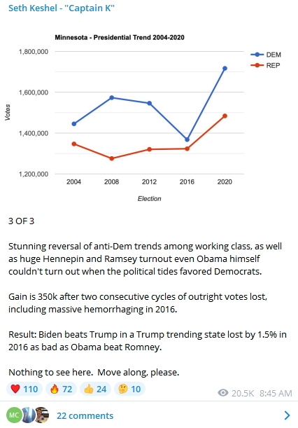
Arizona finds 229,430 early votes in Arizona with obviously mismatched signatures
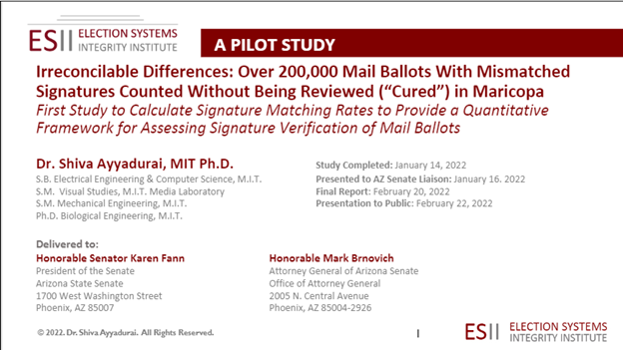
- Arizona attorney general: Election fraud in Maricopa raises questions about 2020

Wisconsin's Voting Machines Were connected to the Intenet During The 2020 Election
- Dominion & ES&S were online and a Democrat operative ran Green Bay's election from his Hyatt Regency hotel room
- In Zuckerberg 5 cities in all counties those nursing homes reported a voting rate of 95% to 100%.
- Mr. Gableman found $8.8 million in Zukerberg grant funds directed soley to 5 Democratic strongholds in Wisconsin violated the state's election codes prohibition on bribery.

Watch Dinesh D'Souza New Movie Here
Buy DVD or Stream it thru Dinesh web Site Here
Hey guys:
Just a quick update on the release schedule for my new movie "2000 Mules."
THEATER SPECIAL EVENTS: On two days, Monday May 2 and Wednesday May 4, we are renting 250 theaters around the country which will show the movie at the 7 pm showing. You will be able to purchase tickets for these showings from a link that will be posted on the 2000Mules website. This is a LIMITED theatrical release so there will be certain places that aren’t showing the movie in theaters.
VIRTUAL PREMIERE: On Friday May 6 we are having a virtual premiere. This is a very exciting way you to buy tickets and log into a live event out of a studio in Las Vegas. This virtual premiere will include exclusive content with President Trump, the screening of the movie, and a live Q & A with me and leading figures in the movie. Additionally, for a higher price, around 300 VIPs will be able to attend this event in person. (Your weekend in Vegas including the live premiere—it might be time to make some plans!)
DIGITAL DOWNLOADS: On Saturday May 7 you will be able to stream the film from two platforms, SalemNow.com and Rumble/Locals.
Details for all of this will be on the website 2000Mules.com which launches soon.
We’re very excited about this movie. 2000Mules exposes the widespread, coordinated voter fraud in the 2020 election, sufficient to change the overall outcome. So get ready!
Dinesh D’Souza
Director and Producer
2000Mules

- New Texas Election Integrity Laws Flag 27,000 Mail-in Ballots for Rejection in Primary
  - Across 120 counties
- Special Report: Election Expose of Flathead County and Beyond by Kirk McKenzie
  - Regarding corruption in Flathead County Montana
  - Commissioners take federal bribes to buy more foreign corporation ballot calculating machines.

- Globalism Rising - Authoritarianism and The Demise of civil Liberties (6 segment videos)
  - Regent University put on this event and you can watch 6 segments link above.
  - The Rise of Authoritarianism Presentation by Gateway Pundit showing time line of major news events starting in 2020 taking down our civil liberities. (49 pages)

- Documentary $400 Million Zuckerberg Effort to Elect Biden
  - "Zuck and his bucks under the guise to make elections more safe dumped private funding into government elections creating a get out the vote efforts for Biden.
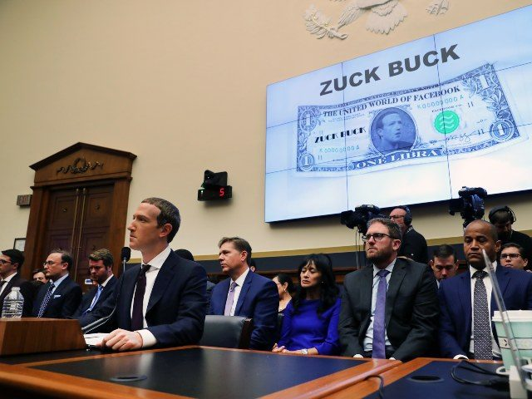
  - Essentially Zuck Bucks pressured gvt. to adopt radical Democrat ideas to xform the election, pushing mail in ballots and number of drop boxes, i.e. rampant invitation for fraud."
- Montana Election CTCL Zucker Bucks by County
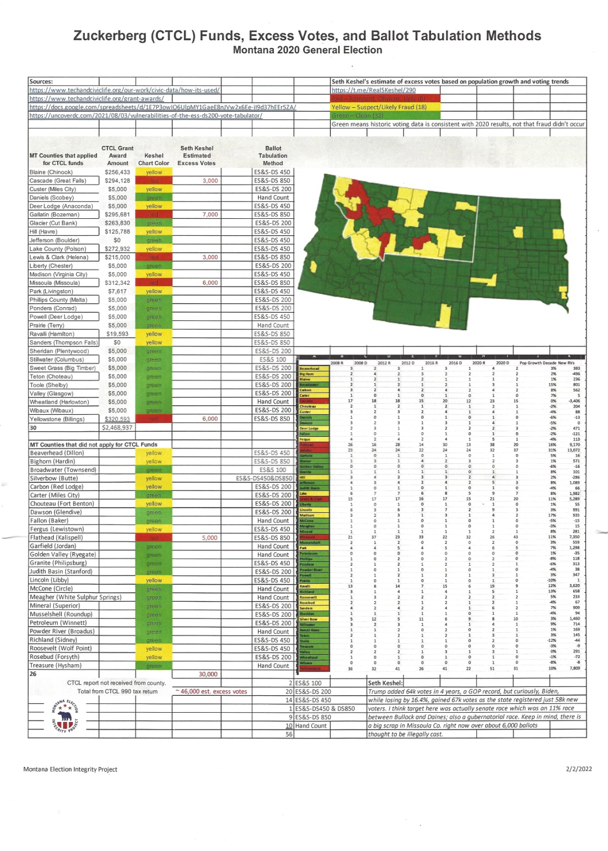
- Montana Election 2020 Zucker CTCL Influence Map
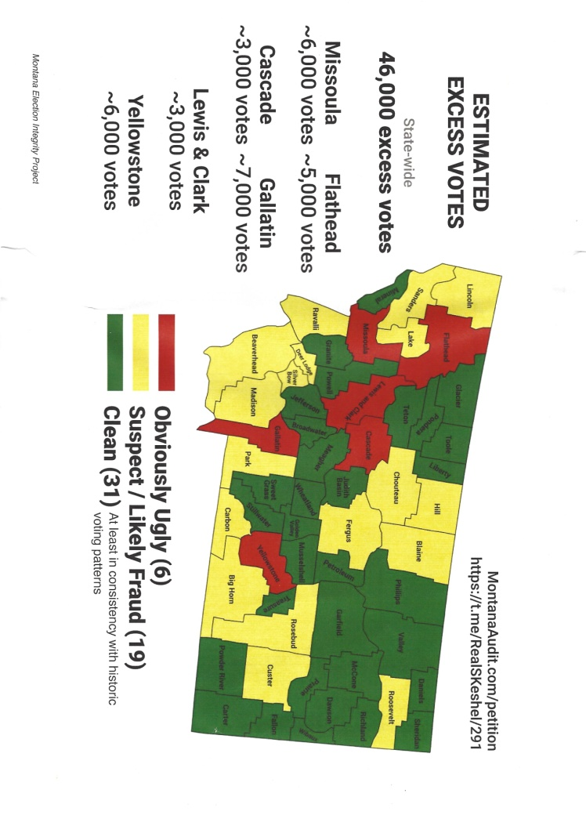
- Catch up on more proof of 2020 election fraud on Frankspeech.com
  - Bombshell Proof Election Machine Manipulation
  - Hacking America's Voting System
  - 34% of Democrats believe the 2020 election was stolen peer Real Clear Politics.com
- Whistleblowers Expose Arizona’s Ballot Trafficking ‘Mafia,’ Implicate GOP
  - (https://rumble.com/v111a5h-arizona-citizen-featured-in-dsouzas-2000-mules-details-ballot-trafficking-b.html)
  - Two men in Yuma County, Arizona, David Lara and Gary Snyder, took down a San Luis ballot trafficking operation using undercover cameras during the 2020 primary election. Their evidence, which was presented to Arizona AG Mark Brnovich, resulted in felony forgery and conspiracy charges filed against Guillermina Fuentes, a member of the San Luis School District Board.
  - Lara and Snyder appear in the upcoming Dinesh D’Souza “2,000 Mules” True the Vote (https://t.me/LibertyOverwatchChannel/6754) documentary. In a recent interview (https://rumble.com/v111a5h-arizona-citizen-featured-in-dsouzas-2000-mules-details-ballot-trafficking-b.html) with The Gateway Pundit, Lara reveals details about Arizona’s vote harvesting “mafia” and the mechanics of ballot trafficking.
  - In Yuma County, Lara says election rigging through ballot harvesting has been going on for 22 years. “It is a professional criminal organization. These are not amateurs, these are people that have been doing it for many, many years, it is well structured… Giuliani would have been perfect for this investigation because it mirrors the mafia, the Italian mafia in New York. It has ranks, has different levels of infrastructure, they have different levels of authority, and it trickles all the way up to the top. And when I say all the way to the top, I'm talking about state and federal levels. The grassroots… will pick up the ballots, and then they'll pass it on to the next person… and so forth. And the reason they do this is in case somebody gets caught, then they're caught with a small amount of ballots, which makes it an amount that would not sway an election either way. So they’re very precise… and that's why I've always said this is a cartel. This is run exactly the way cartels and drug dealers distribute drugs in a community.”
  - Lara also shed light on why ballot traffickers prefer drop boxes to mailboxes. The cartel relies on a last minute drop box deluge to bypass signature checks on forged ballots. This is the exact “playbook” that was used “in the swing states in 2020, when when the election was stolen from Trump,” Lara explained. “The avalanche of mail-in ballots kicked in at midnight, or somewhere around 1AM. The reason they do that is, the harvesters, after they gather hundreds or thousands of ballots, they hold on to them. On Election Day, in the morning, they start to slowly trickle them in… Then they wait to the last hour or two. And then that's when they unload the rest of them. The reason they do that is so that the county recorder will get flooded with an avalanche of ballots, when they're under the clock to verify thousands of votes. It is impossible to verify that many signatures that fast in that short of a time.”
  - “How can you harvest that many ballots?,” Lara asks rhetorically. “That's through nonprofits that are in low income communities. The vast majority in low income communities are controlled by what I called warlords. And I say warlords, because it's to benefit them to remain in control of their community.” Not all the ballots have fake signatures, Lara noted. In some cases, these low income, minority voters actually hand over signed blank ballots, which are then voted straight ticket Democrat.
  - One of the most disturbing revelations in the interview was confirmation that the GOP is involved. In 2020, Arizona audit liaison Ken Bennett brought the DOJ to San Luis to investigate one of Lara’s ballot harvesting complaints. Within hours of their arrival, a flyer, written in Spanish, had circulated throughout the community notifying residents that they did not have to cooperate with the DOJ, answer any questions, or even open their door. The PAC distributing the flyer was funded by the Republican Party. “The real problem in the ballot harvesting is big money Republicans,” Lara said. “These are the RINO establishment that in some ways, somehow they benefit from the ballot harvesting. Could be contracts, it could be favors… So the biggest problem that we have to fight the voter fraud in all of the states are the RINO Republicans who are just entrenched.”
  - Listen | TGP Rumble (https://rumble.com/v111a5h-arizona-citizen-featured-in-dsouzas-2000-mules-details-ballot-trafficking-b.html)
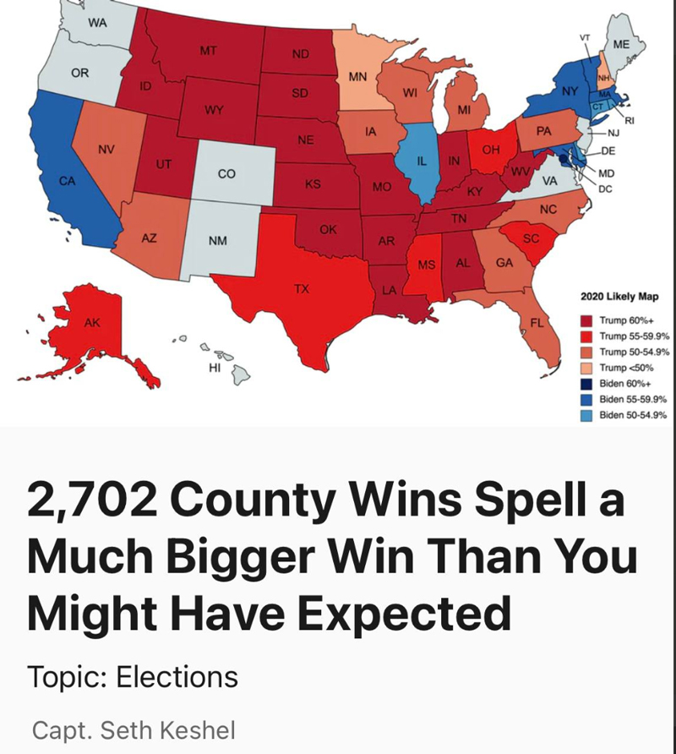
- Capt. Seth Keshel Analysis
"I re-mapped 3,144 county equivalents and came up with at least 113 should-be flips, and it vastly opens up the electoral map in ways not previously imagined."

Jack Venrick
In Freedom For ALL Seasons

Rollins, Montana
www.freedomforallseasons.org
jacksranch@freedomforallseasons.org
Pioneer Family of Montana - Early Settlers
Pioneer Family of Nebraska
Pioneer Family of Wisconsin
The Boeing Company
30 Years Service - Retired
Montana State University
B.S. Electrical Engineering/Electronic Engineering
M.S. Applied Science -
M.S. Business Administration
M.S. Industrial Engineering
Master's Thesis in Vertical Takeoff and Landing Craft
FreedomForAllSeasons.org Table of Contents Hot Links
1. Mission Statement
2. Natural Law & Natural Rights
3. Unalienable Rights vs. Inalienable Rights
4. Organic Laws of The United States of America
5. The British Common Law
6. The U.S. Constitution That Never Was
7. Current Property Battles -Taking Back Our Rights
8. Freedom From ALL Tax Takings Upon Natural Born State Citizens
9. Freedom From Alternative Energy Myths
10. Freedom from Consumer Complaints
11. Freedom From Critical Area Ordinances Myths
12. Freedom From De Facto Laws
13. Freedom From Embattled Property Owner Stories
14. Freedom From Endangered Species Mythomania
15. Freedom From Environmental Extremism
16. Freedom From Fish Myths
17. Freedom From Government Roundabout Nonsense For Humans & Fish
18. Freedom From Illegal Aliens in Government
19. Freedom To Keep & Bear Arms
20. Freedom From King County WA Muni Corporation - The Great Imposter
21. Freedom From Mainstream Media Monopoly Lies
22. Freedom From "Man Caused" Global Warming Myths
23. Freedom From Municipal Monarchy Monopoly Corporations
24. Must Read Must Subscribe Must Support Must See
25. Freedom From Park Takings
26. Freedom From Rails To Trails Takings
27. Freedom From Rural Cleansing & UN Agenda 21 Junk Social Engineering
28. Freedom From Taking - 17 Years of Research & 13 Presentations on How America is Being Taken
29. Freedom From The State of Washington Constitution That Never Was
30. Freedom From The unFederal unReserve
31. Freedom From Water Takings
32. Freedom From World Trade Center Towers Implosion
33. Freedom To Own Land With Allodial Rights
34. Jack's Videos of Freedom For All Seasons (In Work)
35. Jack's Prose From The Heart
36. About Jack

